(1)
(1)
(1)
(2)
(1)
Second Quarter 2026 Results

Press Release

UNITED STATES
SECURITIES AND EXCHANGE COMMISSION
Washington, DC 20549
FORM 8-K
CURRENT REPORT
Pursuant to Section 13 or 15(d) of the
Securities Exchange Act of 1934

Date of Report (Date of earliest event reported): July 29, 2026

BANC OF CALIFORNIA, INC.
(Exact name of registrant as specified in its charter)

Maryland | 001-35522 | 04-3639825
(State or other jurisdiction of incorporation) | (Commission File Number) | (IRS Employer Identification No.)

11611 San Vicente Boulevard, Suite 500, Los Angeles, California 90049
(Address of principal executive offices)(Zip Code)

Registrant’s telephone number, including area code: (855) 361-2262

N/A
(Former name or former address, if changed since last report)
Check the appropriate box below if the Form 8-K filing is intended to simultaneously satisfy the filing obligation of the registrant under any of
the following provisions (see General Instruction A.2.):
☐ | Written communications pursuant to Rule 425 under the Securities Act (17 CFR 230.425)
☐ | Soliciting material pursuant to Rule 14a-12 under the Exchange Act (17 CFR 240.14a-12)
☐ | Pre-commencement communications pursuant to Rule 14d-2(b) under the Exchange Act (17 CFR 240.14d-2(b))
☐ | Pre-commencement communications pursuant to Rule 13e-4(c) under the Exchange Act (17 CFR 240.13e-4(c))

Securities registered pursuant to Section 12(b) of the Act:
Title of each class |  | Trading Symbol(s) |  | Name of each exchange on which  registered
Common Stock, par value $0.01 per share |  | BANC |  | New York Stock Exchange
Depositary Shares, each representing a 1/40th interest in a share of 7.75% fixed rate  reset non-cumulative perpetual preferred stock, Series F |  | BANC/PF |  | New York Stock Exchange
Indicate by check mark whether the registrant is an emerging growth company as defined in Rule 405 of the Securities Act of 1933 (§230.405 of
this chapter) or Rule 12b-2 of the Securities Exchange Act of 1934 (§240.12b-2 of this chapter).

Emerging growth company ☐

If an emerging growth company, indicate by check mark if the registrant has elected not to use the extended transition period for complying with
any new or revised financial accounting standards provided pursuant to Section 13(a) of the Exchange Act. ☐

Item 2.02. Results of Operations and Financial Conditions.
On July 29, 2026, Banc of California, Inc. (the “Company”) issued a press release announcing financial results for
the second quarter ended June 30, 2026.
A copy of the press release is furnished herewith as Exhibit 99.1 and is incorporated by reference herein.
Item 7.01 Regulation FD Disclosure.
The Company will host a conference call to discuss its second quarter 2026 results at 08:00 A.M. Pacific Time on
Wednesday, July 29, 2026. Interested parties may attend the conference call by dialing (888) 317-6003 and
referencing event code 9364475. A live audio webcast will be available through the webcast link to be posted on the
Company’s Investor Relations website at www.bancofcal.com/investor, in addition to the slide presentation for
investor review prior to the call. A copy of the presentation materials is furnished herewith as Exhibit 99.2 and is
incorporated by reference herein.
Item 9.01 Financial Statements and Exhibits.
(d) Exhibits.
99.1Banc of California, Inc. Press Release dated July 29, 2026
99.2Banc of California, Inc. Earnings Conference Call Presentation Materials
104 Cover Page Interactive Data File (embedded within the Inline XBRL document)

SIGNATURES
Pursuant to the requirements of the Securities Exchange Act of 1934, the registrant has duly caused this report to be
signed on its behalf by the undersigned hereunto duly authorized.
BANC OF CALIFORNIA, INC.
/s/ Joseph Kauder
Joseph Kauder
Executive Vice President and
Chief Financial Officer
Date: July 29, 2026
1



Banc of California, Inc. Reports Second Quarter 2026 Financial Results and Announces Strategic Balance Sheet
Repositioning to Enhance Long-Term Earnings
2

The Company reported a net loss available to common and equivalent stockholders of
higher recurring earnings, and accelerate organic capital generation.

significantly higher interest rate reset. Taken together, these actions are expected to immediately improve net interest margin, support

of subordinated debt prior to a
$385.0 million
In addition, the Company retired
expects the transactions to close in the third quarter.
$251.3 million
process, the Company has entered into purchase and sale agreements for the loans transferred to held-for-sale during the quarter and

Following a competitive loan sale
reduce selected credit exposures and lower the potential for future credit-related earnings volatility.

of commercial real estate and multi-family construction loans to
$827.0 million
The Company also commenced a targeted sale process of
of the securities portfolio, all while maintaining capital ratios significantly above “well capitalized” regulatory thresholds.

(1) Non-GAAP measure; refer to section 'Non-GAAP Measures'
on the businesses, clients and markets where we see the greatest opportunities to create shareholder value.”

capital efficiency and provide greater financial flexibility to support future growth. Just as importantly, they allow us to focus our capital

Mr. Wolff continued, "These actions resulted in significant one-time charges, but they increase our long-term earnings power, improve
that together create a more efficient balance sheet and position the Company for even stronger long-term financial performance."

three complementary actions including a securities repositioning, a targeted loan sale and the retirement of higher-cost subordinated debt,

capital toward opportunities that we believe will enhance long-term returns for our shareholders. We implemented that strategy through

Jared Wolff, Chairman & CEO of Banc of California, commented, “During the second quarter, we made a strategic decision to reallocate
share, reflecting the near-term impact of these strategic actions.

per diluted common

$(1.61)
, or
.
$2.3 billion
including (i) the repositioning of

strengthen long-term earnings, expand net interest margin, and increase balance sheet flexibility. The Company took three specific actions

a strategic reallocation of capital toward higher return opportunities to further
completed
During the second quarter, the Company

of lower-yielding securities, (ii) initiating the sale of
June 30, 2026

ended
second quarter
parent company of wholly-owned subsidiary Banc of California (the “Bank”), today reported financial results for the

LOS ANGELES, Calif.--(BUSINESS WIRE)--Banc of California, Inc. (NYSE: BANC) (“Banc of California” or the “Company”), the
9%
Loan Average
Annualized Growth

7/29/2026

basis point yield pickup on redeployed balances, reduced portfolio duration, and improved the risk-weighted asset profile
276
generated a

redeployed a portion of the proceeds into higher-yielding, shorter-duration available-for-sale securities. The securities repositioning

of lower-yielding held-to-maturity securities to available-for-sale, and subsequently sold and
$2.3 billion
The Company transferred
Company Release –
interest reset.

of subordinated debt prior to higher contractual
$385.0 million
real estate and multi-family construction loans, and (iii) the retirement of

of selected commercial
$827.0 million
Quarter Results
Second Quarter 2026 Financial Highlights:
3
.
exceeded the regulatory thresholds for "well capitalized" banks
Capital ratios
•
, respectively.
basis points
154
basis points, and
99

loans and leases held for investment declined by

as classified loans and leases and special mention loans and leases as a percentage of total
Credit quality trends were favorable,
•
, including an estimated
89.3%
basis points to
235
decreased
Loan-to-deposit ratio
•
of average total deposits.
28.5%

during the quarter, with average noninterest-bearing deposits comprising
2.9%
, or
$799.0 million

and tangible book value per share
(2) Non-GAAP measure; refer to section 'Non-GAAP Measures'
are preliminary
June 30, 2026
(1) Capital ratios for
the strategic balance sheet repositioning actions completed during the quarter.

, reflecting the near-term impact of
respectively
,
$16.44

and
$18.38
were
increased
Book value per share
•
9.50-9.60% at the end of the third quarter.
loan sale and to approximately

9.50% upon closing of the targeted
. The CET 1 ratio is expected to increase to approximately 9.45-
ratio
CET 1 capital
9.25%
ratio and

Tier 1 capital
11.67%
276
of loans
$827.0 million

loan sale process involving
targeted
Commenced a
•
.
on securities
pre-tax loss
$256.7 million
and resulted in a

basis point yield pickup on redeployed balances
to reduce selected exposures, enhance capital efficiency,
expected to be invested in the third quarter of 2026. The repositioning generated a

into higher-yielding shorter-duration securities, with the remaining proceeds
$1.7 billion
and partial redeployment of
securities

lower-yielding
of

$2.3 billion
including the sale of
repositioning to drive higher recurring earnings power,
Executed a securities

Total deposits
•
.
6.39%
disbursements with a weighted average interest rate on production of

$2.8 billion of loan production and
, during the quarter, driven by
2.3%
, or
$556.1 million
Average loans increased
•
supporting stronger pre-tax pre-provision earnings.
•
, reducing future funding costs and
of subordinated debt prior to a significantly higher interest rate reset
$385.0 million
Retired
•
.
the lower of cost or market value
at
loans to held for sale

includes the impact of transferring these
$161.8 million
and improve the risk profile of the loan portfolio. Total provision expense of

INCOME STATEMENT HIGHLIGHTS

Net Interest Income and Margin
Summary Income Statement
Total interest income
Total interest expense
Net interest income
Provision for credit losses
(Loss) gain on loans and leases HFS
Loss on securities AFS
Other noninterest income
Total noninterest (loss) income
Total revenue
Total noninterest expense
(Loss) earnings before income taxes
Income tax (benefit) expense
Net (loss) earnings
Preferred stock dividends
Net (loss) earnings available to common
and equivalent stockholders
Diluted (loss) earnings per share

Three Months Ended
Six Months Ended
Second Quarter of 2026 Compared to First Quarter of 2026
4
The average total
. The average yield on interest-earning assets decreased to
4.44%
basis point decrease in the average cost of borrowings to

19
, and a
1.80%
basis point increase in the average total cost of deposits to
2
, as a result of a
2.10%
from
2.14%
cost of funds increased to

5.18%

deposit growth strengthened toward quarter-end, improving the Company's funding profile entering the third quarter.

while core
redemption of subordinated debt,
with strong loan growth and the
an increase in short-term funding associated
impacts and

rimarily driven by nonaccrual interest
The decrease was p
loan sale, net interest margin is expected to increase to approximately 3.30%.

Upon closing of the targeted
.
$323.5 million

.
first quarter
in the
28.9%
, down from
second quarter
deposits in the

of average total
28.5%
decrease in average noninterest-bearing deposits. Average noninterest-bearing deposits represented
$24.4 million

increase in average interest-bearing deposits, offset partially by a
first quarter
, with a
$299.1 million
by
increased
Average total deposits

.
5.63%
basis point decrease in the average yield on loans and leases to
11
, as a result of a
5.25%

from
$8.3 million
in interest expense on our borrowings driven by higher average balances to fund loan growth and
increase

$4.2 million
and a

in interest expense on deposits, attributable to higher average balances,
increase

$4.0 million
The increase in interest expense was due to a

increase in total interest income.
$7.2 million
increase in total interest expense, offset partially by a
replace
decrease was driven by an

. This
first quarter
in the
$251.6 million
, from
second quarter
for the
$250.5 million
to
$1.1 million
by
decreased
increase from investments and deposits in financial institutions driven by higher average balances as a result
for the
3.24%
basis points from
11
, down
second quarter
for the
3.13%
Net interest margin was
nonaccrual status.

reduction primarily related to loans placed on
$4.6 million
of the securities repositioning. These increases were offset partially by a

Net interest income
$2.3 million
the quarter, and a

from higher average loan balances and an additional day in
increase

$10.4 million
. The increase in interest income was driven by a
quarter

Notes due 2031 during the second
Subordinated
subordinated debt funding, following the redemption of the 3.25% Fixed-to-Floating Rate

______________
Summary
Average Balance
and Yield/Cost Data
Assets:
Loans and leases(1)
Investment securities
Deposits in financial institutions
Total interest-earning assets
Liabilities:
Noninterest-bearing demand deposits
Total interest-bearing deposits
Total deposits
Total interest-bearing liabilities
Net interest income(1)
Net interest margin
Total funds(2)

Three Months Ended
Increase (Decrease)

5
2.12%
increase in average noninterest-bearing deposits and a
$229.2 million
year over year, as a result of a
$356.0 million
deposits increased by

second half of 2025. Average total
in the
, reflecting the impact of federal funds rate cuts
1.79%
basis points to
33
deposits declined by

, driven mainly by lower market interest rates. The average cost of

basis points to
30
The average total cost of funds decreased by
.
5.21%
basis point decrease in the average yield on interest-earning assets to
20
offset partially by a

,
2.12%
basis point decrease in the average total cost of funds to
30
. The year-over-year improvement was primarily driven by a
30, 2025
60

yield on loans and leases.

basis point decline in the average
23
, due primarily to a
5.21%
basis points to
20
The average yield on interest-earning assets declined by
lower-cost long-term Federal Home Loan Bank ("FHLB") advances.

, reflecting the paydown of higher-cost borrowings in the prior year and their replacement with
4.52%
basis points to

decreased by

. The average cost of borrowings also
2025
for the comparable period in
28.2%
, up from
six months ended June 30, 2026
deposits for the

of average total
28.7%
increase in average interest-bearing deposits. Average noninterest-bearing deposits represented
$126.8 million
June 30, 2025
decrease in interest expense on deposits primarily due
$41.0 million
. The increase was primarily driven by a
months ended June 30, 2025

six
for the
$472.6 million
, from
six months ended June 30, 2026
for the
$502.1 million
to
$29.5 million
Net interest income increased

vs YTD
June 30, 2026
YTD
divided by average total funds.

(2) Total funds is the sum of total interest-bearing liabilities and noninterest-bearing demand deposits. The cost of total funds is calculated as annualized total interest expense
, respectively.
March 31, 2026
and
June 30, 2026
for the three months ended
$12.2 million
and
$11.2 million
second quarter of 2026, and a
six months ended June
for the
3.09%
basis points from
9
, up
six months ended June 30, 2026
for the
3.18%
The net interest margin was

interest on loans placed on nonaccrual status, offset partially by the benefit of higher average loan balances.

decrease in loan interest income primarily attributable to a reversal of previously accrued
$3.6 million
(1) Includes net loan discount accretion of

increase in borrowing costs associated with funding loan growth and the subordinated debt redemption in the
$6.3 million
interest rates, a

decrease in interest income from deposits in financial institutions due to lower balances and lower market
$10.3 million
partially by a

reflecting the benefits of prior balance sheet repositioning actions and reinvestment into higher-yielding assets. These benefits were offset

increase in interest income from investment securities
$8.8 million
to lower interest rates following federal funds rate cuts, and an
______________
Summary
Average Balance
and Yield/Cost Data
Assets:
Loans and leases(1)
Investment securities
Deposits in financial institutions
Total interest-earning assets
Liabilities:
Noninterest-bearing demand
deposits
Total interest-bearing deposits
Total deposits
Total interest-bearing liabilities
Net interest income(1)
Net interest margin
Total funds(2)

Six Months Ended
Increase (Decrease)

Second Quarter of 2026 Compared to First Quarter of 2026
(1) Includes net loan discount accretion of
$23.4 million
and
$32.1 million
for the
six months ended

June 30, 2026
and
2025
.
(2) Total funds is the sum of total interest-bearing liabilities and noninterest-bearing demand deposits. The cost of total funds is calculated as annualized total interest expense

divided by average total funds.
Provision For Credit Losses
The first quarter provision for loan losses and unfunded loan commitments was primarily driven by net charge off activity and changes in
, the impact of loan growth and higher loss given default rates on commercial real estate
additional provision expense during the quarter.

targeted loan sale process. The transfer required the loans to be recorded at lower of cost or market value, resulting in charge-offs and

of loans to held for sale ("HFS") in connection with the
$827.0 million
the transfer of
net charge-offs in the quarter related primarily to

held for investment ("HFI") portfolio. The increase in
and multi-family construction loans, offset partially by improved risk ratings for our

The provision for credit losses was
of charge-offs
$161.6 million
primarily driven by

. The increase was
first quarter
for the
$9.8 million
compared to
second quarter
for the
$161.8 million
loan risk ratings including specific reserves, offset partially by lower balances in the HFI portfolio and lower qualitative reserves.
6
HFS and recorded at
The provision for the
six months ended

June 30, 2025

included the impact of

$506.7 million
of loans transferred to
reduction in provision for unfunded loan commitments.

the lower of cost or market value
. The remaining increase in the provision for loan losses and unfunded loan commitments was primarily

driven by net charge-off activity experienced in the first half of the year, with additional impacts from changes in loan risk ratings, and

higher unfunded commitments. These were offset partially by lower qualitative reserves, lower specific reserves, and a favorable shift in

the portfolio mix due to growth in loan segments with lower expected credit losses.
for the
June 30, 2026
vs YTD
June 30, 2025
The provision for credit losses was
$171.6 million
for the
six months ended June 30, 2026
, compared to
$48.4 million
YTD
six months

ended June 30, 2025
. The provision for 2026 included a provision for loan losses of
$171.8 million
, including the impact of the proposed

targeted loan sale process, offset by a
$2.0 million

Second Quarter of 2026 Compared to First Quarter of 2026
Noninterest Income

Second Quarter of 2026 Compared to First Quarter of 2026
six months ended June 30, 2026
$3.8 million
gain recognized on the sale of the Company's single-family mortgage

servicing rights portfolio, which serviced approximately $
1.35 billion
of underlying loans.
YTD
June 30, 2026
vs YTD
June 30, 2025
Noninterest income decreased by
$265.1 million
to a loss of
$198.8 million
for the
during the quarter. The loss was offset partially by a
, compared to income

of
$66.3 million
for the same period 2025. The year-to-date decrease was primarily attributable to the $
256.7 million
pre-tax loss

recognized as part of the securities repositioning, and a $
12.5 million
lower of cost or market adjustment on the HFS loans, as discussed

above.
Noninterest Expense
256.7 million
decreased
by
$269.4 million
, resulting in a loss of
$234.1 million
for the
second quarter
, compared to noninterest

income of
$35.3 million
for the
first quarter
. The decrease was primarily driven by a $
Noninterest income
pre-tax loss recognized as part of the

securities repositioning, and a
$12.5 million loss
recorded as part of the lower of cost or market adjustment on HFS loans. Also included in

noninterest income was a
$
3.1 million
loss
related to the redemption of
$385.0 million
aggregate principal amount of subordinated notes

Second Quarter of 2026 Compared to First Quarter of 2026
six months ended June 30, 2026
increase in other expense related mainly to software
$6.3 million
. The increase is primarily due to a
months ended June 30, 2025

six
for the
$369.5 million
from

for the
$371.3 million
to
$1.7 million
Noninterest expense increased by
June 30, 2025
vs YTD
June 30, 2026

Income Taxes
decrease in leased equipment depreciation.

$3.0 million
related expenses primarily due to federal fund rate cuts in the fourth quarter of 2025 and a
customer
decrease in
million
YTD
$6.5
increase in loans expense related to legal fees. These increases were offset partially by a
$2.5 million
sheet repositioning, and a

increase in insurance and assessment due to the higher assessment rate resulting from the balance
$4.6 million
obsolescence charges, a
$181.4 million
in insurance and assessment due to a higher FDIC assessment rate resulting from the balance sheet
increase

$7.7 million
reflecting a

, primarily
first quarter
for the

from
second quarter
for the
$189.9 million
to
$8.5 million
by
increased
. These increases were offset partially by a

.
related costs recognized in the first quarter

in compensation expense due to seasonal payroll
decrease

$6.0 million
Noninterest expense
obsolescence charges

in other expense related mainly to software
increase

$5.0 million
and a
repositioning and its effect on assessment-related metrics

7

June 30, 2026
vs YTD
June 30, 2025
Income tax benefit
of
$70.1 million

was recorded for the
six months ended June 30, 2026
, resulting in an effective tax rate of
29.3%
,
YTD
compared to income tax expense of
$39.0 million
and effective tax rate of
32.2%
for the same period 2025.
The decrease in effective tax

rate from 2025 to 2026 is due primarily to the impact of deferred tax asset revaluation recorded following the
California state tax changes

passed as part of the 2025 California budget enacted on June 30, 2025.
24.9%
$93.9 million
was recorded for the
second quarter
, resulting in an effective tax rate of
28.0%
,
compared to income

tax expense of
$23.8 million
and an effective tax rate of
Income tax benefit of
for the
first quarter
.
The second quarter tax rate reflects the effects of the

Company's balance sheet repositioning actions. Due to the significant impact of these actions
on projected annual earnings, the Company

calculated its second quarter income tax provision using a year to date effective tax rate approach rather than the estimated annual effective

tax rate method.
BALANCE SHEET HIGHLIGHTS

8
, offset
decrease
$8.2 million
of maturities,
$16.7 million
of principal paydowns,
$116.9 million
as part of the securities repositioning,
,
$2.3 billion

partially by the sale of

$1.9 billion
purchases of
and
$2.3 billion

AFS of
, due primarily to the transfer of HTM securities to
2026

March 31,
$143.3 million

.
no HTM securities
, there are
June 30, 2026
As of

, driven by higher interest rates.
March 31, 2026
at
at
up from
,
$145.3 million
after-tax losses in AOCI of

, AFS securities had aggregate unrealized net
June 30, 2026
of net amortization. As of
$2.0 million
in the fair value of AFS securities, and
The
improved the

. The transaction
$251.3 million
and were sold at a pre-tax loss of
2.1%
securities sold had an average yield of approximately
of
billion

$2.3
Company's earning-asset mix by facilitating the redeployment of proceeds into higher-yielding assets while enhancing

.
sold primarily all of the securities
to available-for-sale ("AFS") securities and subsequently

$2.3 billion
amortized cost basis of

As part of the securities repositioning, the Company reclassified its entire held-to-maturity ("HTM") securities portfolio with an aggregate
Securities
basis point yield pickup on redeployed balances.
$2.7 billion
compared to
June 30, 2026
at
$4.5 billion
to
second quarter
during the
$1.8 billion
AFS securities increased by
Selected Balance Sheet Items
Cash and cash equivalents
Securities available-for-sale
Securities held-to-maturity
Loans held for sale
Loans and leases held for investment
Total loans and leases
Total assets
Noninterest-bearing deposits
Total deposits
Borrowings
Total liabilities
Total stockholders' equity

276
, which resulted in a
4.87%
at a weighted average yield of
$1.7 billion
June 30, 2026 we reinvested
As of
balance sheet flexibility.

June 30,
March 31,
June 30,
Increase (Decrease)
9
in the
loans,

venture capital loans, and asset-based lending portfolios.
Loan production and disbursements totaled
$2.8 billion
in the
second quarter

with

a weighted average interest rate on production of 6.39%.
Total loans and leases HFS increased by
$656.1 million
real estate mortgage
second quarter
and totaled
$915.2 million
at
June 30, 2026
.
The increase

was primarily driven by the Company'
s targeted loan sale process di
scussed above
.
part, the transfer of
Loans and Leases
The following table sets forth the composition, by loan category, of our loan and lease portfolio HFI as of the dates indicated:
Composition of Loans and Leases
Real estate mortgage:
Commercial
Multi-family
Other residential
Total real estate mortgage
Real estate construction and land:
Commercial
Residential
Total real estate construction and land
Total real estate
Commercial:
Asset-based
Venture capital
Other commercial
Total commercial
Consumer
Total loans and leases HFI
Total unfunded loan commitments
Composition as % of Total Loans and Leases
Real estate mortgage:
Commercial
Multi-family
Other residential
Total real estate mortgage
Real estate construction and land:
Commercial
Residential
Total real estate construction and land
Total real estate
Commercial:
Asset-based
Venture capital
Other commercial
Total commercial
Consumer
Total loans and leases HFI

Total loans and leases HFI decreased by
$569.5 million
in the
second quarter
to
$24.2 billion
at
June 30, 2026
. The decline reflected, in

$827.0 million
of loans to HFS in connection with the balance sheet repositioning, including
$491.9 million
of multi-
family loans,
$300.6 million
of multi-family construction loans, and
$34.5 million

of commercial real estate mortgage loans. Excluding the

impact of the loans transferred to HFS, the Company continued to generate loan growth in other residential
June 30,
March 31,
December 31,
September 30,
June 30,

10
, nonperforming loans and leases increased by
$91.8 million
charge-offs of
,
$248.0 million
HFS of

, offset partially by transfers to loans
$391.7 million
additions of
due to
$18.0 million

, paydowns of
quarter

second
. During the
March 31, 2026
at
$185.7 million
, compared to
$203.7 million
, nonperforming loans and leases were
June 30, 2026
At
, or
family residences.
consisting primarily of single-
of foreclosed assets,
$16.3 million
, nonperforming assets included
June 30, 2026
. At
March 31, 2026
as of

of total assets,
0.59%
commercial real estate loans.
$203.8 million
of total assets, compared to
0.63%
, or
$220.0 million
, nonperforming assets were
June 30, 2026
At
.
$1.5 million
, and transfers to accrual status of
$32.4 million
basis points and
March 31, 2026
at
$345.1 million
, compared to
$173.7 million
, total delinquent loans and leases were
June 30, 2026
At
basis points, respectively.

154

.
99
, and decreased
basis points
9

increased
repositioning. Nonperforming, classified, and special mention loans and leases as a percentage of total loans held for investment

edit quality metrics improved from the first quarter, primarily reflecting the transfer of certain loans to HFS as part of the balance sheet
Cr
Asset Quality Information and Ratios
Delinquent loans and leases held for investment:
30 to 89 days delinquent
90+ days delinquent
Total delinquent loans and leases
Total delinquent loans and leases to loans and leases HFI
Nonperforming assets, excluding loans held for sale:
Nonaccrual loans and leases
90+ days delinquent loans and still accruing
Total nonperforming loans and leases ("NPLs")
Foreclosed assets, net
Total nonperforming assets ("NPAs")
Classified loans and leases HFI
Special mention loans and leases HFI
Criticized loans and leases HFI
Allowance for loan and lease losses
Allowance for loan and lease losses to NPLs
NPLs to loans and leases HFI
NPAs to total assets
Classified loans and leases to loans and leases HFI
Special mention loans and leases to loans and leases HFI

Credit Quality
$27.9

in
$23.2 million
in multi-family real estate mortgage loans, offset partially by decreases of
$9.1 million
other commercial loans and

in
$11.8 million
in other residential real estate mortgage loans. In the 90 or more days delinquent category, there were increases of
million

in multi-family real estate mortgage loans, offset partially by increases of
$32.8 million
estate construction and land loans, and

in commercial real
$32.9 million
in residential real estate construction and land loans,
$140.7 million

delinquent category decreased by

The 30 to 89 days
June 30,
March 31,
December 31,
September 30,
June 30,
11
June 30, 2026
at
136%
The ACL coverage of nonperforming loans and leases was
.
March 31, 2026
at
1.60%

compared to
June 30, 2026
at

of total loans and leases
1.63%
which equaled
,
top of our ACL ratio. We refer to this adjusted ACL ratio as our economic coverage ratio

credit-linked notes and unearned credit marks is added to our allowance for credit losses, this provides additional economic coverage on
of average loans and leases (annualized) for the
(1) Non-GAAP measure; refer to section 'Non-GAAP Measures'

.
first quarter

for the
0.23%
, compared to net charge-offs of
second quarter

2.54%
Net charge-offs were

.
March 31, 2026
at
149%
compared to
June 30, 2026

$0.3 million
. The
March 31, 2026
of total loans and leases at
1.12%
, or
$276.5 million
, compared to
decrease in the allowance was driven by net charge-offs of
total loans and leases at

of
1.14%
, or
$276.2 million
The allowance for credit losses - loans, which includes the reserve for unfunded loan commitments, totaled
Allowance for Credit Losses - Loans
Allowance for loan and lease losses ("ALLL"):
Balance at beginning of period
Charge-offs
Recoveries
Net charge-offs
Provision for loan losses
Balance at end of period
Reserve for unfunded loan commitments ("RUC"):
Balance at beginning of period
Provision for credit losses
Balance at end of period
Allowance for credit losses ("ACL") - Loans:
Balance at beginning of period
Charge-offs
Recoveries
Net charge-offs
Provision for credit losses
Balance at end of period
ALLL to loans and leases HFI
ACL to loans and leases HFI
ACL to NPLs
ACL to NPAs
Annualized net charge-offs to average loans and leases

Allowance for Credit Losses – Loans
$105.0 million
of purchased loans without credit deterioration. When the loss coverage from the
on approximately $1.2 billion
$12.9 million
marks of

$2.1 billion of single-family residential mortgage loans in our portfolio; and (ii) unearned credit
the bank sold the first 5% of any losses on

of loss coverage from the credit-linked notes, pursuant to which
Our ability to absorb credit losses is also bolstered by (i)

.
$160.0 million
quarter, offset partially by the provision of

, largely associated with loans transferred to HFS during the
$160.3 million
Three Months Ended
Six Months Ended

12
liquidity. These off-balance sheet client funds totaled
to
$90.9 million
Borrowings decreased by
Borrowings
.
March 31, 2026
as of
$1.2 billion
and
June 30, 2026
as of
$1.0 billion
$2.5 billion

In addition to deposit products, we also offer alternative, non-depository corporate treasury solutions for select clients to invest excess
.
March 31, 2026
of total deposits, at

28%
, or
$7.8 billion
of total deposits, compared to

27%
outstanding aggregate principal amount of its
at March 31, 2026.
$954.1 million
at June 30, 2026, from
$573.6 million
decreased to

were recorded as a loss on redemption of subordinated notes in noninterest income. As a result of the redemption, subordinated debt

Subordinated Notes due 2031 originally issued by Pacific Western Bank. The remaining unamortized discount and debt issuance costs

Fixed-to-Floating Rate
3.25%
, or
$385 million
On May 1, 2026, the Company redeemed all
Subordinated Debt
repayment of a long-term FHLB advance.

, driven primarily by the
March 31, 2026
at
$2.6 billion
from
June 30, 2026
at
March 31, 2026
$493.2 million
and higher money market accounts of
$560.9 million
increased due mainly to higher balances in checking accounts of

. Interest-bearing deposits
$39.4 million
and a decrease in noninterest-bearing deposits of
$838.5 million
interest-bearing deposits of

, driven by an increase in
,
at
$27.3 billion
from
June 30, 2026
at
$28.1 billion
to
$799.0 million
Total deposits increased by
Composition of Deposits
Noninterest-bearing checking
Interest-bearing:
Checking
Money market
Savings
Time deposits:
Non-brokered
Brokered
Total time deposits
Total interest-bearing
Total deposits
Composition as % of
Total Deposits
Noninterest-bearing checking
Interest-bearing:
Checking
Money market
Savings
Time deposits:
Non-brokered
Brokered
Total time deposits
Total interest-bearing
Total deposits

The following table sets forth the composition of our deposits at the dates indicated:
Deposits and Client Investment Funds
of total deposits, compared to
$7.6 billion
, uninsured and uncollateralized deposits totaled
June 30, 2026
At
.
March 31, 2026
total deposits, at

of
29%
, or
$7.8 billion
28%
, or
$7.8 billion
, noninterest-bearing checking deposits totaled
June 30, 2026
At
.
$59.1 million
and lower brokered and non-brokered time deposits of
$156.5 million
offset partially by lower savings accounts of

June 30,
March 31,
December 31,
September 30,
June 30,

______________
March 31, 2026
June 30, 2026

six-month period ended
For the
completed during the quarter.

the repositioning actions
reflected
. The decrease primarily
, the Company repurchased
at
$17.77
compared to
$16.44
decreased to
common share

, and tangible book value per
March 31, 2026
June 30, 2026
Capital Ratios(1)
Banc of California, Inc.
Total risk-based capital ratio
Tier 1 risk-based capital ratio
Common equity tier 1 capital ratio
Tier 1 leverage ratio
Banc of California
Total risk-based capital ratio
Tier 1 risk-based capital ratio
Common equity tier 1 capital ratio
Tier 1 leverage ratio

The following table sets forth our regulatory capital ratios as of the dates indicated:
CAPITAL AND LIQUIDITY
(1) Non-GAAP measure; refer to section 'Non-GAAP Measures'
the current stock repurchase authorization, which expires in March 2027.

remained available under
$82.6 million
,
at
in the aggregate. As of
$31.9 million
, or
$18.68
weighted average price per share of

shares of common and common equivalent stock at a
1,709,935
decreased
. The decrease in total stockholders’ equity for the
June 30, 2026
at

$2.6 billion
to
$136.8 million
by

second quarter
and tangible common equity
$3.4 billion
to
$143.2 million

, total stockholders’ equity decreased by
second quarter
During the
Equity

$19.80
compared to
$18.38
, book value per common share decreased to
June 30, 2026
At
.
$125.3 million
after-tax net loss in AOCI for AFS and HTM securities of
, offset partially by a decrease in the unrealized
on
$29.3 milli
and common and preferred stock dividends of
$241.3 million
net losses of

resulted primarily from
June 30,
March 31,
December 31,
September 30,
June 30,

13
$2.6 billion
.
second quarter

at the end of the
$14.1 billion
, total available liquidity was
$3.6 billion
and unpledged AFS securities of
$7.9 billion
borrowing capacity of

. Combined with total available
(1)
Our immediately available cash and cash equivalents (excluding restricted cash) were
.
March 31, 2026
from
$600.8 million
, up
$2.8 billion
, cash and cash equivalents totaled
June 30, 2026
At
capital ratios are preliminary.
June 30, 2026

14
Factors that could cause actual results to differ materially from the results anticipated or projected include, but are not limited to: (i)
of fraud, any of which may lead to increased loan delinquencies, losses, and non-performing assets, and may result in our allowance for

condition of borrowers, and the operational risk of lending activities, including the effectiveness of our underwriting practices and the risk

renewed inflation; (iii) the credit risks of lending activities, which may be affected by deterioration in real estate markets and the financial

and obligations, the realization of deferred tax assets, the availability and cost of capital and liquidity, and the impacts of continuing or

recent and potential future changes in the FRB benchmark rate, which could adversely affect our revenue and expenses, the value of assets

supply chain disruptions, and the risk of recession or an economic downturn; (ii) changes in the interest rate environment, including the

changes in general economic conditions, either nationally or in our market areas, including the impact of tariffs and retaliatory tariffs,

circumstances that occur after the date on which such statements were made, except as required by law.

undertakes no obligation to revise or publicly release any revision or update to these forward-looking statements to reflect events or

time in the documents filed or furnished by the Company with the Securities and Exchange Commission ("SEC"). The Company

uncertainty and actual results could differ materially from those anticipated due to various factors, including those set forth from time to

You are cautioned not to place undue reliance on any forward-looking statements. These statements are necessarily subject to risk and

anticipated,” “estimate,” “project,” “plans,” “strategy,” or similar expressions are intended to identify these forward-looking statements.

historical statements. Words or phrases such as “believe,” “will,” “should,” “will likely result,” “are expected to,” “will continue,” “is

certain assets, refrain from issuing an approval or non-objection to certain capital or other actions, increase our allowance for credit losses,

and the possibility that any such regulatory authority may, among other things, limit our business activities, restrict our ability to invest in

innovations affecting both the Company and the banking industry; (xiii) results of examinations by regulatory authorities of the Company

including stablecoins and other digital currencies, tokenized deposits, blockchain, artificial intelligence, quantum computing, and related

revenues, cost savings, synergies, and other benefits; (xii) the competitive and other impacts on our business of emerging technologies,

expenses and charges related to these transactions being significantly higher than anticipated; and our inability to achieve expected

Company’s acquisitions, including disruption to current plans and operations; difficulties in customer and employee retention; fees,
non-
otherwise; (ix) our ability to raise capital or incur debt on reasonable terms; (x) the costs and effects of litigation; (xi) risks related to the

described herein or otherwise, or the failure to complete our anticipated loan sales due to a condition to closing not being satisfied or

(viii) our ability to achieve or maintain the anticipated benefits of our strategic repositioning due to one or more of the other factors

rising or high interest rate environment; (vii) the rapid withdrawal of a significant amount of demand deposits over a short period of time;

base, including among our venture banking clients, or other low cost funding sources necessary to fund our activities particularly in a

in our market area; (v) the quality and composition of our securities portfolio; (vi) our ability to develop and maintain a strong core deposit

credit losses not being adequate; (iv) fluctuations in the demand for loans, and fluctuations in commercial and residential real estate values

Banc of California, Inc. (NYSE: BANC) is a bank holding company with over $34 billion in assets and the parent company of Banc of
About Banc of California, Inc.
.
7085829
and referencing event code
(855) 669-9658
website at www.bancofcal.com/investor or by dialing

to the call. A replay of the call will be made available approximately one hour after the call has ended on the Company’s Investor Relations

www.bancofcal.com/investor. The slide presentation for the call will also be available on the Company's Investor Relations website prior

A live audio webcast will also be available, and the webcast link will be posted on the Company’s Investor Relations website at
California. Banc of California is one of the nation’s premier relationship-based business banks, providing banking and treasury
.
9364475
and referencing event code
(888) 317-6003
. Interested parties are welcome to attend the conference call by dialing
July 29, 2026

financial results at 8:00 a.m. Pacific Time (PT) on Wednesday,
2026

second quarter
The Company will host a conference call to discuss its
Conference Call

possible net interest income and net interest margin expansion and an enhanced earnings profile; and other
strengthened credit profile,

performance of our business, liquidity and capital ratios; the anticipated benefits of our strategic repositioning including, among others, a

Litigation Reform Act of 1995. These statements include, but are not limited to, statements related to our expectations regarding the

This press release includes forward-looking statements within the meaning of the “Safe-Harbor” provisions of the Private Securities
Forward-Looking Statements
at www.bancofcal.com.

and job training, small business support, affordable housing, and more. Member FDIC. For more information, please visit us

its local communities through the Banc of California Charitable Foundation, and by supporting organizations that provide financial literacy
Community Association Management industry nationwide with its technology-forward platform, SmartStreet™. The bank is committed to

as through regional offices nationwide. The bank also provides full-service payment processing solutions to its clients and serves the

full-service branches located throughout California and in Denver, Colorado, and Durham, North Carolina, as well
77

and services through

headquartered in Los Angeles and the third largest bank headquartered in California and offers a broad range of loan and deposit products

management services to small, middle-market, and venture-backed businesses. Banc of California is the largest independent bank

15

in realized losses on investment securities or other assets; (xxiv) the effects of any damage to our reputation resulting from developments

related to any of the items identified above; and (xxv) other economic, competitive, governmental, regulatory, and technological factors

affecting our operations, pricing, products and services and the other risks described in our Annual Report on Form 10-K for the fiscal year

ended
December 31, 2025
and from time to time in other documents that we file with or furnish to the SEC.
Non-GAAP Financial Measures
Included in this press release are certain non-GAAP financial measures, such as tangible common equity, tangible book value per common
additional capital and to meet our debt obligations; (xxiii) changes in market conditions or strategic balance sheet actions, which may result
share, return on average tangible common equity, pre-tax pre-provision income, efficiency ratio, and economic coverage ratio, designed to

complement the financial information presented in accordance with U.S. GAAP because management believes such measures are useful to

investors. These non-GAAP financial measures should be considered only as supplemental to, and not superior to, financial measures

provided in accordance with GAAP. Please refer to the “Non-GAAP Measures” section of this release for additional detail including

reconciliations of the non-GAAP financial measures included in this press release to the most directly comparable financial measures

prepared in accordance with GAAP.
Banc of California, Inc.
(855) 361-2262
Jared Wolff, (310) 424-1230
Joe Kauder, (310) 844-5224
Ann DeVries, (646) 376-7011
Media Contact:
Debora Vrana, Banc of California
(213) 533-3122
Deb.Vrana@bancofcal.com

which we depend; (xviii) our ability to attract and retain key members of our senior management team; (xix) the effects of climate change,
result in write-downs of asset values, restrict our ability or that of our bank subsidiary to pay dividends, or impose fines, penalties or

sanctions; (xiv) legislative or regulatory changes that adversely affect our business, including changes in tax laws and policies, accounting

policies and practices, privacy laws, and regulatory capital or other rules; (xv) the risk that our enterprise risk management framework may

not be effective in mitigating risk and reducing the potential for losses; (xvi) errors in estimates of the fair values of certain of our assets

and liabilities, as well as the value of collateral supporting our loans, which may result in significant changes in valuation or recoveries;

(xvii) cybersecurity threats and failures or security breaches with respect to the network, applications, vendors and computer systems on

severe weather events, natural disasters such as earthquakes and wildfires, pandemics, epidemics and other public health crises, military

activity (including the ongoing Iran war) or acts of terrorism, and other external events on our business; (xx) the impact of bank failures or

other adverse developments at other banks on general depositor and investor sentiment regarding the stability and liquidity of banks; (xxi)

the possibility that our recorded goodwill could become impaired, which may have an adverse impact on our earnings and capital; (xxii)

our existing indebtedness, together with any future incurrence of additional indebtedness, could adversely affect our ability to raise

Investor Relations Inquiries:

______________
CONSOLIDATED STATEMENTS OF FINANCIAL CONDITION
(UNAUDITED)
ASSETS:
Cash and due from banks
Interest-earning deposits in financial institutions
Total cash and cash equivalents
Securities AFS
Securities HTM
FRB and FHLB stock
Total investment securities
Loans HFS
Loans and leases HFI
Allowance for loan and lease losses
Total loans and leases HFI, net
Equipment leased to others under operating leases
Premises and equipment, net
Bank owned life insurance
Goodwill
Intangible assets, net
Deferred tax asset, net
Other assets
Total assets
LIABILITIES:
Noninterest-bearing deposits
Interest-bearing deposits
Total deposits
Borrowings
Subordinated debt
Accrued interest payable and other liabilities
Total liabilities
STOCKHOLDERS' EQUITY:
Preferred stock
Common stock
Class B non-voting common stock
Non-voting common stock equivalents
Additional paid-in-capital
Retained deficit
Accumulated other comprehensive loss, net
Total stockholders’ equity
Total liabilities and stockholders’ equity
Common shares outstanding (1)

BANC OF CALIFORNIA, INC.
16
(1) Common shares outstanding include non-voting common stock equivalents that are participating securities. There were no non-voting common stock equivalents

outstanding as of June 30, 2026 and March 31, 2026.

17
CONSOLIDATED STATEMENTS OF EARNINGS
(UNAUDITED)
Interest income:
Loans and leases
Investment securities
Deposits in financial institutions
Total interest income
Interest expense:
Deposits
Borrowings
Subordinated debt
Total interest expense
Net interest income
Provision for credit losses
Net interest income after provision for credit losses
Noninterest income:
Service charges on deposit accounts
Commissions and fees
Leased equipment income
(Loss) gain on loans and leases HFS
Loss on securities AFS
Dividends and gains (loss) on equity investments
Warrant income
Other income
Total noninterest (loss) income
Noninterest expense:
Compensation
Occupancy
Information technology and data processing
Other professional services
Insurance and assessments
Intangible asset amortization
Leased equipment depreciation
Customer related expense
Loan expense
Other expense
Total noninterest expense
(Loss) earnings before income taxes
Income tax (benefit) expense
Net (loss) earnings
Preferred stock dividends
Net (loss) earnings available to common
and equivalent stockholders
(Loss) earnings per common share:
Basic
Diluted
Weighted average number of common shares outstanding: (1)
Basic
Diluted

______________
(1) Common shares outstanding include non-voting common stock equivalents that are participating securities.
BANC OF CALIFORNIA, INC.

18
SELECTED FINANCIAL DATA
(UNAUDITED)
Profitability and Other Ratios
Return on average assets (1)
Return on average equity (1)
Return on average tangible common equity (1)(2)
Dividend payout ratio (3)
Average yield on loans and leases (1)
Average yield on interest-earning assets (1)
Average cost of interest-bearing deposits (1)
Average total cost of deposits (1)
Average cost of interest-bearing liabilities (1)
Average total cost of funds (1)
Net interest spread
Net interest margin (1)
Noninterest income to total revenue (4)
Noninterest expense to average total assets (1)
Noninterest expense to total revenue (4)
Efficiency ratio (2)(5)
Loans to deposits ratio
Average loans and leases to average deposits
Average investment securities to average total assets
Average stockholders' equity to average total assets

______________
(1) Annualized.
(2) Non-GAAP measure.
(3) Ratio calculated by dividing dividends declared per common and equivalent share by basic (loss) earnings per common and equivalent share.
(4) Total revenue equals the sum of net interest income and noninterest income.
(5) Ratio calculated by dividing noninterest expense (less intangible asset amortization and acquisition, integration and reorganization costs) by total revenue (the sum of net

interest income and noninterest income, less gain (loss) on securities AFS) .

BANC OF CALIFORNIA, INC.

______________
AVERAGE BALANCE, AVERAGE YIELD EARNED, AND AVERAGE COST PAID
(UNAUDITED)
Assets:
Loans and leases (1)
Investment securities
Deposits in financial institutions
Total interest-earning assets
Other assets
Total assets
Liabilities and Stockholders' Equity:
Interest checking
Money market
Savings
Time
Total interest-bearing deposits
Borrowings
Subordinated debt
Total interest-bearing liabilities
Noninterest-bearing demand deposits
Other liabilities
Total liabilities
Stockholders' equity
Total liabilities and stockholders' equity
Net interest income (1)
Net interest spread
Net interest margin
Total deposits (2)
Total funds (3)

BANC OF CALIFORNIA, INC.

19
March 31, 2026
divided by average total funds.

(3) Total funds is the sum of total interest-bearing liabilities and noninterest-bearing demand deposits. The cost of total funds is calculated as annualized total interest expense
on total deposits divided by average total deposits.

(2) Total deposits is the sum of total interest-bearing deposits and noninterest-bearing demand deposits. The cost of total deposits is calculated as annualized interest expense
.
June 30, 2025
, and
(1) Includes net loan discount accretion of
,
June 30, 2026
for the three months ended
$16.1 million
, and
$12.2 million
,
$11.2 million
______________
AVERAGE BALANCE, AVERAGE YIELD EARNED, AND AVERAGE COST PAID
(UNAUDITED)
Assets:
Loans and leases (1)
Investment securities
Deposits in financial institutions
Total interest-earning assets
Other assets
Total assets
Liabilities and Stockholders' Equity:
Interest checking
Money market
Savings
Time
Total interest-bearing deposits
Borrowings
Subordinated debt
Total interest-bearing liabilities
Noninterest-bearing demand deposits
Other liabilities
Total liabilities
Stockholders' equity
Total liabilities and stockholders' equity
Net interest income (1)
Net interest spread
Net interest margin
Total deposits (2)
Total funds (3)

BANC OF CALIFORNIA, INC.

20
2025
divided by average total funds.

(3) Total funds is the sum of total interest-bearing liabilities and noninterest-bearing demand deposits. The cost of total funds is calculated as annualized total interest expense
on total deposits divided by average total deposits.

(2) Total deposits is the sum of total interest-bearing deposits and noninterest-bearing demand deposits. The cost of total deposits is calculated as annualized interest expense

.
(1) Includes net loan discount accretion of
and
June 30, 2026

six months ended
for the
$32.1 million
and
$23.4 million
BANC OF CALIFORNIA, INC.

21
Management believes the presentation of these financial measures adjusting the impact of these items provides useful supplemental

and noninterest income.
Efficiency ratio is calculated by dividing noninterest expense (less intangible asset amortization and acquisition, integration and

reorganization costs) by total revenue (the sum of net interest income and noninterest income, less gain (loss) on securities AFS).
Economic coverage ratio is calculated by dividing the allowance for credit losses adjusted for the impact of the credit-linked notes and

unearned credit mark from purchase accounting by loans and leases HFI.
Pre-tax pre-provision income is calculated by subtracting noninterest expense from total revenue, which is the sum of net interest income

information that is essential to a proper understanding of the financial results and operating performance of the Company. This disclosure

should not be viewed as a substitute for results determined in accordance with GAAP, nor is it necessarily comparable to non-GAAP

performance measures that may be presented by other companies.

The following tables provide reconciliations of the non-GAAP measures to financial measures defined by GAAP.

ES
We refer to certain financial measures that are not recognized under U.S. generally accepted accounting principles (“GAAP”) in this press

release, including: tangible common equity, tangible book value per common share, return on average tangible common equity, pre-tax

pre-provision income, efficiency ratio, and economic coverage ratio. These non-GAAP measures are used by management in its analysis of

the Company's performance.
NON-GAAP MEASUR
Tangible common equity is calculated by subtracting preferred stock, as applicable, from total common equity. Return on average tangible

common equity is calculated by dividing net earnings available to common stockholders, after adjustment for amortization of intangible

assets and any goodwill impairment, by average tangible common equity. Banking regulators also exclude goodwill and other intangible

assets from stockholders' equity when assessing the capital adequacy of a financial institution.

22
NON-GAAP MEASURES
(UNAUDITED)
Tangible Common Equity
and Tangible Book Value Per Share
Stockholders' equity
Less: Preferred stock
Total common equity
Less: Goodwill and intangible assets
Tangible common equity
Book value per common share (1)
Tangible book value per common share (2)
Common shares outstanding (3)

______________
(1) Total common equity divided by common shares outstanding.
(2) Tangible common equity divided by common shares outstanding.
(3) Common shares outstanding include non-voting common stock equivalents that are participating securities. There were no non-voting common stock equivalents

outstanding as of
June 30, 2026 and March 31, 2026.
BANC OF CALIFORNIA, INC.

23
.

and

23.12%
used for the six months ended
June 30, 2026
and
2025
29.30%
(2) Annualized
net (loss) earnings
divided by average stockholders' equity.
(3)
Annualized adjusted net (loss) earnings available to common and equivalent stockholders for ROATCE
divided by average tangible common equity.

Pre-Tax Pre-Provision (Loss) Income
Net interest income (GAAP)
Add: Noninterest (loss) income (GAAP)
Total revenues (GAAP)
Less: Noninterest expense (GAAP)
Pre-tax pre-provision (loss) income (Non-GAAP)

used for the three months ended
NON-GAAP MEASURES
(UNAUDITED)
Return on Average Tangible
Common Equity ("ROATCE")
Net (loss) earnings
Adjustments:
Intangible asset amortization
Tax impact of adjustment above (1)
Adjustment to net (loss) earnings
Adjusted net (loss) earnings for ROATCE
Less: Preferred stock dividends
Adjusted net (loss) earnings available to
common and equivalent stockholders for ROATCE
Average stockholders' equity
Less: Average goodwill and intangible assets
Less: Average preferred stock
Average tangible common equity
Return on average equity (2)
ROATCE (3)

______________
(1) Effective tax rates of
28.00%
,
25.14%
, and
23.12%
June 30, 2026
,
March 31, 2026
, and
June 30, 2025
, respectively. Effective tax rates of

Three Months Ended
Six Months Ended
BANC OF CALIFORNIA, INC.


NON-GAAP MEASURES
(UNAUDITED)
Efficiency Ratio
Noninterest expense
Less: Intangible asset amortization
Noninterest expense used for efficiency ratio
Net interest income
Noninterest (loss) income
Total revenue
Add: Loss on securities AFS
Total revenue used for efficiency ratio
Noninterest expense to total revenue
Efficiency ratio (1)

______________
(1) Noninterest expense used for efficiency ratio divided by total revenue used for efficiency ratio.
Economic Coverage Ratio
Allowance for credit losses ("ACL")
Add: Unearned credit mark from purchase accounting (1)
Add: Credit-linked notes (2)
Adjusted allowance for credit losses
Loans and leases HFI
ACL to loans and leases HFI (3)
Economic coverage ratio (4)

______________
(1) Unearned credit mark from purchase accounting estimated by using the same pro rata split between the credit and yield marks associated with non-PCD loans (purchased

loans without credit deterioration at the time of purchase).
(2) Credit-linked notes loss coverage equal to 5% of the unpaid principal balance of the pledged loans.
(3) Allowance for credit losses divided by loans and leases HFI.
(4) Adjusted allowance for credit losses divided by loans and leases HFI.
BANC OF CALIFORNIA, INC.
June 30,
March 31,
June 30,
Investor Presentation Second Quarter 2026 Results

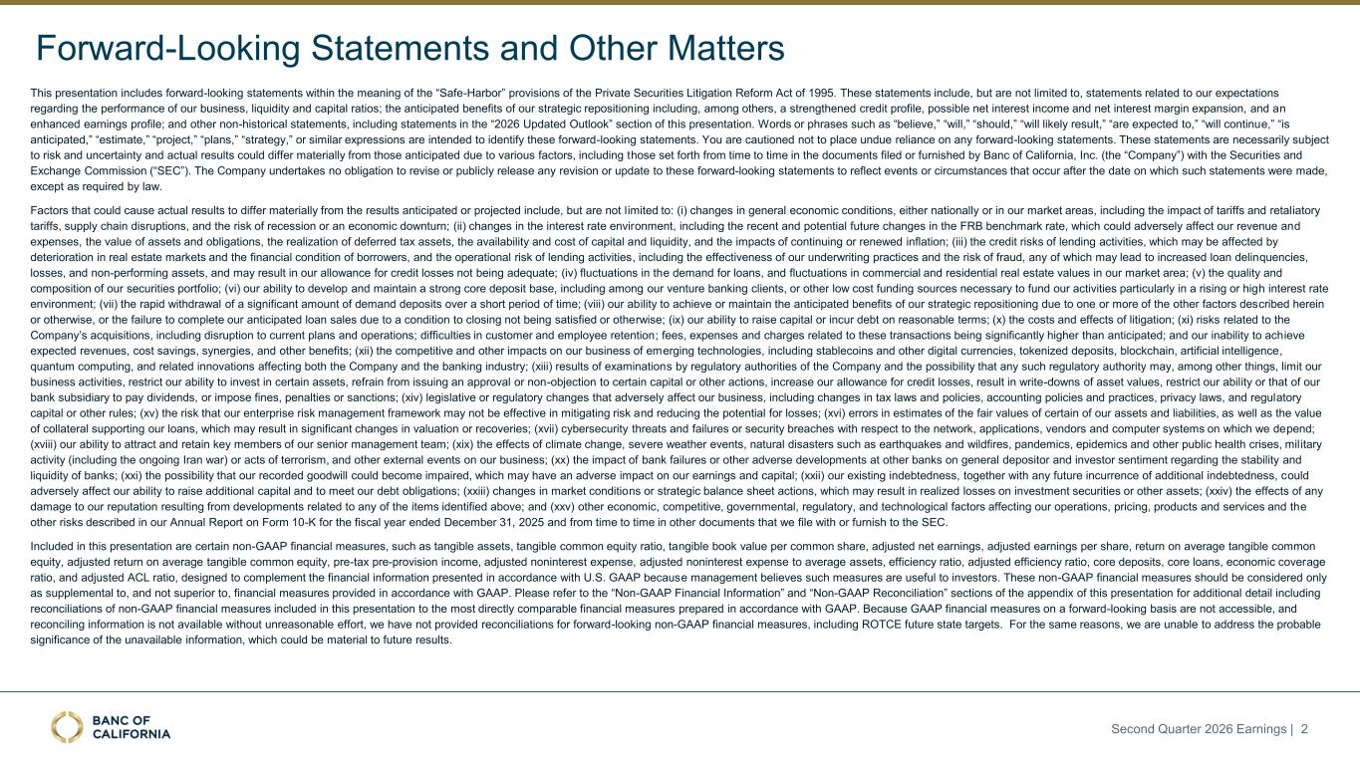
Forward-Looking Statements and Other Matters This presentation includes forward-looking statements within the meaning of the “Safe-Harbor” provisions of the Private Securities Litigation Reform Act of 1995. These statements include, but are not limited to, statements related to our expectations regarding the performance of our business, liquidity and capital ratios; the anticipated benefits of our strategic repositioning including, among others, a strengthened credit profile, possible net interest income and net interest margin expansion, and an enhanced earnings profile; and other non-historical statements, including statements in the “2026 Updated Outlook” section of this presentation. Words or phrases such as “believe,” “will,” “should,” “will likely result,” “are expected to,” “will continue,” “is anticipated,” “estimate,” “project,” “plans,” “strategy,” or similar expressions are intended to identify these forward-looking statements. You are cautioned not to place undue reliance on any forward-looking statements. These statements are necessarily subject to risk and uncertainty and actual results could differ materially from those anticipated due to various factors, including those set forth from time to time in the documents filed or furnished by Banc of California, Inc. (the “Company”) with the Securities and Exchange Commission (“SEC”). The Company undertakes no obligation to revise or publicly release any revision or update to these forward-looking statements to reflect events or circumstances that occur after the date on which such statements were made, except as required by law. Factors that could cause actual results to differ materially from the results anticipated or projected include, but are not limited to: (i) changes in general economic conditions, either nationally or in our market areas, including the impact of tariffs and retaliatory tariffs, supply chain disruptions, and the risk of recession or an economic downturn; (ii) changes in the interest rate environment, including the recent and potential future changes in the FRB benchmark rate, which could adversely affect our revenue and expenses, the value of assets and obligations, the realization of deferred tax assets, the availability and cost of capital and liquidity, and the impacts of continuing or renewed inflation; (iii) the credit risks of lending activities, which may be affected by deterioration in real estate markets and the financial condition of borrowers, and the operational risk of lending activities, including the effectiveness of our underwriting practices and the risk of fraud, any of which may lead to increased loan delinquencies, losses, and non-performing assets, and may result in our allowance for credit losses not being adequate; (iv) fluctuations in the demand for loans, and fluctuations in commercial and residential real estate values in our market area; (v) the quality and composition of our securities portfolio; (vi) our ability to develop and maintain a strong core deposit base, including among our venture banking clients, or other low cost funding sources necessary to fund our activities particularly in a rising or high interest rate environment; (vii) the rapid withdrawal of a significant amount of demand deposits over a short period of time; (viii) our ability to achieve or maintain the anticipated benefits of our strategic repositioning due to one or more of the other factors described herein or otherwise, or the failure to complete our anticipated loan sales due to a condition to closing not being satisfied or otherwise; (ix) our ability to raise capital or incur debt on reasonable terms; (x) the costs and effects of litigation; (xi) risks related to the Company’s acquisitions, including disruption to current plans and operations; difficulties in customer and employee retention; fees, expenses and charges related to these transactions being significantly higher than anticipated; and our inability to achieve expected revenues, cost savings, synergies, and other benefits; (xii) the competitive and other impacts on our business of emerging technologies, including stablecoins and other digital currencies, tokenized deposits, blockchain, artificial intelligence, quantum computing, and related innovations affecting both the Company and the banking industry; (xiii) results of examinations by regulatory authorities of the Company and the possibility that any such regulatory authority may, among other things, limit our business activities, restrict our ability to invest in certain assets, refrain from issuing an approval or non-objection to certain capital or other actions, increase our allowance for credit losses, result in write-downs of asset values, restrict our ability or that of our bank subsidiary to pay dividends, or impose fines, penalties or sanctions; (xiv) legislative or regulatory changes that adversely affect our business, including changes in tax laws and policies, accounting policies and practices, privacy laws, and regulatory capital or other rules; (xv) the risk that our enterprise risk management framework may not be effective in mitigating risk and reducing the potential for losses; (xvi) errors in estimates of the fair values of certain of our assets and liabilities, as well as the value of collateral supporting our loans, which may result in significant changes in valuation or recoveries; (xvii) cybersecurity threats and failures or security breaches with respect to the network, applications, vendors and computer systems on which we depend; (xviii) our ability to attract and retain key members of our senior management team; (xix) the effects of climate change, severe weather events, natural disasters such as earthquakes and wildfires, pandemics, epidemics and other public health crises, military activity (including the ongoing Iran war) or acts of terrorism, and other external events on our business; (xx) the impact of bank failures or other adverse developments at other banks on general depositor and investor sentiment regarding the stability and liquidity of banks; (xxi) the possibility that our recorded goodwill could become impaired, which may have an adverse impact on our earnings and capital; (xxii) our existing indebtedness, together with any future incurrence of additional indebtedness, could adversely affect our ability to raise additional capital and to meet our debt obligations; (xxiii) changes in market conditions or strategic balance sheet actions, which may result in realized losses on investment securities or other assets; (xxiv) the effects of any damage to our reputation resulting from developments related to any of the items identified above; and (xxv) other economic, competitive, governmental, regulatory, and technological factors affecting our operations, pricing, products and services and the other risks described in our Annual Report on Form 10-K for the fiscal year ended December 31, 2025 and from time to time in other documents that we file with or furnish to the SEC. Included in this presentation are certain non-GAAP financial measures, such as tangible assets, tangible common equity ratio, tangible book value per common share, adjusted net earnings, adjusted earnings per share, return on average tangible common equity, adjusted return on average tangible common equity, pre-tax pre-provision income, adjusted noninterest expense, adjusted noninterest expense to average assets, efficiency ratio, adjusted efficiency ratio, core deposits, core loans, economic coverage ratio, and adjusted ACL ratio, designed to complement the financial information presented in accordance with U.S. GAAP because management believes such measures are useful to investors. These non-GAAP financial measures should be considered only as supplemental to, and not superior to, financial measures provided in accordance with GAAP. Please refer to the “Non-GAAP Financial Information” and “Non-GAAP Reconciliation” sections of the appendix of this presentation for additional detail including reconciliations of non-GAAP financial measures included in this presentation to the most directly comparable financial measures prepared in accordance with GAAP. Because GAAP financial measures on a forward-looking basis are not accessible, and reconciling information is not available without unreasonable effort, we have not provided reconciliations for forward-looking non-GAAP financial measures, including ROTCE future state targets. For the same reasons, we are unable to address the probable significance of the unavailable information, which could be material to future results. Second Quarter 2026 Earnings | 2

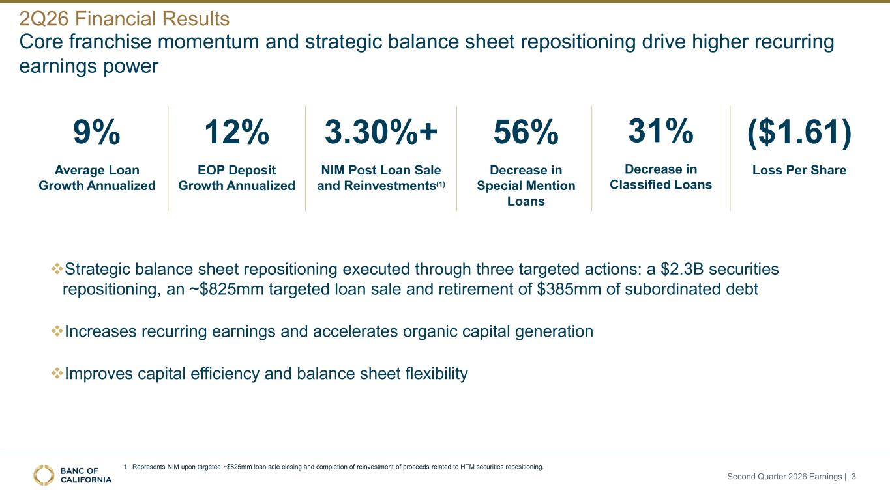
Core franchise momentum and strategic balance sheet repositioning drive higher recurring earnings power 2Q26 Financial Results Second Quarter 2026 Earnings | 3 ($1.61) Loss Per Share 56% Decrease in Special Mention Loans 9% Average Loan Growth Annualized 12% EOP Deposit Growth Annualized 3.30%+ NIM Post Loan Sale and Reinvestments(1) 31% Decrease in Classified Loans ❖Strategic balance sheet repositioning executed through three targeted actions: a $2.3B securities repositioning, an ~$825mm targeted loan sale and retirement of $385mm of subordinated debt ❖Increases recurring earnings and accelerates organic capital generation ❖Improves capital efficiency and balance sheet flexibility 1. Represents NIM upon targeted ~$825mm loan sale closing and completion of reinvestment of proceeds related to HTM securities repositioning.

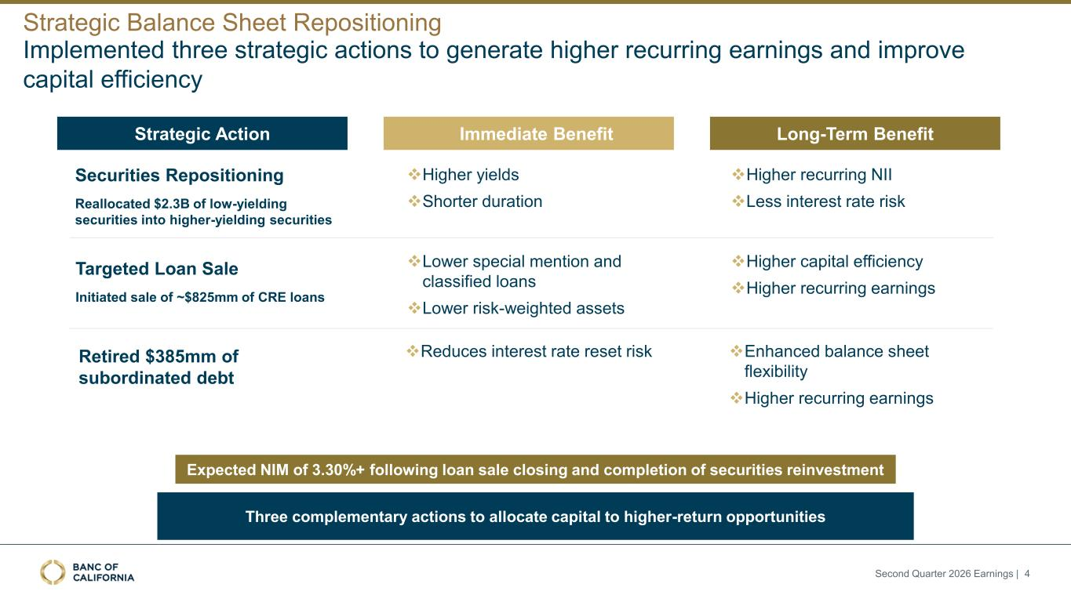
Implemented three strategic actions to generate higher recurring earnings and improve capital efficiency Strategic Balance Sheet Repositioning Second Quarter 2026 Earnings | 4 Three complementary actions to allocate capital to higher-return opportunities Strategic Action • Immediate Benefit Long-Term Benefit Securities Repositioning Reallocated $2.3B of low-yielding securities into higher-yielding securities Targeted Loan Sale Initiated sale of ~$825mm of CRE loans Retired $385mm of subordinated debt ❖Higher yields ❖Shorter duration ❖Lower special mention and classified loans ❖Lower risk-weighted assets ❖Reduces interest rate reset risk ❖Higher recurring NII ❖Less interest rate risk ❖Higher capital efficiency ❖Higher recurring earnings ❖Enhanced balance sheet flexibility ❖Higher recurring earnings Expected NIM of 3.30%+ following loan sale closing and completion of securities reinvestment

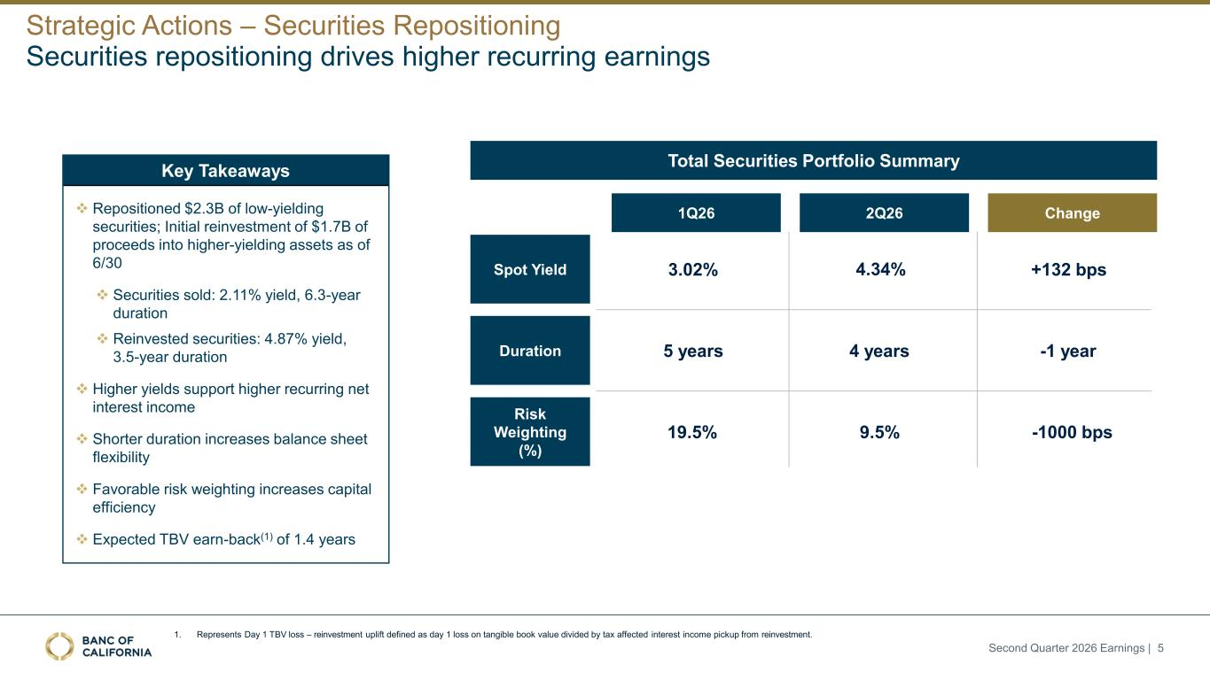
Securities repositioning drives higher recurring earnings Strategic Actions – Securities Repositioning Second Quarter 2026 Earnings | 5 Total Securities Portfolio Summary 3.02% 4.34% 19.5% 9.5% 5 years 4 years 1Q26 2Q26 Change +132 bps -1 year -1000 bps Spot Yield Duration Risk Weighting (%) Key Takeaways ❖ Repositioned $2.3B of low-yielding securities; Initial reinvestment of $1.7B of proceeds into higher-yielding assets as of 6/30 ❖ Securities sold: 2.11% yield, 6.3-year duration ❖ Reinvested securities: 4.87% yield, 3.5-year duration ❖ Higher yields support higher recurring net interest income ❖ Shorter duration increases balance sheet flexibility ❖ Favorable risk weighting increases capital efficiency ❖ Expected TBV earn-back(1) of 1.4 years 1. Represents Day 1 TBV loss – reinvestment uplift defined as day 1 loss on tangible book value divided by tax affected interest income pickup from reinvestment.

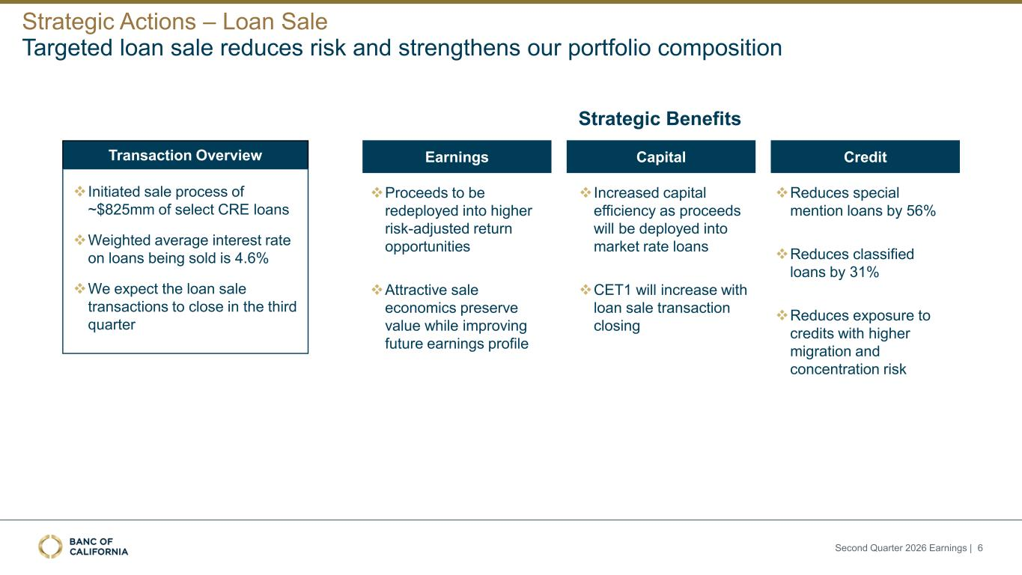
Targeted loan sale reduces risk and strengthens our portfolio composition Strategic Actions – Loan Sale Second Quarter 2026 Earnings | 6 Earnings Capital CreditTransaction Overview ❖ Initiated sale process of ~$825mm of select CRE loans ❖Weighted average interest rate on loans being sold is 4.6% ❖We expect the loan sale transactions to close in the third quarter Strategic Benefits ❖Reduces special mention loans by 56% ❖Reduces classified loans by 31% ❖Reduces exposure to credits with higher migration and concentration risk ❖ Increased capital efficiency as proceeds will be deployed into market rate loans ❖CET1 will increase with loan sale transaction closing ❖Proceeds to be redeployed into higher risk-adjusted return opportunities ❖Attractive sale economics preserve value while improving future earnings profile

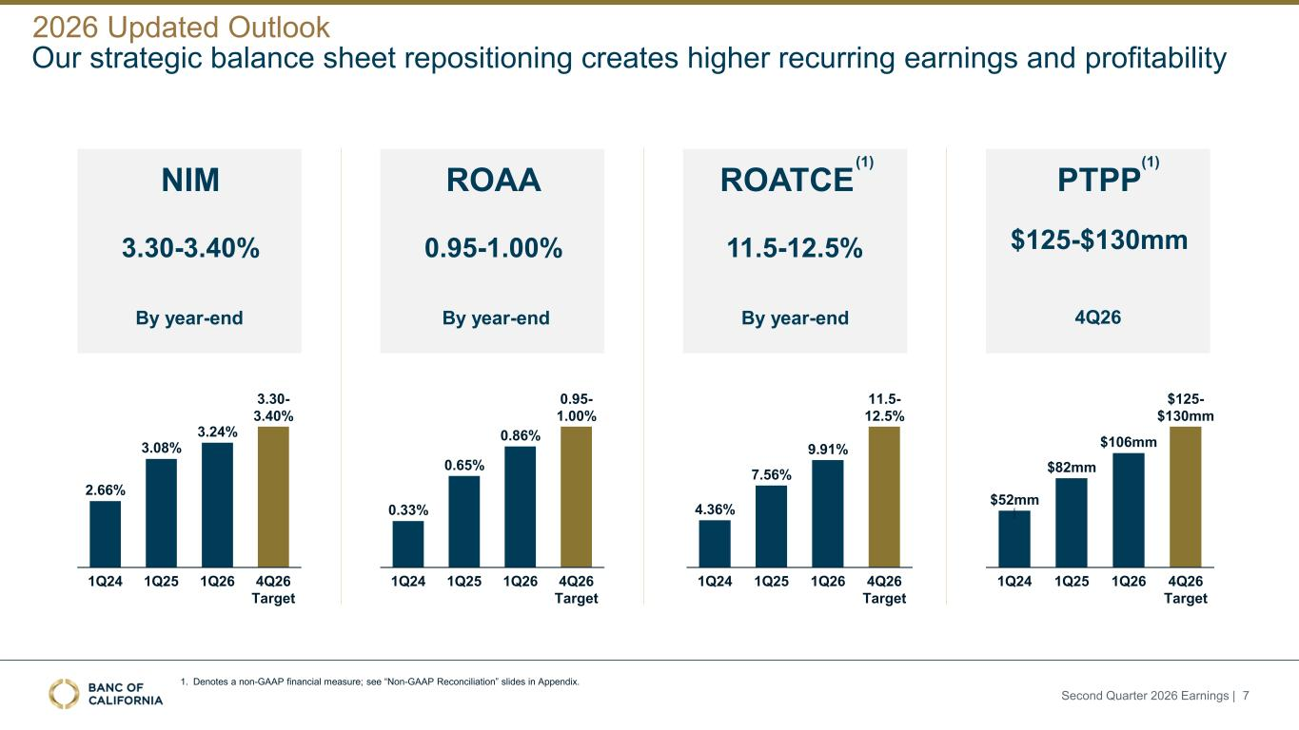
Our strategic balance sheet repositioning creates higher recurring earnings and profitability 2026 Updated Outlook Second Quarter 2026 Earnings | 7 NIM 3.30-3.40% By year-end ROAA 0.95-1.00% By year-end ROATCE 11.5-12.5% By year-end PTPP $125-$130mm 4Q26 (1) (1) 1. Denotes a non-GAAP financial measure; see “Non-GAAP Reconciliation” slides in Appendix. 2.66% 3.08% 3.24% 1Q24 1Q25 1Q26 4Q26 Target 3.30- 3.40% $52mm $82mm $106mm 1Q24 1Q25 1Q26 4Q26 Target $125- $130mm 0.33% 0.65% 0.86% 1Q24 1Q25 1Q26 4Q26 Target 0.95- 1.00% 4.36% 7.56% 9.91% 1Q24 1Q25 1Q26 4Q26 Target 11.5- 12.5%

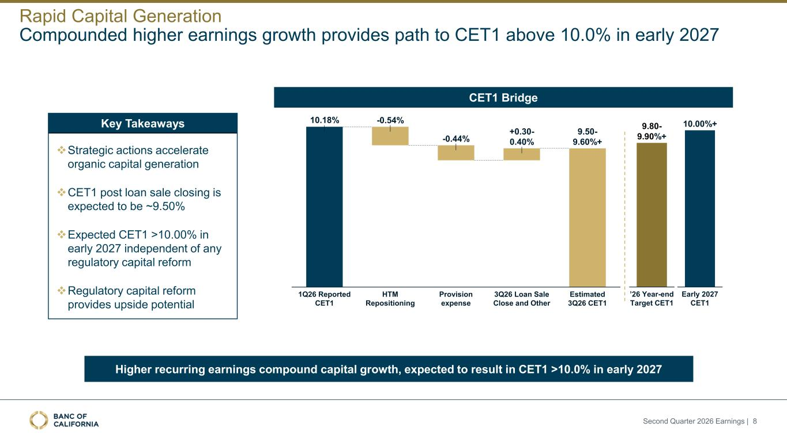
Second Quarter 2026 Earnings | 8 Rapid Capital Generation Compounded higher earnings growth provides path to CET1 above 10.0% in early 2027 10.18% 1Q26 Reported CET1 -0.54% HTM Repositioning -0.44% Provision expense +0.30- 0.40% 3Q26 Loan Sale Close and Other Estimated 3Q26 CET1 9.50- 9.60%+ ’26 Year-end Target CET1 9.80- 9.90%+ Early 2027 CET1 10.00%+ CET1 Bridge Key Takeaways ❖Strategic actions accelerate organic capital generation ❖CET1 post loan sale closing is expected to be ~9.50% ❖Expected CET1 >10.00% in early 2027 independent of any regulatory capital reform ❖Regulatory capital reform provides upside potential Higher recurring earnings compound capital growth, expected to result in CET1 >10.0% in early 2027

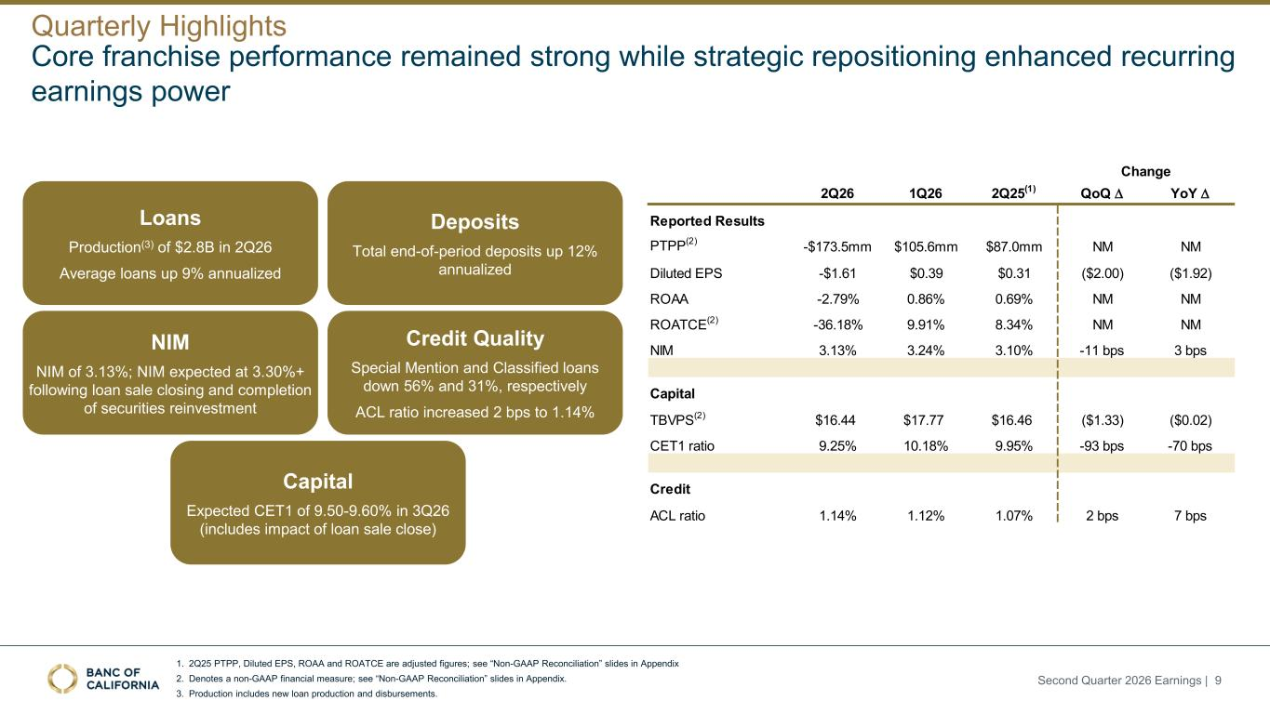
1. 2Q25 PTPP, Diluted EPS, ROAA and ROATCE are adjusted figures; see “Non-GAAP Reconciliation” slides in Appendix 2. Denotes a non-GAAP financial measure; see “Non-GAAP Reconciliation” slides in Appendix. 3. Production includes new loan production and disbursements. Core franchise performance remained strong while strategic repositioning enhanced recurring earnings power Quarterly Highlights Second Quarter 2026 Earnings | 9 Change 2Q26 1Q26 2Q25(1) QoQ D YoY D Reported Results PTPP(2) -$173.5mm $105.6mm $87.0mm NM NM Diluted EPS -$1.61 $0.39 $0.31 ($2.00) ($1.92) ROAA -2.79% 0.86% 0.69% NM NM ROATCE(2) -36.18% 9.91% 8.34% NM NM NIM 3.13% 3.24% 3.10% -11 bps 3 bps Capital TBVPS(2) $16.44 $17.77 $16.46 ($1.33) ($0.02) CET1 ratio 9.25% 10.18% 9.95% -93 bps -70 bps Credit ACL ratio 1.14% 1.12% 1.07% 2 bps 7 bps NIM NIM of 3.13%; NIM expected at 3.30%+ following loan sale closing and completion of securities reinvestment Credit Quality Special Mention and Classified loans down 56% and 31%, respectively ACL ratio increased 2 bps to 1.14% Loans Production(3) of $2.8B in 2Q26 Average loans up 9% annualized Deposits Total end-of-period deposits up 12% annualized Capital Expected CET1 of 9.50-9.60% in 3Q26 (includes impact of loan sale close)

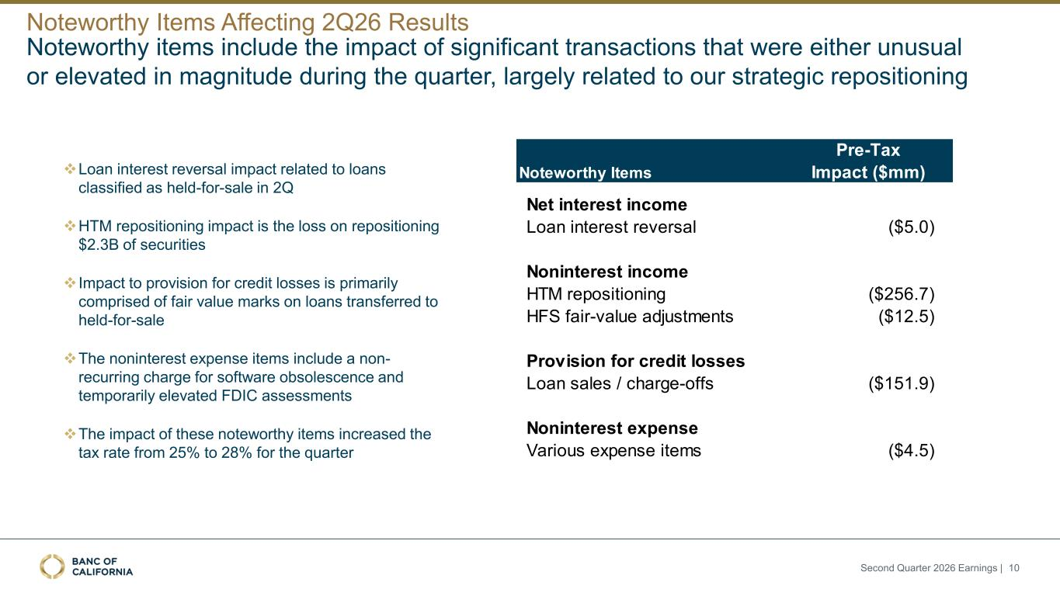
Noteworthy items include the impact of significant transactions that were either unusual or elevated in magnitude during the quarter, largely related to our strategic repositioning Noteworthy Items Affecting 2Q26 Results Second Quarter 2026 Earnings | 10 Noteworthy Items Pre-Tax Impact ($mm) Net interest income Loan interest reversal ($5.0) Noninterest income HTM repositioning ($256.7) HFS fair-value adjustments ($12.5) Provision for credit losses Loan sales / charge-offs ($151.9) Noninterest expense Various expense items ($4.5) ❖Loan interest reversal impact related to loans classified as held-for-sale in 2Q ❖HTM repositioning impact is the loss on repositioning $2.3B of securities ❖ Impact to provision for credit losses is primarily comprised of fair value marks on loans transferred to held-for-sale ❖The noninterest expense items include a non- recurring charge for software obsolescence and temporarily elevated FDIC assessments ❖The impact of these noteworthy items increased the tax rate from 25% to 28% for the quarter

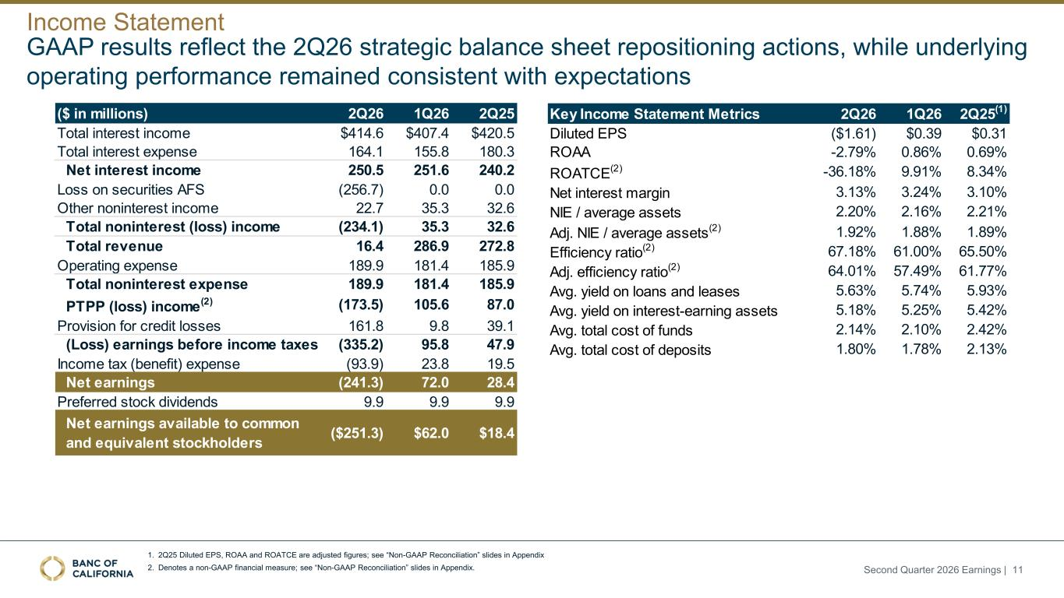
1. 2Q25 Diluted EPS, ROAA and ROATCE are adjusted figures; see “Non-GAAP Reconciliation” slides in Appendix 2. Denotes a non-GAAP financial measure; see “Non-GAAP Reconciliation” slides in Appendix. GAAP results reflect the 2Q26 strategic balance sheet repositioning actions, while underlying operating performance remained consistent with expectations Income Statement ($ in millions) 2Q26 1Q26 2Q25 Total interest income $414.6 $407.4 $420.5 Total interest expense 164.1 155.8 180.3 Net interest income 250.5 251.6 240.2 Loss on securities AFS (256.7) 0.0 0.0 Other noninterest income 22.7 35.3 32.6 Total noninterest (loss) income (234.1) 35.3 32.6 Total revenue 16.4 286.9 272.8 Operating expense 189.9 181.4 185.9 Total noninterest expense 189.9 181.4 185.9 PTPP (loss) income(2) (173.5) 105.6 87.0 Provision for credit losses 161.8 9.8 39.1 (Loss) earnings before income taxes (335.2) 95.8 47.9 Income tax (benefit) expense (93.9) 23.8 19.5 Net earnings (241.3) 72.0 28.4 Preferred stock dividends 9.9 9.9 9.9 Net earnings available to common and equivalent stockholders ($251.3) $62.0 $18.4 Key Income Statement Metrics 2Q26 1Q26 2Q25(1) Diluted EPS ($1.61) $0.39 $0.31 ROAA -2.79% 0.86% 0.69% ROATCE(2) -36.18% 9.91% 8.34% Net interest margin 3.13% 3.24% 3.10% NIE / average assets 2.20% 2.16% 2.21% Adj. NIE / average assets(2) 1.92% 1.88% 1.89% Efficiency ratio(2) 67.18% 61.00% 65.50% Adj. efficiency ratio(2) 64.01% 57.49% 61.77% Avg. yield on loans and leases 5.63% 5.74% 5.93% Avg. yield on interest-earning assets 5.18% 5.25% 5.42% Avg. total cost of funds 2.14% 2.10% 2.42% Avg. total cost of deposits 1.80% 1.78% 2.13% Second Quarter 2026 Earnings | 11

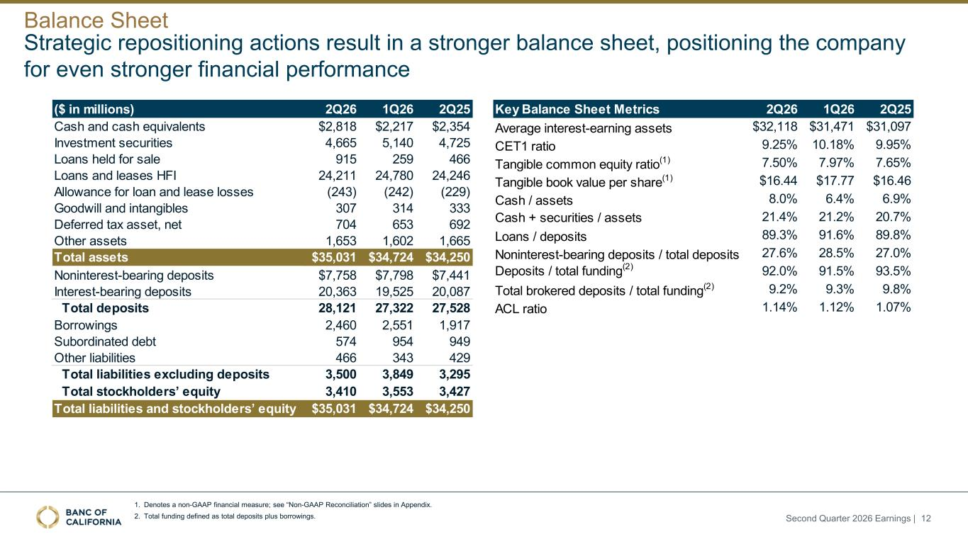
Strategic repositioning actions result in a stronger balance sheet, positioning the company for even stronger financial performance 1. Denotes a non-GAAP financial measure; see “Non-GAAP Reconciliation” slides in Appendix. 2. Total funding defined as total deposits plus borrowings. Balance Sheet Second Quarter 2026 Earnings | 12 ($ in millions) 2Q26 1Q26 2Q25 Cash and cash equivalents $2,818 $2,217 $2,354 Investment securities 4,665 5,140 4,725 Loans held for sale 915 259 466 Loans and leases HFI 24,211 24,780 24,246 Allowance for loan and lease losses (243) (242) (229) Goodwill and intangibles 307 314 333 Deferred tax asset, net 704 653 692 Other assets 1,653 1,602 1,665 Total assets $35,031 $34,724 $34,250 Noninterest-bearing deposits $7,758 $7,798 $7,441 Interest-bearing deposits 20,363 19,525 20,087 Total deposits 28,121 27,322 27,528 Borrowings 2,460 2,551 1,917 Subordinated debt 574 954 949 Other liabilities 466 343 429 Total liabilities excluding deposits 3,500 3,849 3,295 Total stockholders’ equity 3,410 3,553 3,427 Total liabilities and stockholders’ equity $35,031 $34,724 $34,250 Key Balance Sheet Metrics 2Q26 1Q26 2Q25 Average interest-earning assets $32,118 $31,471 $31,097 CET1 ratio 9.25% 10.18% 9.95% Tangible common equity ratio(1) 7.50% 7.97% 7.65% Tangible book value per share(1) $16.44 $17.77 $16.46 Cash / assets 8.0% 6.4% 6.9% Cash + securities / assets 21.4% 21.2% 20.7% Loans / deposits 89.3% 91.6% 89.8% Noninterest-bearing deposits / total deposits 27.6% 28.5% 27.0% Deposits / total funding(2) 92.0% 91.5% 93.5% Total brokered deposits / total funding(2) 9.2% 9.3% 9.8% ACL ratio 1.14% 1.12% 1.07%

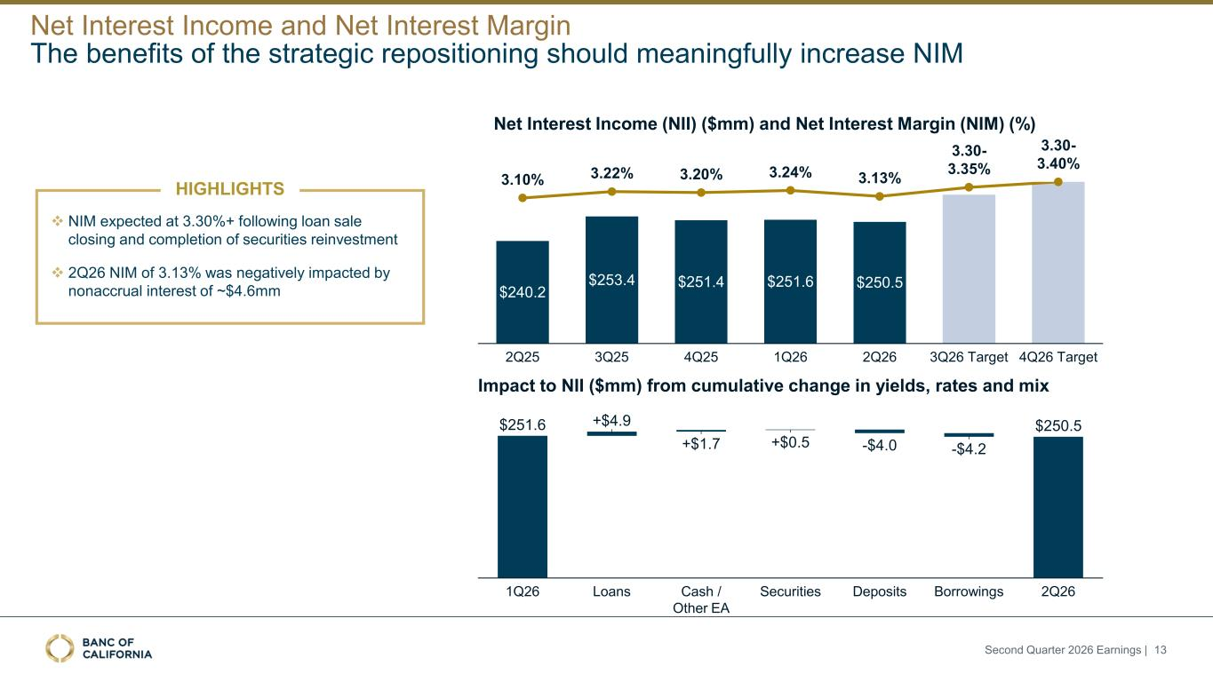
Net Interest Income (NII) ($mm) and Net Interest Margin (NIM) (%) Impact to NII ($mm) from cumulative change in yields, rates and mix 1Q26 +$4.9 Loans +$1.7 Cash / Other EA +$0.5 Securities Deposits -$4.2 Borrowings 2Q26 $251.6 -$4.0 $250.5 $240.2 $253.4 $251.4 $251.6 $250.5 3.20% 4Q25 3.24% 1Q26 3.13% 2Q26 3Q26 Target 4Q26 Target2Q25 3Q25 3.10% 3.22% 3.30- 3.35% 3.30- 3.40% The benefits of the strategic repositioning should meaningfully increase NIM Net Interest Income and Net Interest Margin ❖ NIM expected at 3.30%+ following loan sale closing and completion of securities reinvestment ❖ 2Q26 NIM of 3.13% was negatively impacted by nonaccrual interest of ~$4.6mm HIGHLIGHTS Second Quarter 2026 Earnings | 13

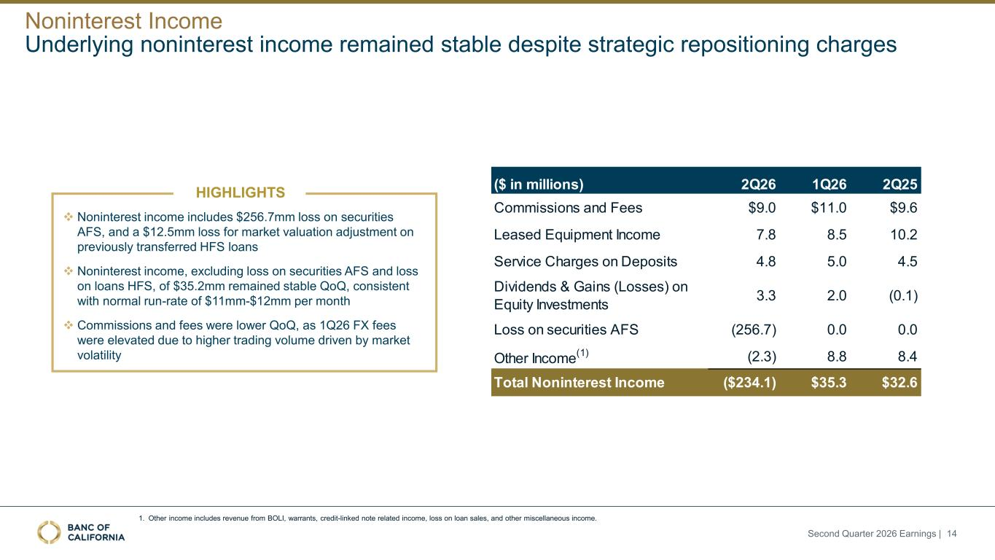
Underlying noninterest income remained stable despite strategic repositioning charges ($ in millions) 2Q26 1Q26 2Q25 Commissions and Fees $9.0 $11.0 $9.6 Leased Equipment Income 7.8 8.5 10.2 Service Charges on Deposits 4.8 5.0 4.5 Dividends & Gains (Losses) on Equity Investments 3.3 2.0 (0.1) Loss on securities AFS (256.7) 0.0 0.0 Other Income (1) (2.3) 8.8 8.4 Total Noninterest Income ($234.1) $35.3 $32.6 Noninterest Income HIGHLIGHTS ❖ Noninterest income includes $256.7mm loss on securities AFS, and a $12.5mm loss for market valuation adjustment on previously transferred HFS loans ❖ Noninterest income, excluding loss on securities AFS and loss on loans HFS, of $35.2mm remained stable QoQ, consistent with normal run-rate of $11mm-$12mm per month ❖ Commissions and fees were lower QoQ, as 1Q26 FX fees were elevated due to higher trading volume driven by market volatility 1. Other income includes revenue from BOLI, warrants, credit-linked note related income, loss on loan sales, and other miscellaneous income. Second Quarter 2026 Earnings | 14

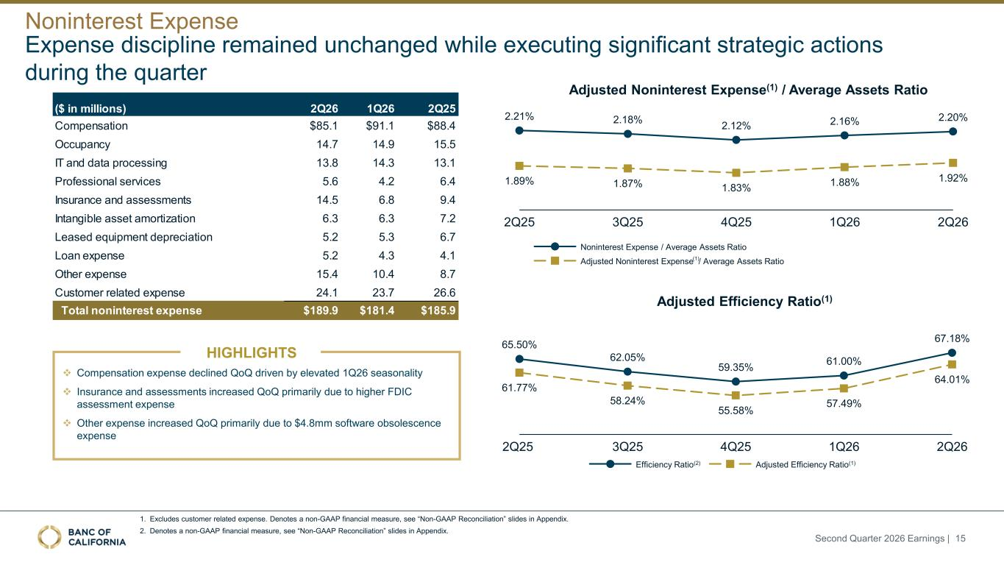
Adjusted Noninterest Expense(1) / Average Assets Ratio 1. Excludes customer related expense. Denotes a non-GAAP financial measure, see “Non-GAAP Reconciliation” slides in Appendix. 2. Denotes a non-GAAP financial measure, see “Non-GAAP Reconciliation” slides in Appendix. Expense discipline remained unchanged while executing significant strategic actions during the quarter 65.50% 62.05% 59.35% 61.00% 67.18% 61.77% 58.24% 55.58% 57.49% 64.01% 2Q25 3Q25 4Q25 1Q26 2Q26 Efficiency Ratio(2) Adjusted Efficiency Ratio(1) Adjusted Efficiency Ratio(1) 2.21% 1.89% 2Q25 2.18% 1.87% 3Q25 2.12% 1.83% 4Q25 2.16% 1.88% 1Q26 2.20% 1.92% 2Q26 Noninterest Expense / Average Assets Ratio Adjusted Noninterest Expense / Average Assets Ratio Noninterest Expense (1) Second Quarter 2026 Earnings | 15 ❖ Compensation expense declined QoQ driven by elevated 1Q26 seasonality ❖ Insurance and assessments increased QoQ primarily due to higher FDIC assessment expense ❖ Other expense increased QoQ primarily due to $4.8mm software obsolescence expense HIGHLIGHTS ($ in millions) 2Q26 1Q26 2Q25 Compensation $85.1 $91.1 $88.4 Occupancy 14.7 14.9 15.5 IT and data processing 13.8 14.3 13.1 Professional services 5.6 4.2 6.4 Insurance and assessments 14.5 6.8 9.4 Intangible asset amortization 6.3 6.3 7.2 Leased equipment depreciation 5.2 5.3 6.7 Loan expense 5.2 4.3 4.1 Other expense 15.4 10.4 8.7 Customer related expense 24.1 23.7 26.6 Total noninterest expense $189.9 $181.4 $185.9

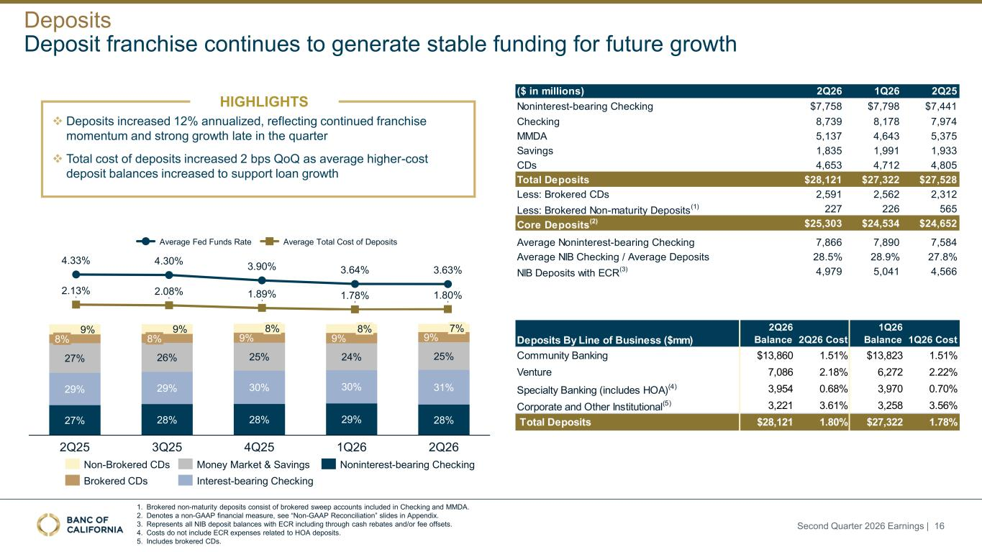
Deposit franchise continues to generate stable funding for future growth 4.33% 4.30% 3.90% 3.64% 3.63% 2.13% 2.08% 1.89% 1.78% 1.80% Average Fed Funds Rate Average Total Cost of Deposits 27% 28% 28% 29% 28% 29% 29% 30% 30% 31% 27% 26% 25% 24% 25% 9% 9% 9% 9% 9% 8% 2Q25 8% 3Q25 8% 4Q25 8% 1Q26 7% 2Q26 Non-Brokered CDs Brokered CDs Money Market & Savings Interest-bearing Checking Noninterest-bearing Checking 1. Brokered non-maturity deposits consist of brokered sweep accounts included in Checking and MMDA. 2. Denotes a non-GAAP financial measure, see “Non-GAAP Reconciliation” slides in Appendix. 3. Represents all NIB deposit balances with ECR including through cash rebates and/or fee offsets. 4. Costs do not include ECR expenses related to HOA deposits. 5. Includes brokered CDs. Deposits By Line of Business ($mm) 2Q26 Balance 2Q26 Cost 1Q26 Balance 1Q26 Cost Community Banking $13,860 1.51% $13,823 1.51% Venture 7,086 2.18% 6,272 2.22% Specialty Banking (includes HOA)(4) 3,954 0.68% 3,970 0.70% Corporate and Other Institutional(5) 3,221 3.61% 3,258 3.56% Total Deposits $28,121 1.80% $27,322 1.78% ❖ Deposits increased 12% annualized, reflecting continued franchise momentum and strong growth late in the quarter ❖ Total cost of deposits increased 2 bps QoQ as average higher-cost deposit balances increased to support loan growth Deposits ($ in millions) 2Q26 1Q26 2Q25 Noninterest-bearing Checking $7,758 $7,798 $7,441 Checking 8,739 8,178 7,974 MMDA 5,137 4,643 5,375 Savings 1,835 1,991 1,933 CDs 4,653 4,712 4,805 Total Deposits $28,121 $27,322 $27,528 Less: Brokered CDs 2,591 2,562 2,312 Less: Brokered Non-maturity Deposits (1) 227 226 565 Core Deposits (2) $25,303 $24,534 $24,652 Average Noninterest-bearing Checking 7,866 7,890 7,584 Average NIB Checking / Average Deposits 28.5% 28.9% 27.8% NIB Deposits with ECR (3) 4,979 5,041 4,566 HIGHLIGHTS Second Quarter 2026 Earnings | 16

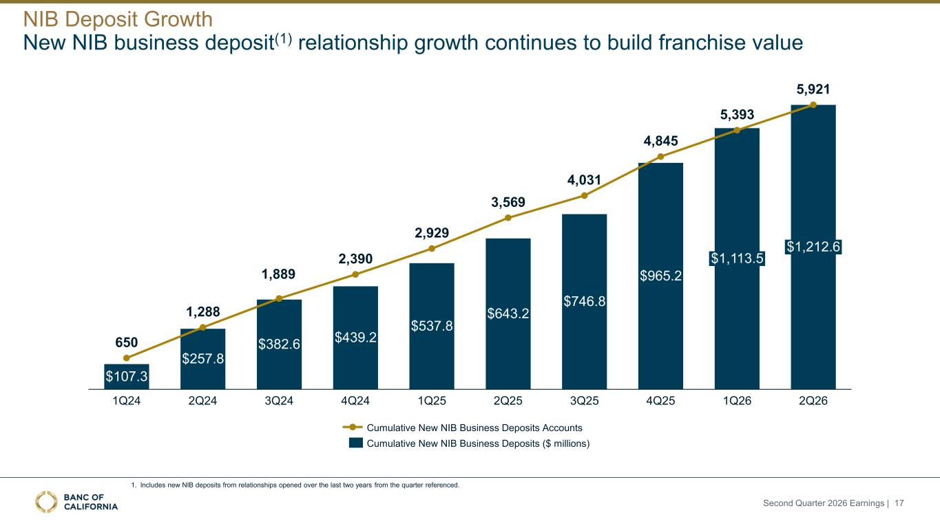
650 1,288 1,889 2,390 2,929 3,569 4,031 4,845 5,393 5,921 $107.3 1Q24 $257.8 2Q24 $382.6 3Q24 $439.2 4Q24 $537.8 1Q25 $643.2 2Q25 $746.8 3Q25 $965.2 4Q25 $1,113.5 1Q26 $1,212.6 2Q26 Cumulative New NIB Business Deposits Accounts Cumulative New NIB Business Deposits ($ millions) New NIB business deposit(1) relationship growth continues to build franchise value 1. Includes new NIB deposits from relationships opened over the last two years from the quarter referenced. NIB Deposit Growth Second Quarter 2026 Earnings | 17

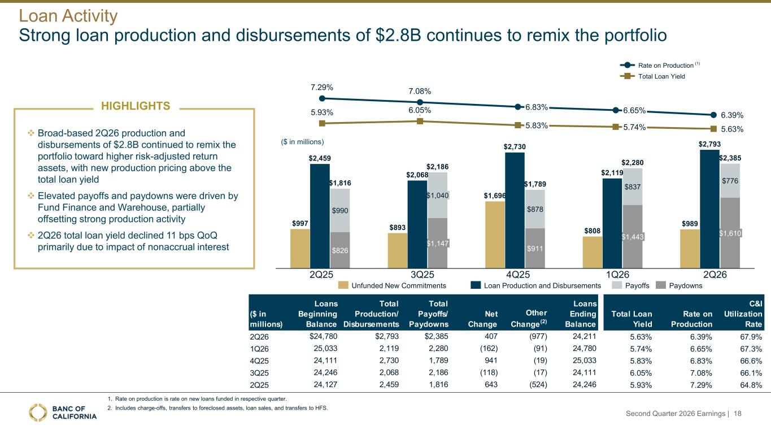
$990 $826 $1,040 $1,147 $878 $911 $837 $1,443 $776 $1,610 $1,816 $2,186 $1,789 $2,280 $2,385 7.29% 7.08% 6.39%5.93% 6.05% 5.63% 6.83% 5.83% 6.65% 5.74% Rate on Production Total Loan Yield ($ in millions) 1. Rate on production is rate on new loans funded in respective quarter. 2. Includes charge-offs, transfers to foreclosed assets, loan sales, and transfers to HFS. Strong loan production and disbursements of $2.8B continues to remix the portfolio $997 $893 $1,696 $808 $989 Payoffs PaydownsUnfunded New Commitments 2Q25 3Q25 4Q25 1Q26 2Q26 $2,459 $2,068 $2,730 $2,119 $2,793 Loan Production and Disbursements Loan Activity (1) ❖ Broad-based 2Q26 production and disbursements of $2.8B continued to remix the portfolio toward higher risk-adjusted return assets, with new production pricing above the total loan yield ❖ Elevated payoffs and paydowns were driven by Fund Finance and Warehouse, partially offsetting strong production activity ❖ 2Q26 total loan yield declined 11 bps QoQ primarily due to impact of nonaccrual interest HIGHLIGHTS Second Quarter 2026 Earnings | 18 ($ in millions) Loans Beginning Balance Total Production/ Disbursements Total Payoffs/ Paydowns Net Change Other Change(2) Loans Ending Balance Total Loan Yield Rate on Production C&I Utilization Rate 2Q26 $24,780 $2,793 $2,385 407 (977) 24,211 5.63% 6.39% 67.9% 1Q26 25,033 2,119 2,280 (162) (91) 24,780 5.74% 6.65% 67.3% 4Q25 24,111 2,730 1,789 941 (19) 25,033 5.83% 6.83% 66.6% 3Q25 24,246 2,068 2,186 (118) (17) 24,111 6.05% 7.08% 66.1% 2Q25 24,127 2,459 1,816 643 (524) 24,246 5.93% 7.29% 64.8%

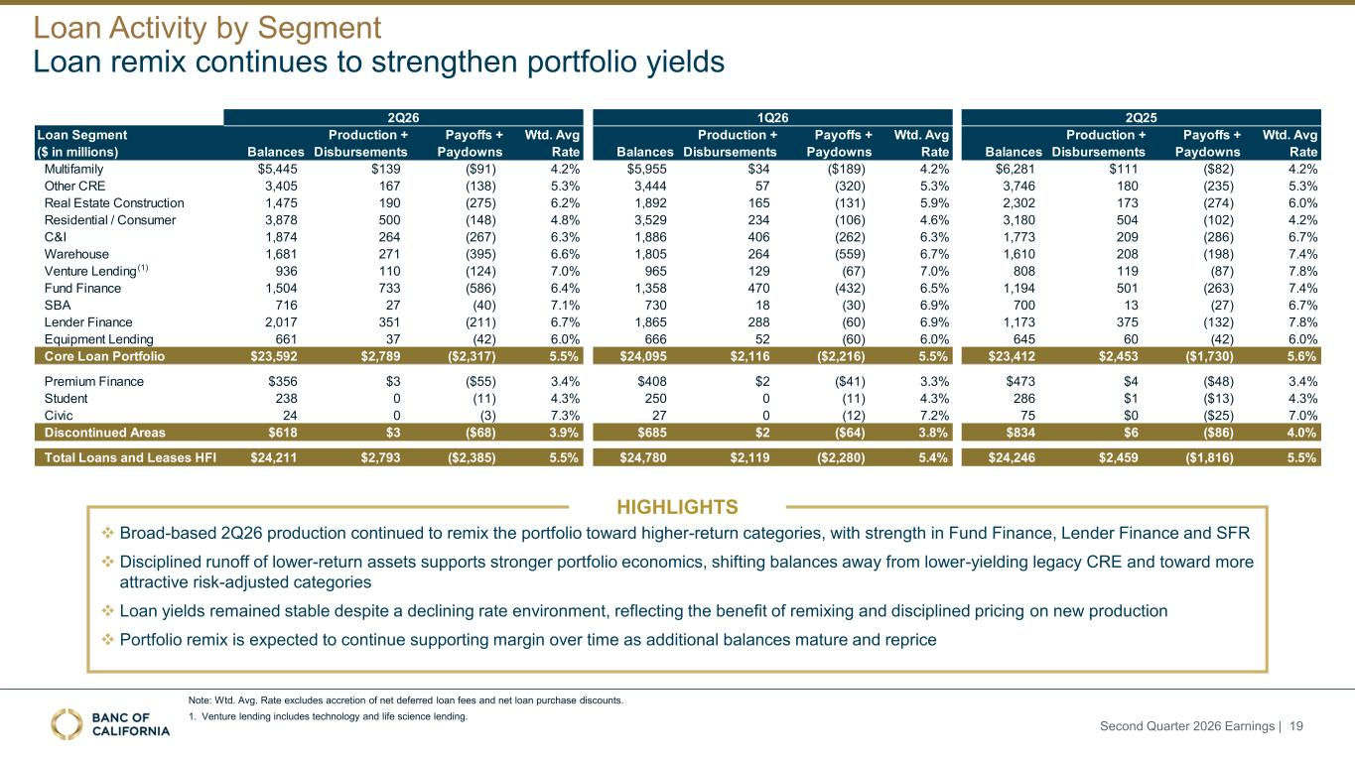
Loan remix continues to strengthen portfolio yields Note: Wtd. Avg. Rate excludes accretion of net deferred loan fees and net loan purchase discounts. 1. Venture lending includes technology and life science lending. Loan Activity by Segment ❖ Broad-based 2Q26 production continued to remix the portfolio toward higher-return categories, with strength in Fund Finance, Lender Finance and SFR ❖ Disciplined runoff of lower-return assets supports stronger portfolio economics, shifting balances away from lower-yielding legacy CRE and toward more attractive risk-adjusted categories ❖ Loan yields remained stable despite a declining rate environment, reflecting the benefit of remixing and disciplined pricing on new production ❖ Portfolio remix is expected to continue supporting margin over time as additional balances mature and reprice HIGHLIGHTS 2Q26 1Q26 2Q25 Loan Segment ($ in millions) Balances Production + Disbursements Payoffs + Paydowns Wtd. Avg Rate Balances Production + Disbursements Payoffs + Paydowns Wtd. Avg Rate Balances Production + Disbursements Payoffs + Paydowns Wtd. Avg Rate Multifamily $5,445 $139 ($91) 4.2% $5,955 $34 ($189) 4.2% $6,281 $111 ($82) 4.2% Other CRE 3,405 167 (138) 5.3% 3,444 57 (320) 5.3% 3,746 180 (235) 5.3% Real Estate Construction 1,475 190 (275) 6.2% 1,892 165 (131) 5.9% 2,302 173 (274) 6.0% Residential / Consumer 3,878 500 (148) 4.8% 3,529 234 (106) 4.6% 3,180 504 (102) 4.2% C&I 1,874 264 (267) 6.3% 1,886 406 (262) 6.3% 1,773 209 (286) 6.7% Warehouse 1,681 271 (395) 6.6% 1,805 264 (559) 6.7% 1,610 208 (198) 7.4% Venture Lending 936 110 (124) 7.0% 965 129 (67) 7.0% 808 119 (87) 7.8% Fund Finance 1,504 733 (586) 6.4% 1,358 470 (432) 6.5% 1,194 501 (263) 7.4% SBA 716 27 (40) 7.1% 730 18 (30) 6.9% 700 13 (27) 6.7% Lender Finance 2,017 351 (211) 6.7% 1,865 288 (60) 6.9% 1,173 375 (132) 7.8% Equipment Lending 661 37 (42) 6.0% 666 52 (60) 6.0% 645 60 (42) 6.0% Core Loan Portfolio $23,592 $2,789 ($2,317) 5.5% $24,095 $2,116 ($2,216) 5.5% $23,412 $2,453 ($1,730) 5.6% Premium Finance $356 $3 ($55) 3.4% $408 $2 ($41) 3.3% $473 $4 ($48) 3.4% Student 238 0 (11) 4.3% 250 0 (11) 4.3% 286 $1 ($13) 4.3% Civic 24 0 (3) 7.3% 27 0 (12) 7.2% 75 $0 ($25) 7.0% Discontinued Areas $618 $3 ($68) 3.9% $685 $2 ($64) 3.8% $834 $6 ($86) 4.0% Total Loans and Leases HFI $24,211 $2,793 ($2,385) 5.5% $24,780 $2,119 ($2,280) 5.4% $24,246 $2,459 ($1,816) 5.5% (1) Second Quarter 2026 Earnings | 19

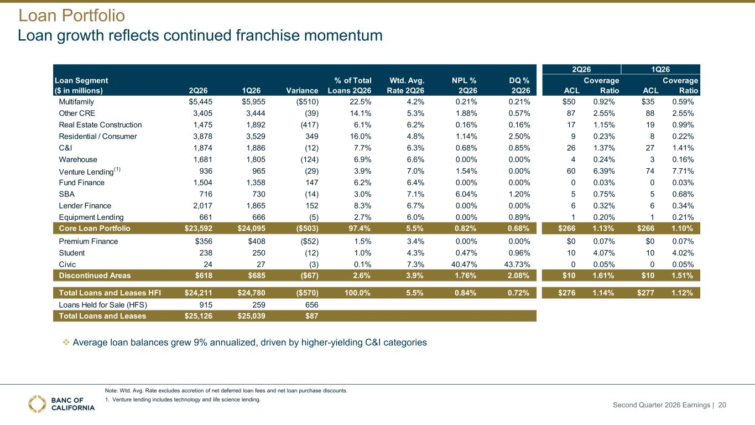
Loan growth reflects continued franchise momentum Note: Wtd. Avg. Rate excludes accretion of net deferred loan fees and net loan purchase discounts. 1. Venture lending includes technology and life science lending. Loan Portfolio 2Q26 1Q26 2Q26 1Q26 Variance % of Total Loans 2Q26 Wtd. Avg. Rate 2Q26 NPL % 2Q26 DQ % 2Q26 ACL Coverage Ratio ACL Coverage Ratio Multifamily $5,445 $5,955 ($510) 22.5% 4.2% 0.21% 0.21% $50 0.92% $35 0.59% Other CRE 3,405 3,444 (39) 14.1% 5.3% 1.88% 0.57% 87 2.55% 88 2.55% Real Estate Construction 1,475 1,892 (417) 6.1% 6.2% 0.16% 0.16% 17 1.15% 19 0.99% Residential / Consumer 3,878 3,529 349 16.0% 4.8% 1.14% 2.50% 9 0.23% 8 0.22% C&I 1,874 1,886 (12) 7.7% 6.3% 0.68% 0.85% 26 1.37% 27 1.41% Warehouse 1,681 1,805 (124) 6.9% 6.6% 0.00% 0.00% 4 0.24% 3 0.16% Venture Lending (1) 936 965 (29) 3.9% 7.0% 1.54% 0.00% 60 6.39% 74 7.71% Fund Finance 1,504 1,358 147 6.2% 6.4% 0.00% 0.00% 0 0.03% 0 0.03% SBA 716 730 (14) 3.0% 7.1% 6.04% 1.20% 5 0.75% 5 0.68% Lender Finance 2,017 1,865 152 8.3% 6.7% 0.00% 0.00% 6 0.32% 6 0.34% Equipment Lending 661 666 (5) 2.7% 6.0% 0.00% 0.89% 1 0.20% 1 0.21% Core Loan Portfolio $23,592 $24,095 ($503) 97.4% 5.5% 0.82% 0.68% $266 1.13% $266 1.10%0 0 0% 0.00% 0.00% Premium Finance $356 $408 ($52) 1.5% 3.4% 0.00% 0.00% $0 0.07% $0 0.07% Student 238 250 (12) 1.0% 4.3% 0.47% 0.96% 10 4.07% 10 4.02% Civic 24 27 (3) 0.1% 7.3% 40.47% 43.73% 0 0.05% 0 0.05% Discontinued Areas $618 $685 ($67) 2.6% 3.9% 1.76% 2.08% $10 1.61% $10 1.51% Total Loans and Leases HFI $24,211 $24,780 ($570) 100.0% 5.5% 0.84% 0.72% $276 1.14% $277 1.12% Loans Held for Sale (HFS) 915 259 656 Total Loans and Leases $25,126 $25,039 $87 Loan Segment ($ in millions) Second Quarter 2026 Earnings | 20 ❖ Average loan balances grew 9% annualized, driven by higher-yielding C&I categories

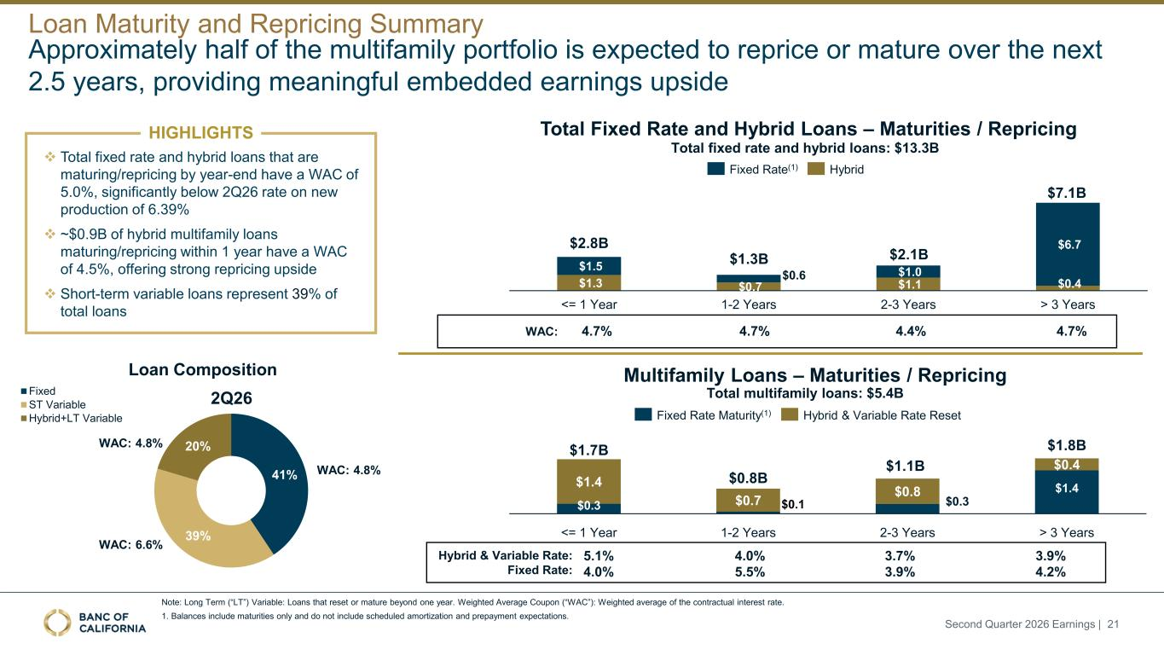
Approximately half of the multifamily portfolio is expected to reprice or mature over the next 2.5 years, providing meaningful embedded earnings upside Note: Long Term (“LT”) Variable: Loans that reset or mature beyond one year. Weighted Average Coupon (“WAC”): Weighted average of the contractual interest rate. 1. Balances include maturities only and do not include scheduled amortization and prepayment expectations. Loan Composition ❖ Total fixed rate and hybrid loans that are maturing/repricing by year-end have a WAC of 5.0%, significantly below 2Q26 rate on new production of 6.39% ❖ ~$0.9B of hybrid multifamily loans maturing/repricing within 1 year have a WAC of 4.5%, offering strong repricing upside ❖ Short-term variable loans represent 39% of total loans HIGHLIGHTS Loan Maturity and Repricing Summary Second Quarter 2026 Earnings | 21 41% 39% 20% 2Q26 Fixed ST Variable Hybrid+LT Variable WAC: 4.8% WAC: 6.6% WAC: 4.8% $0.3 $0.1 $0.3 $1.4 $1.4 $0.7 $0.8 $0.4 4.0% 5.5% 3.7% 3.9% 3.9% 4.2% 5.1% 4.0% Multifamily Loans – Maturities / Repricing Hybrid & Variable Rate: Fixed Rate: Total Fixed Rate and Hybrid Loans – Maturities / Repricing Total fixed rate and hybrid loans: $13.3B Total multifamily loans: $5.4B 4.7% 4.4% 4.7%4.7%WAC: <= 1 Year 1-2 Years 2-3 Years > 3 Years $1.7B $0.8B $1.1B $1.8B Fixed Rate Maturity(1) Hybrid & Variable Rate Reset $1.3 $0.7 $1.1 $0.4 $1.5 $0.6 $1.0 $6.7 <= 1 Year 1-2 Years 2-3 Years > 3 Years $2.8B $1.3B $2.1B $7.1B Fixed Rate(1) Hybrid

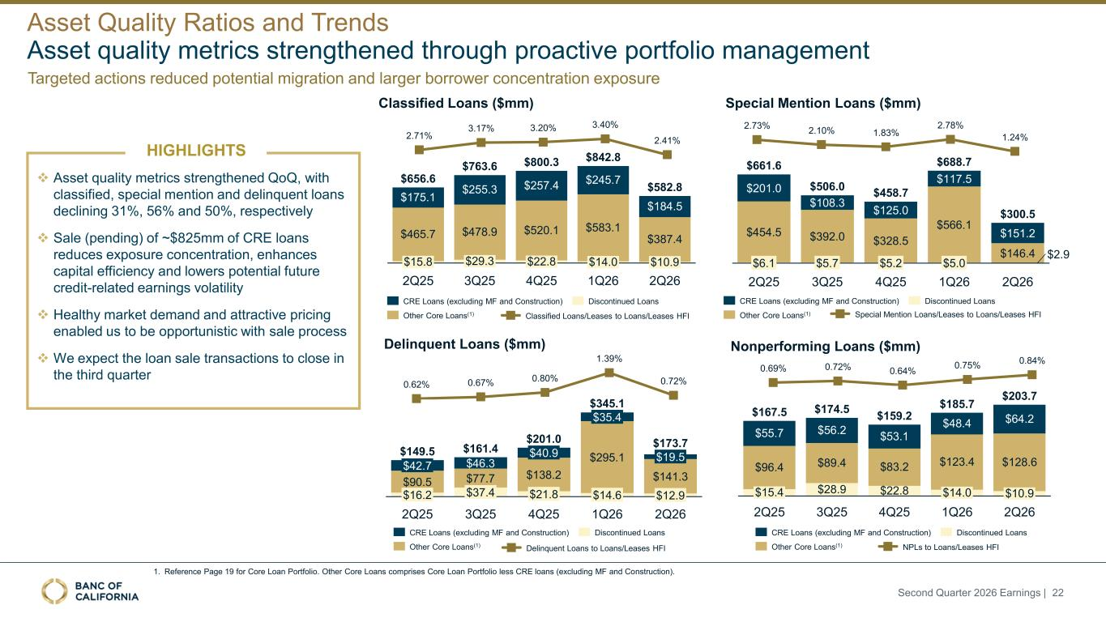
Asset quality metrics strengthened through proactive portfolio management ❖ Asset quality metrics strengthened QoQ, with classified, special mention and delinquent loans declining 31%, 56% and 50%, respectively ❖ Sale (pending) of ~$825mm of CRE loans reduces exposure concentration, enhances capital efficiency and lowers potential future credit-related earnings volatility ❖ Healthy market demand and attractive pricing enabled us to be opportunistic with sale process ❖ We expect the loan sale transactions to close in the third quarter Special Mention Loans ($mm) Delinquent Loans ($mm) Classified Loans ($mm) $311.3 $320.1 $275.3 $281.9 $175.1 $465.7 $15.8 2Q25 $255.3 $478.9 $29.3 3Q25 $257.4 $520.1 $22.8 4Q25 $245.7 $583.1 $14.0 1Q26 $184.5 $387.4 $10.9 2Q26 $656.6 $763.6 $800.3 $842.8 $582.8 2.71% 3.17% 3.20% 3.40% 2.41% Classified Loans/Leases to Loans/Leases HFI CRE Loans (excluding MF and Construction) Other Core Loans(1) Discontinued Loans 0.62% 0.67% 0.80% 1.39% 0.72% Delinquent Loans to Loans/Leases HFI 1. Reference Page 19 for Core Loan Portfolio. Other Core Loans comprises Core Loan Portfolio less CRE loans (excluding MF and Construction). HIGHLIGHTS Nonperforming Loans ($mm) $55.7 $96.4 $15.4 2Q25 $56.2 $89.4 $28.9 3Q25 $53.1 $83.2 $22.8 4Q25 $48.4 $123.4 $14.0 1Q26 $64.2 $128.6 $10.9 2Q26 $167.5 $174.5 $159.2 $185.7 $203.7 CRE Loans (excluding MF and Construction) Other Core Loans(1) Discontinued Loans 0.69% 0.72% 0.64% 0.75% 0.84% $201.0 $454.5 $6.1 2Q25 $108.3 $392.0 $5.7 3Q25 $125.0 $328.5 $5.2 4Q25 $117.5 $566.1 $5.0 1Q26 $151.2 $146.4 $2.9 2Q26 $661.6 $506.0 $458.7 $688.7 $300.5 CRE Loans (excluding MF and Construction) Other Core Loans(1) Discontinued Loans 2.73% 2.10% 1.83% 2.78% 1.24% Special Mention Loans/Leases to Loans/Leases HFI NPLs to Loans/Leases HFI $42.7 $90.5 $16.2 2Q25 $46.3 $77.7 $37.4 3Q25 $40.9 $138.2 $21.8 4Q25 $35.4 $295.1 $14.6 1Q26 $19.5 $141.3 $12.9 2Q26 $149.5 $161.4 $201.0 $345.1 $173.7 CRE Loans (excluding MF and Construction) Other Core Loans(1) Discontinued Loans Asset Quality Ratios and Trends Second Quarter 2026 Earnings | 22 Targeted actions reduced potential migration and larger borrower concentration exposure

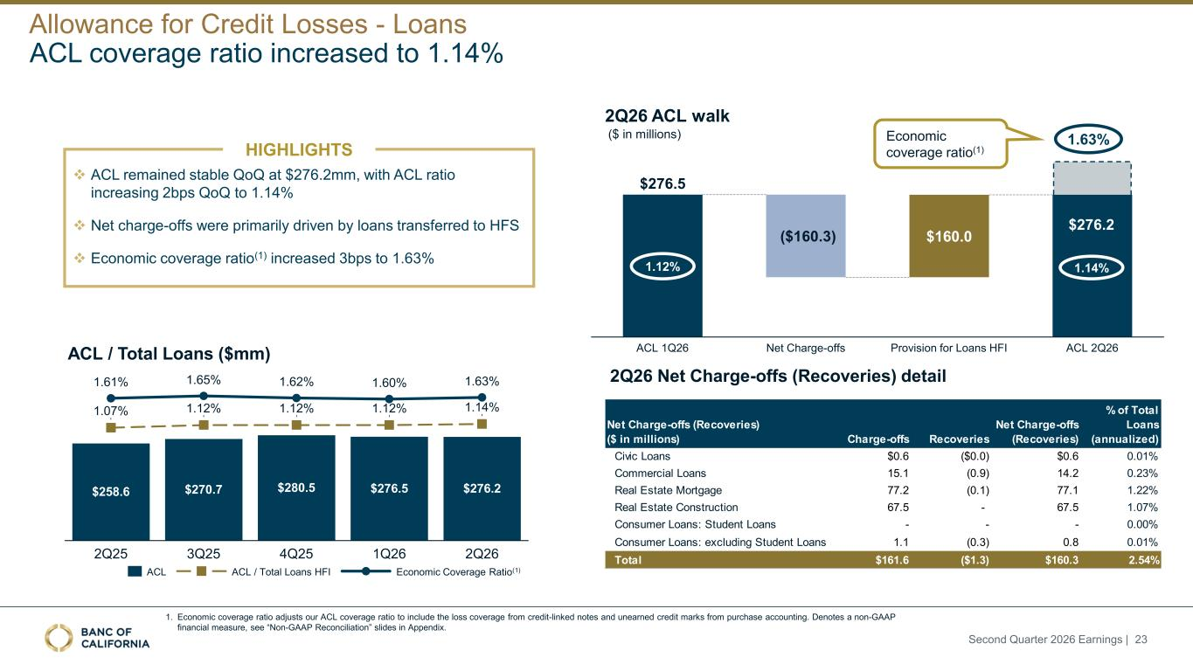
❖ ACL remained stable QoQ at $276.2mm, with ACL ratio increasing 2bps QoQ to 1.14% ❖ Net charge-offs were primarily driven by loans transferred to HFS ❖ Economic coverage ratio(1) increased 3bps to 1.63% ($ in millions) 2Q26 Net Charge-offs (Recoveries) detail ($160.3) ACL 1Q26 Net Charge-offs $160.0 Provision for Loans HFI ACL 2Q26 $276.5 ACL coverage ratio increased to 1.14% HIGHLIGHTS 1. Economic coverage ratio adjusts our ACL coverage ratio to include the loss coverage from credit-linked notes and unearned credit marks from purchase accounting. Denotes a non-GAAP financial measure, see “Non-GAAP Reconciliation” slides in Appendix. 1.63% Economic coverage ratio(1) $276.2 $258.6 1.07% 1.61% 2Q25 $270.7 1.12% 1.65% 3Q25 $280.5 1.12% 1.62% 4Q25 $276.5 1.12% 1.60% 1Q26 $276.2 1.14% 1.63% 2Q26 ACL ACL / Total Loans HFI Economic Coverage Ratio(1) ACL / Total Loans ($mm) 2Q26 ACL walk 1.12% 1.14% Net Charge-offs (Recoveries) ($ in millions) Charge-offs Recoveries Net Charge-offs (Recoveries) % of Total Loans (annualized) Civic Loans $0.6 ($0.0) $0.6 0.01% Commercial Loans 15.1 (0.9) 14.2 0.23% Real Estate Mortgage 77.2 (0.1) 77.1 1.22% Real Estate Construction 67.5 - 67.5 1.07% Consumer Loans: Student Loans - - - 0.00% Consumer Loans: excluding Student Loans 1.1 (0.3) 0.8 0.01% Total $161.6 ($1.3) $160.3 2.54% Allowance for Credit Losses - Loans Second Quarter 2026 Earnings | 23

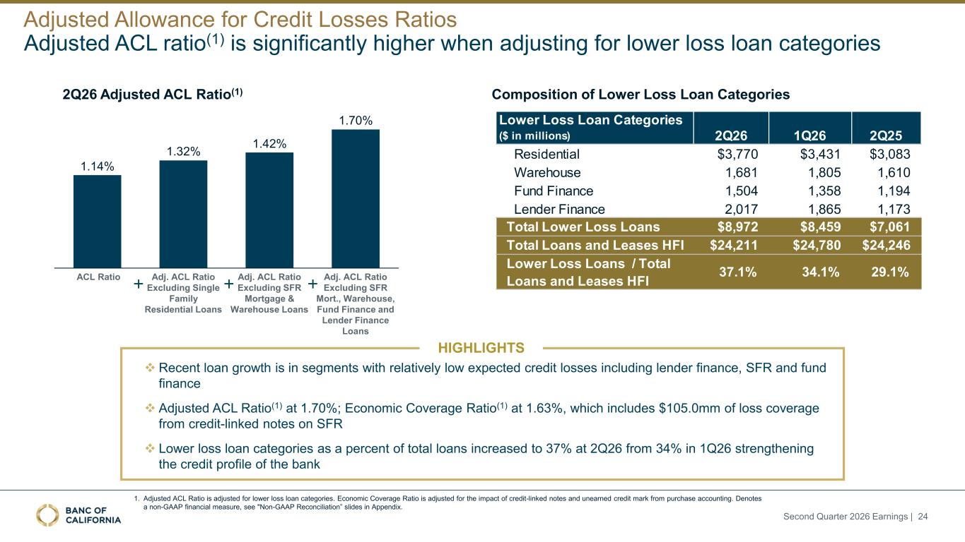
Adjusted ACL ratio(1) is significantly higher when adjusting for lower loss loan categories 2Q26 Adjusted ACL Ratio(1) Composition of Lower Loss Loan Categories ❖ Recent loan growth is in segments with relatively low expected credit losses including lender finance, SFR and fund finance ❖ Adjusted ACL Ratio(1) at 1.70%; Economic Coverage Ratio(1) at 1.63%, which includes $105.0mm of loss coverage from credit-linked notes on SFR ❖ Lower loss loan categories as a percent of total loans increased to 37% at 2Q26 from 34% in 1Q26 strengthening the credit profile of the bank 1.14% 1.32% 1.42% 1.70% ACL Ratio Adj. ACL Ratio Excluding Single Family Residential Loans Adj. ACL Ratio Excluding SFR Mortgage & Warehouse Loans Adj. ACL Ratio Excluding SFR Mort., Warehouse, Fund Finance and Lender Finance Loans HIGHLIGHTS 1. Adjusted ACL Ratio is adjusted for lower loss loan categories. Economic Coverage Ratio is adjusted for the impact of credit-linked notes and unearned credit mark from purchase accounting. Denotes a non-GAAP financial measure, see "Non-GAAP Reconciliation” slides in Appendix. Adjusted Allowance for Credit Losses Ratios Lower Loss Loan Categories ($ in millions) 2Q26 1Q26 2Q25 Residential $3,770 $3,431 $3,083 Warehouse 1,681 1,805 1,610 Fund Finance 1,504 1,358 1,194 Lender Finance 2,017 1,865 1,173 Total Lower Loss Loans $8,972 $8,459 $7,061 Total Loans and Leases HFI $24,211 $24,780 $24,246 Lower Loss Loans / Total Loans and Leases HFI 37.1% 34.1% 29.1% Second Quarter 2026 Earnings | 24

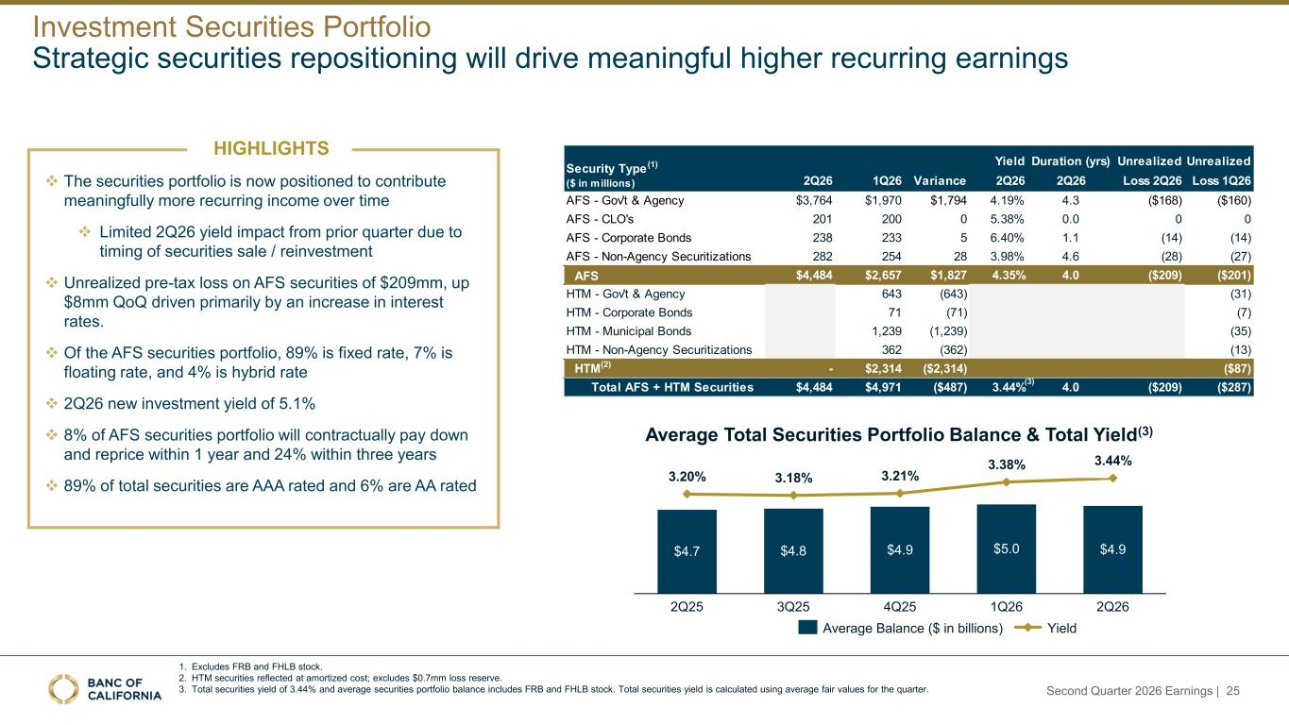
Average Total Securities Portfolio Balance & Total Yield(3) 1. Excludes FRB and FHLB stock. 2. HTM securities reflected at amortized cost; excludes $0.7mm loss reserve. 3. Total securities yield of 3.44% and average securities portfolio balance includes FRB and FHLB stock. Total securities yield is calculated using average fair values for the quarter. Strategic securities repositioning will drive meaningful higher recurring earnings ❖ The securities portfolio is now positioned to contribute meaningfully more recurring income over time ❖ Limited 2Q26 yield impact from prior quarter due to timing of securities sale / reinvestment ❖ Unrealized pre-tax loss on AFS securities of $209mm, up $8mm QoQ driven primarily by an increase in interest rates. ❖ Of the AFS securities portfolio, 89% is fixed rate, 7% is floating rate, and 4% is hybrid rate ❖ 2Q26 new investment yield of 5.1% ❖ 8% of AFS securities portfolio will contractually pay down and reprice within 1 year and 24% within three years ❖ 89% of total securities are AAA rated and 6% are AA rated HIGHLIGHTS $4.7 3.20% 2Q25 $4.8 3.18% 3Q25 $4.9 3.21% 4Q25 $5.0 3.38% 1Q26 $4.9 3.44% 2Q26 Average Balance ($ in billions) Yield Investment Securities Portfolio Yield Duration (yrs) Unrealized Unrealized 2Q26 1Q26 Variance 2Q26 2Q26 Loss 2Q26 Loss 1Q26 AFS - Gov't & Agency $3,764 $1,970 $1,794 4.19% 4.3 ($168) ($160) AFS - CLO's 201 200 0 5.38% 0.0 0 0 AFS - Corporate Bonds 238 233 5 6.40% 1.1 (14) (14) AFS - Non-Agency Securitizations 282 254 28 3.98% 4.6 (28) (27) AFS $4,484 $2,657 $1,827 4.35% 4.0 ($209) ($201) HTM - Gov't & Agency 643 (643) (31) HTM - Corporate Bonds 71 (71) (7) HTM - Municipal Bonds 1,239 (1,239) (35) HTM - Non-Agency Securitizations 362 (362) (13) HTM(2) - $2,314 ($2,314) ($87) Total AFS + HTM Securities $4,484 $4,971 ($487) 3.44% 4.0 ($209) ($287) Security Type (1) ($ in millions) Second Quarter 2026 Earnings | 25 (3)

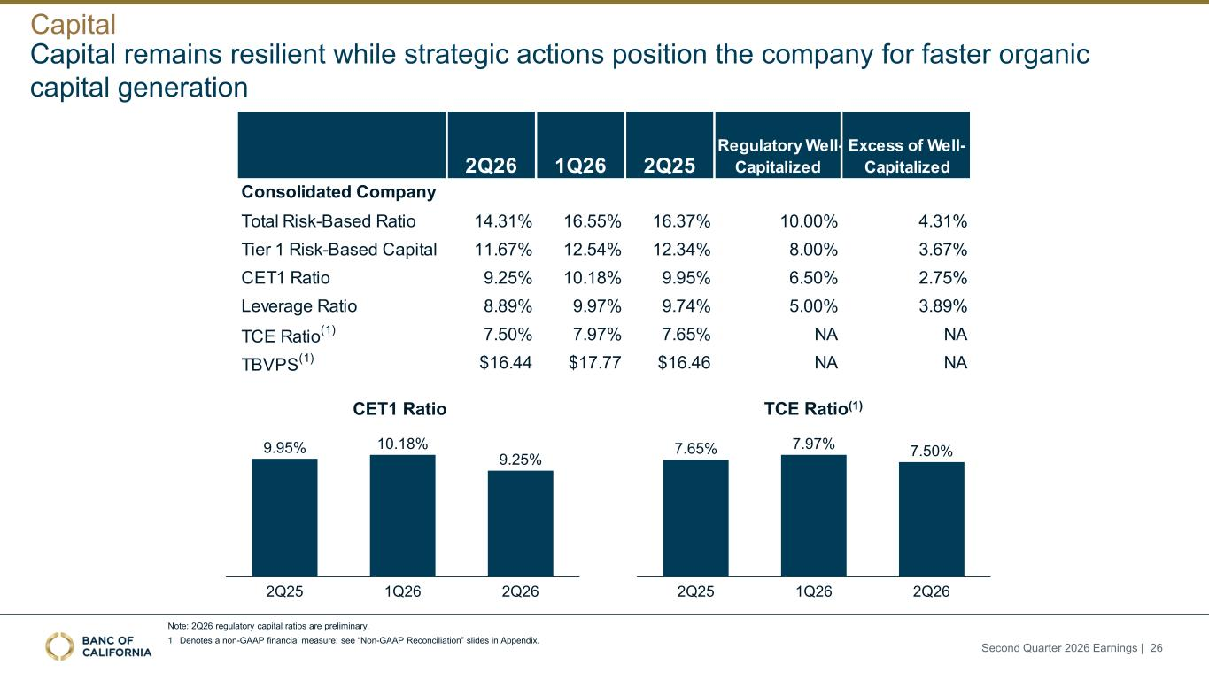
9.95% 10.18% 9.25% 2Q25 1Q26 2Q26 7.65% 7.97% 7.50% 2Q25 1Q26 2Q26 CET1 Ratio TCE Ratio(1) Note: 2Q26 regulatory capital ratios are preliminary. 1. Denotes a non-GAAP financial measure; see “Non-GAAP Reconciliation” slides in Appendix. Capital remains resilient while strategic actions position the company for faster organic capital generation Capital 2Q26 1Q26 2Q25 Regulatory Well- Capitalized Excess of Well- Capitalized Consolidated Company Total Risk-Based Ratio 14.31% 16.55% 16.37% 10.00% 4.31% Tier 1 Risk-Based Capital 11.67% 12.54% 12.34% 8.00% 3.67% CET1 Ratio 9.25% 10.18% 9.95% 6.50% 2.75% Leverage Ratio 8.89% 9.97% 9.74% 5.00% 3.89% TCE Ratio (1) 7.50% 7.97% 7.65% NA NA TBVPS (1) $16.44 $17.77 $16.46 NA NA Second Quarter 2026 Earnings | 26

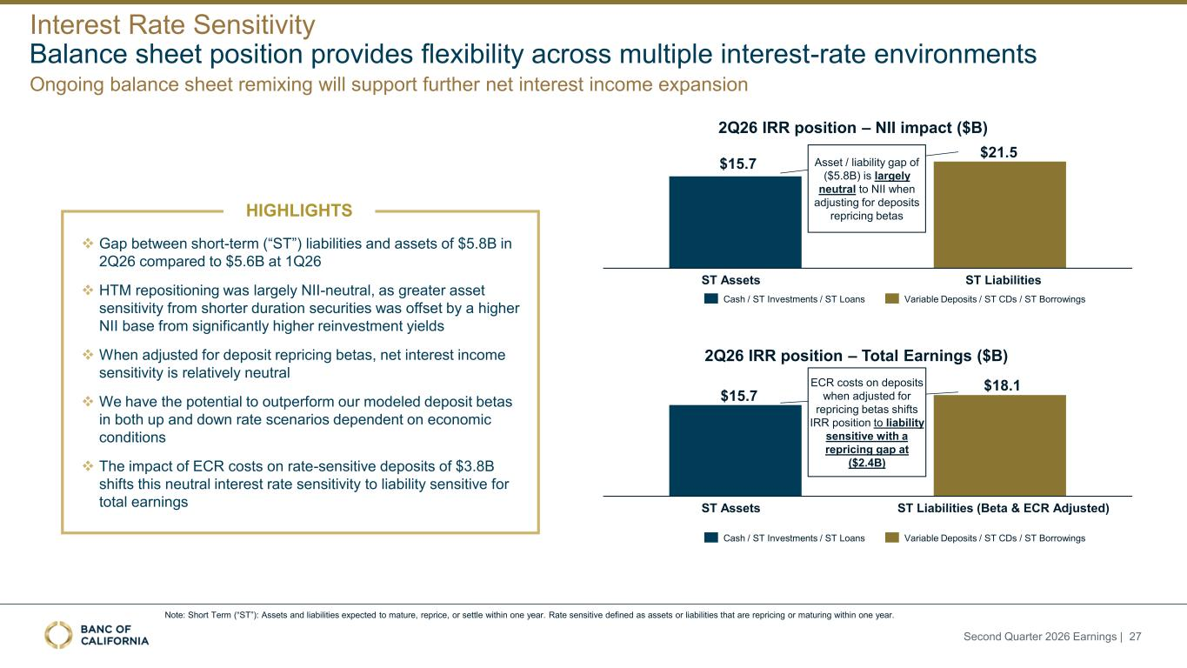
2Q26 IRR position – NII impact ($B) ❖ Gap between short-term (“ST”) liabilities and assets of $5.8B in 2Q26 compared to $5.6B at 1Q26 ❖ HTM repositioning was largely NII-neutral, as greater asset sensitivity from shorter duration securities was offset by a higher NII base from significantly higher reinvestment yields ❖ When adjusted for deposit repricing betas, net interest income sensitivity is relatively neutral ❖ We have the potential to outperform our modeled deposit betas in both up and down rate scenarios dependent on economic conditions ❖ The impact of ECR costs on rate-sensitive deposits of $3.8B shifts this neutral interest rate sensitivity to liability sensitive for total earnings HIGHLIGHTS $15.7 $21.5 ST Assets ST Liabilities Asset / liability gap of ($5.8B) is largely neutral to NII when adjusting for deposits repricing betas 2Q26 IRR position – Total Earnings ($B) $15.7 $18.1 ST Assets ST Liabilities (Beta & ECR Adjusted) ECR costs on deposits when adjusted for repricing betas shifts IRR position to liability sensitive with a repricing gap at ($2.4B) Cash / ST Investments / ST Loans Cash / ST Investments / ST Loans Variable Deposits / ST CDs / ST Borrowings Variable Deposits / ST CDs / ST Borrowings Note: Short Term (“ST”): Assets and liabilities expected to mature, reprice, or settle within one year. Rate sensitive defined as assets or liabilities that are repricing or maturing within one year. Second Quarter 2026 Earnings | 27 Balance sheet position provides flexibility across multiple interest-rate environments Interest Rate Sensitivity Ongoing balance sheet remixing will support further net interest income expansion


Supplemental Information

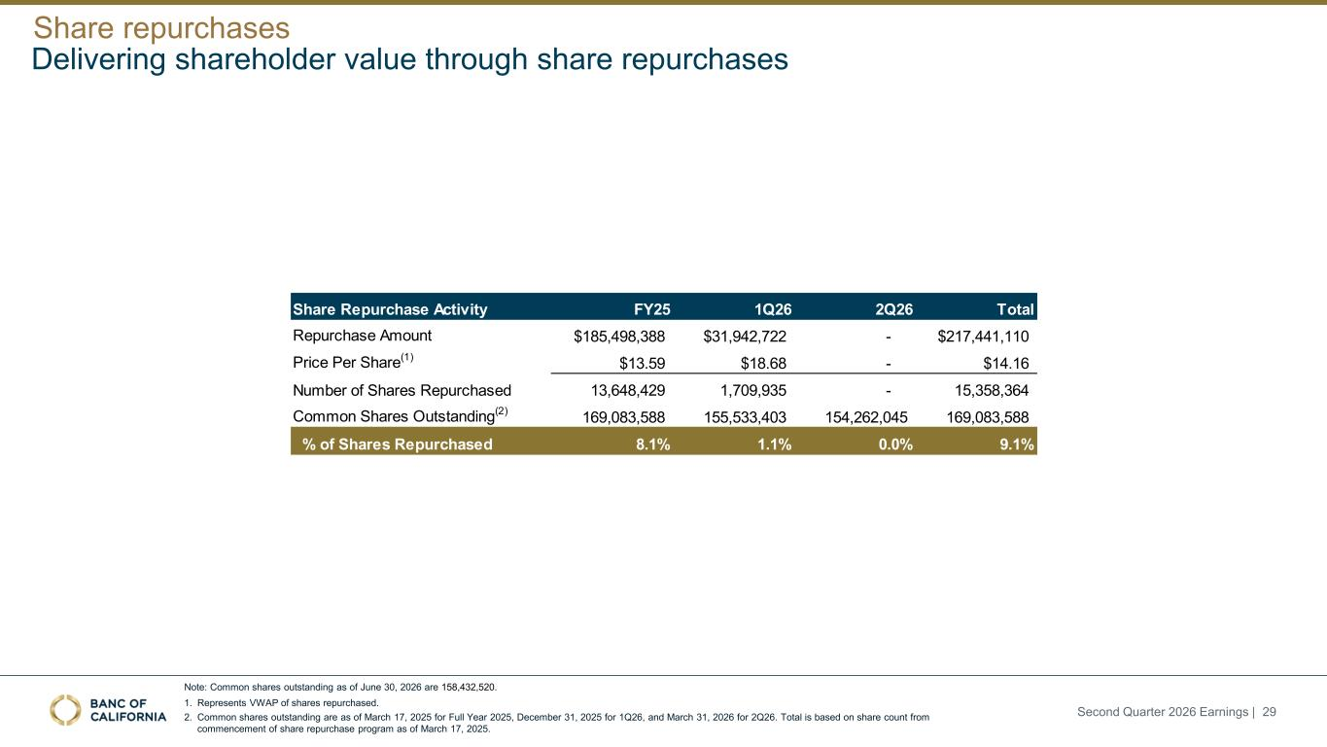
Note: Common shares outstanding as of June 30, 2026 are 158,432,520. 1. Represents VWAP of shares repurchased. 2. Common shares outstanding are as of March 17, 2025 for Full Year 2025, December 31, 2025 for 1Q26, and March 31, 2026 for 2Q26. Total is based on share count from commencement of share repurchase program as of March 17, 2025. Delivering shareholder value through share repurchases Share repurchases Second Quarter 2026 Earnings | 29 Share Repurchase Activity FY25 1Q26 2Q26 Total Repurchase Amount $185,498,388 $31,942,722 - $217,441,110 Price Per Share(1) $13.59 $18.68 - $14.16 Number of Shares Repurchased 13,648,429 1,709,935 - 15,358,364 Common Shares Outstanding(2) 169,083,588 155,533,403 154,262,045 169,083,588 % of Shares Repurchased 8.1% 1.1% 0.0% 9.1%

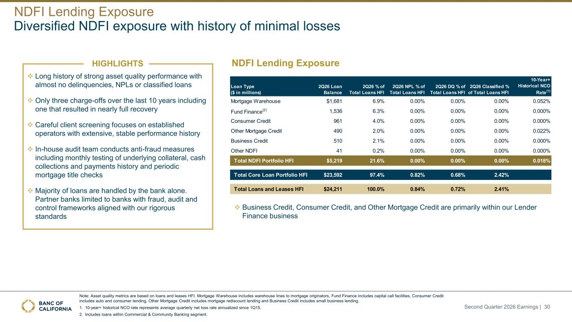
Diversified NDFI exposure with history of minimal losses NDFI Lending Exposure Note: Asset quality metrics are based on loans and leases HFI. Mortgage Warehouse includes warehouse lines to mortgage originators, Fund Finance includes capital call facilities, Consumer Credit includes auto and consumer lending, Other Mortgage Credit includes mortgage rediscount lending and Business Credit includes small business lending. 1. 10-year+ historical NCO rate represents average quarterly net loss rate annualized since 1Q15. 2. Includes loans within Commercial & Community Banking segment. HIGHLIGHTS ❖ Long history of strong asset quality performance with almost no delinquencies, NPLs or classified loans ❖ Only three charge-offs over the last 10 years including one that resulted in nearly full recovery ❖ Careful client screening focuses on established operators with extensive, stable performance history ❖ In-house audit team conducts anti-fraud measures including monthly testing of underlying collateral, cash collections and payments history and periodic mortgage title checks ❖ Majority of loans are handled by the bank alone. Partner banks limited to banks with fraud, audit and control frameworks aligned with our rigorous standards NDFI Lending Exposure ❖ Business Credit, Consumer Credit, and Other Mortgage Credit are primarily within our Lender Finance business Loan Type ($ in millions) 2Q26 Loan Balance 2Q26 % of Total Loans HFI 2Q26 NPL % of Total Loans HFI 2Q26 DQ % of Total Loans HFI 2Q26 Classified % of Total Loans HFI 10-Year+ Historical NCO Rate(1) Mortgage Warehouse $1,681 6.9% 0.00% 0.00% 0.00% 0.052% Fund Finance(2) 1,536 6.3% 0.00% 0.00% 0.00% 0.000% Consumer Credit 961 4.0% 0.00% 0.00% 0.00% 0.000% Other Mortgage Credit 490 2.0% 0.00% 0.00% 0.00% 0.022% Business Credit 510 2.1% 0.00% 0.00% 0.00% 0.000% Other NDFI 41 0.2% 0.00% 0.00% 0.00% 0.000% Total NDFI Portfolio HFI $5,219 21.6% 0.00% 0.00% 0.00% 0.018% Total Core Loan Portfolio HFI $23,592 97.4% 0.82% 0.68% 2.42% Total Loans and Leases HFI $24,211 100.0% 0.84% 0.72% 2.41% Second Quarter 2026 Earnings | 30

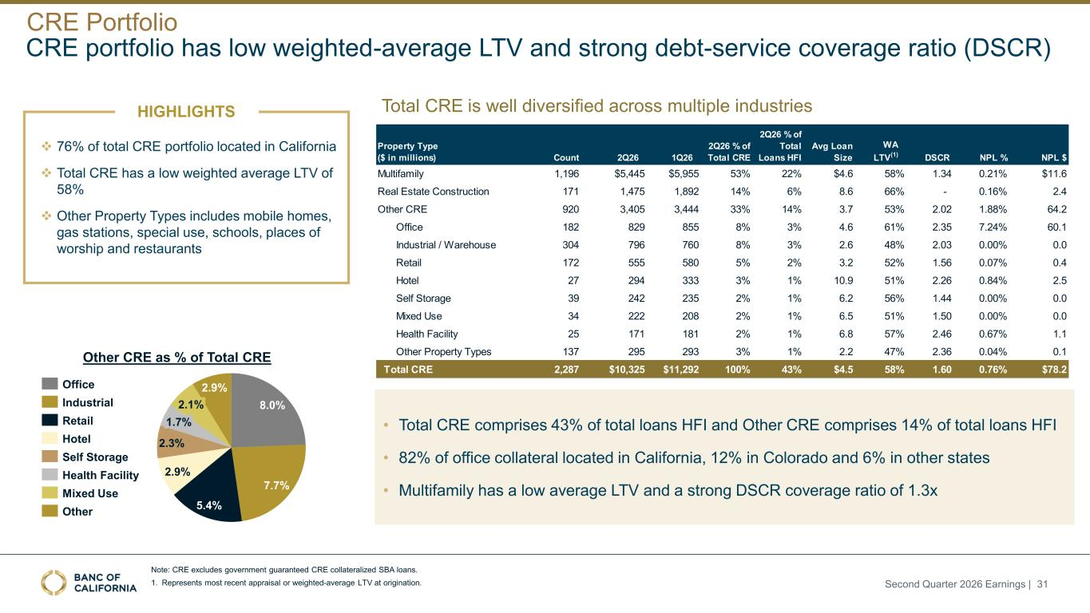
❖ 76% of total CRE portfolio located in California ❖ Total CRE has a low weighted average LTV of 58% ❖ Other Property Types includes mobile homes, gas stations, special use, schools, places of worship and restaurants 8.0% 7.7% 5.4% 2.9% 2.3% 2.9% 1.7% 2.1% Office Industrial Retail Hotel Self Storage Health Facility Mixed Use Other Other CRE as % of Total CRE Total CRE is well diversified across multiple industries • Total CRE comprises 43% of total loans HFI and Other CRE comprises 14% of total loans HFI • 82% of office collateral located in California, 12% in Colorado and 6% in other states • Multifamily has a low average LTV and a strong DSCR coverage ratio of 1.3x Note: CRE excludes government guaranteed CRE collateralized SBA loans. 1. Represents most recent appraisal or weighted-average LTV at origination. CRE portfolio has low weighted-average LTV and strong debt-service coverage ratio (DSCR) HIGHLIGHTS CRE Portfolio Property Type ($ in millions) Count 2Q26 1Q26 2Q26 % of Total CRE 2Q26 % of Total Loans HFI Avg Loan Size WA LTV(1) DSCR NPL % NPL $ Multifamily 1,196 $5,445 $5,955 53% 22% $4.6 58% 1.34 0.21% $11.6 Real Estate Construction 171 1,475 1,892 14% 6% 8.6 66% - 0.16% 2.4 Other CRE 920 3,405 3,444 33% 14% 3.7 53% 2.02 1.88% 64.2 Office 182 829 855 8% 3% 4.6 61% 2.35 7.24% 60.1 Industrial / Warehouse 304 796 760 8% 3% 2.6 48% 2.03 0.00% 0.0 Retail 172 555 580 5% 2% 3.2 52% 1.56 0.07% 0.4 Hotel 27 294 333 3% 1% 10.9 51% 2.26 0.84% 2.5 Self Storage 39 242 235 2% 1% 6.2 56% 1.44 0.00% 0.0 Mixed Use 34 222 208 2% 1% 6.5 51% 1.50 0.00% 0.0 Health Facility 25 171 181 2% 1% 6.8 57% 2.46 0.67% 1.1 Other Property Types 137 295 293 3% 1% 2.2 47% 2.36 0.04% 0.1 Total CRE 2,287 $10,325 $11,292 100% 43% $4.5 58% 1.60 0.76% $78.2 Second Quarter 2026 Earnings | 31

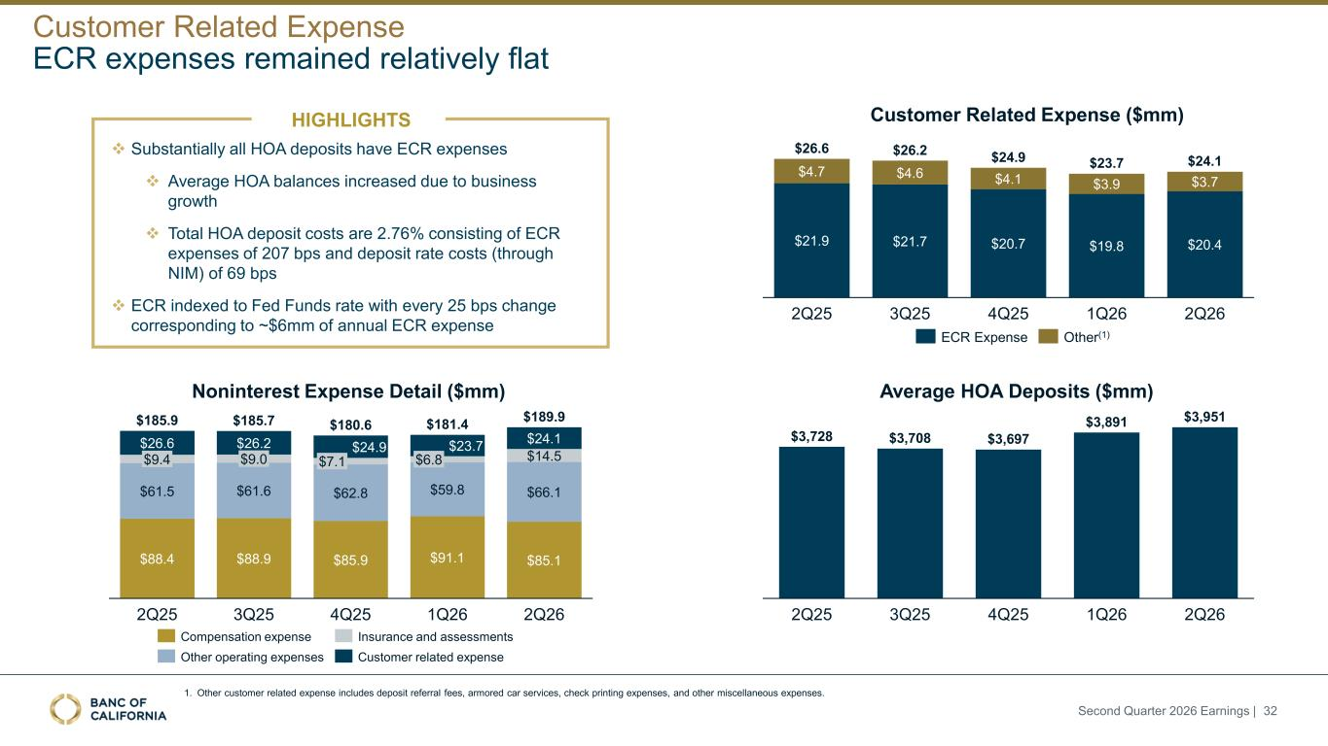
Noninterest Expense Detail ($mm) $26.6 $9.4 $61.5 $88.4 2Q25 $26.2 $9.0 $61.6 $88.9 3Q25 $24.9 $7.1 $62.8 $85.9 4Q25 $23.7 $6.8 $59.8 $91.1 1Q26 $24.1 $14.5 $66.1 $85.1 2Q26 $185.9 $185.7 $180.6 $181.4 $189.9 Compensation expense Other operating expenses Insurance and assessments Customer related expense Customer Related Expense ($mm) $21.9 $4.7 2Q25 $21.7 $4.6 3Q25 $20.7 $4.1 4Q25 $19.8 $3.9 1Q26 2Q26 $26.6 $26.2 $24.9 $23.7 $24.1 $20.4 $3.7 ECR Expense Other(1) 1. Other customer related expense includes deposit referral fees, armored car services, check printing expenses, and other miscellaneous expenses. ECR expenses remained relatively flat 2Q25 3Q25 4Q25 1Q26 2Q26 $3,728 $3,708 $3,697 $3,891 $3,951 Average HOA Deposits ($mm) Customer Related Expense HIGHLIGHTS ❖ Substantially all HOA deposits have ECR expenses ❖ Average HOA balances increased due to business growth ❖ Total HOA deposit costs are 2.76% consisting of ECR expenses of 207 bps and deposit rate costs (through NIM) of 69 bps ❖ ECR indexed to Fed Funds rate with every 25 bps change corresponding to ~$6mm of annual ECR expense Second Quarter 2026 Earnings | 32

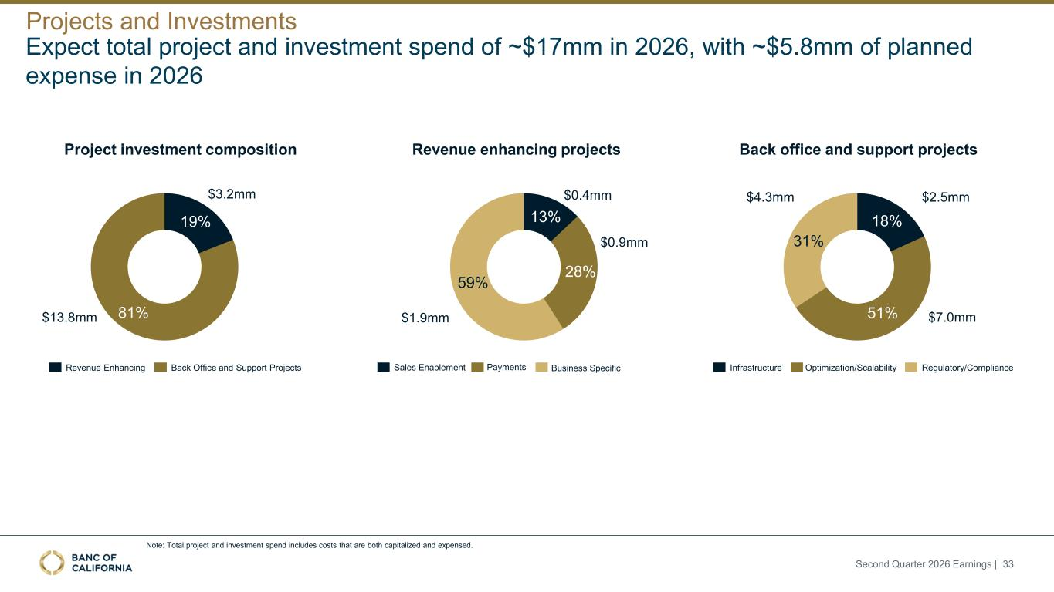
Expect total project and investment spend of ~$17mm in 2026, with ~$5.8mm of planned expense in 2026 Project investment composition Revenue enhancing projects Back office and support projects Projects and Investments Note: Total project and investment spend includes costs that are both capitalized and expensed. Second Quarter 2026 Earnings | 33 19% 81% Revenue Enhancing Back Office and Support Projects $3.2mm $13.8mm 18% 51% 31% Infrastructure Optimization/Scalability Regulatory/Compliance $7.0mm $4.3mm $2.5mm 13% 28% 59% Sales Enablement Payments Business Specific $0.9mm $1.9mm $0.4mm

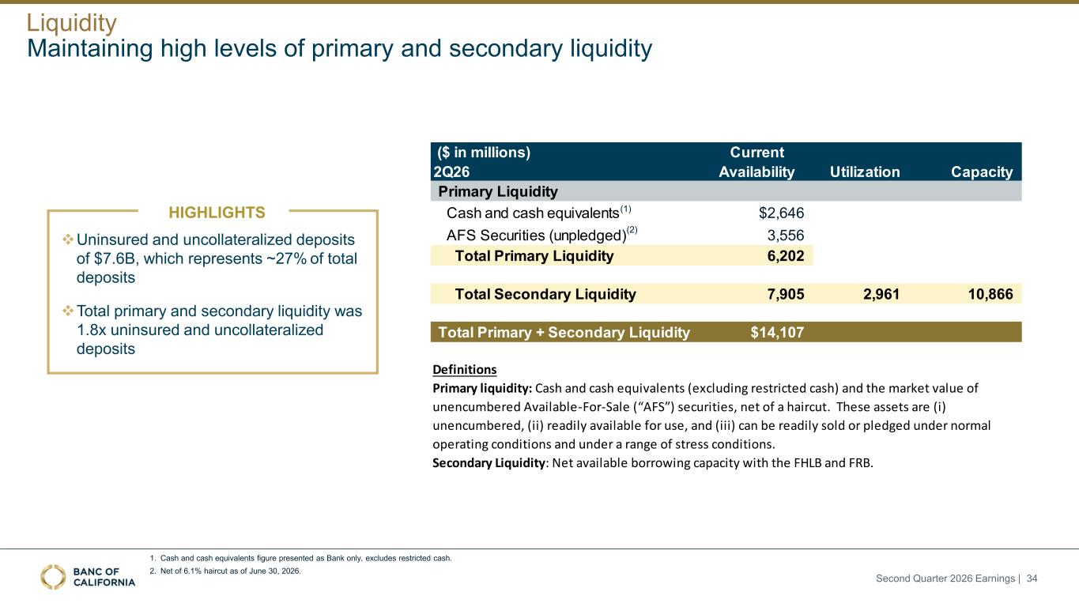
❖Uninsured and uncollateralized deposits of $7.6B, which represents ~27% of total deposits ❖Total primary and secondary liquidity was 1.8x uninsured and uncollateralized deposits Maintaining high levels of primary and secondary liquidity 1. Cash and cash equivalents figure presented as Bank only, excludes restricted cash. 2. Net of 6.1% haircut as of June 30, 2026. ($ in millions) 2Q26 Current Availability Utilization Capacity Primary Liquidity Cash and cash equivalents $2,646 AFS Securities (unpledged) 3,556 Total Primary Liquidity 6,202 Total Secondary Liquidity 7,905 2,961 10,866 Total Primary + Secondary Liquidity $14,107 Definitions Secondary Liquidity: Net available borrowing capacity with the FHLB and FRB. Primary liquidity: Cash and cash equivalents (excluding restricted cash) and the market value of unencumbered Available-For-Sale (“AFS”) securities, net of a haircut. These assets are (i) unencumbered, (ii) readily available for use, and (iii) can be readily sold or pledged under normal operating conditions and under a range of stress conditions. (1) (2) Liquidity HIGHLIGHTS Second Quarter 2026 Earnings | 34


Experienced Management Team with Track Record of Success at Leading Institutions Scott Ladd Chief Credit Officer for Specialty Banking and Credit Operations 25+ years banking and consulting experience, previously served as EVP, Group Head, Portfolio Management at PacWest Bancorp Hamid Hussain President of the Bank 30+ years of banking experience, previously served as EVP, Real Estate Market Executive for Wells Fargo Bryan Corsini Chief Credit Officer 35+ years of banking experience, previously served as CCO of PacWest Bancorp and Director of Pacific Western Bank Ido Dotan General Counsel and Chief Administrative Officer 20+ years experience in corporate securities, M&A, and structured finance. Previously served as EVP of Carrington Mortgage Holdings Olivia Lindsay Chief Risk Officer 25+ years of experience in regulatory processes and controls, previously spent 15 years at MUFG Union Bank Steve Schwimmer Chief Information Officer 30+ years of experience in banking technology, previously served as the EVP, Chief Innovation Officer at PacWest Bancorp Sean Lynden President, Venture Banking Group 30+ years of banking and related experience. Previously served as President of Venture Banking Group for Pacific Western Bank Kim Tu EVP, Chief People Officer 15+ years of banking and financial services experience across Human Resources. Previously held HR leadership roles at Mr. Cooper and JPMorgan Chase Karen Hon Chief Accounting Officer & Deputy Chief Financial Officer 25+ years of finance & accounting experience, previously served as Chief Accounting Officer at Silicon Valley Bank Jared Wolff Chairman and Chief Executive Officer 30+ years of banking and law. Previously held senior executive positions with City National Bank (RBC) and PacWest Bancorp Joe Kauder Chief Financial Officer 30+ years of banking experience, previously served as EVP, CFO Wells Fargo Wholesale Banking Bill Rhodes Chief Internal Audit Officer 25+ years of banking and internal audit experience, previously served as CAE of Coastal Community Bank and Deputy CAE of Silicon Valley Bank Joe Rice Vice Chairman and Senior EVP 30+ years of banking and related experience. Previously served as Chief Credit Officer and Chief Operational Risk Officer at Wells Fargo Second Quarter 2026 Earnings | 35


Appendix

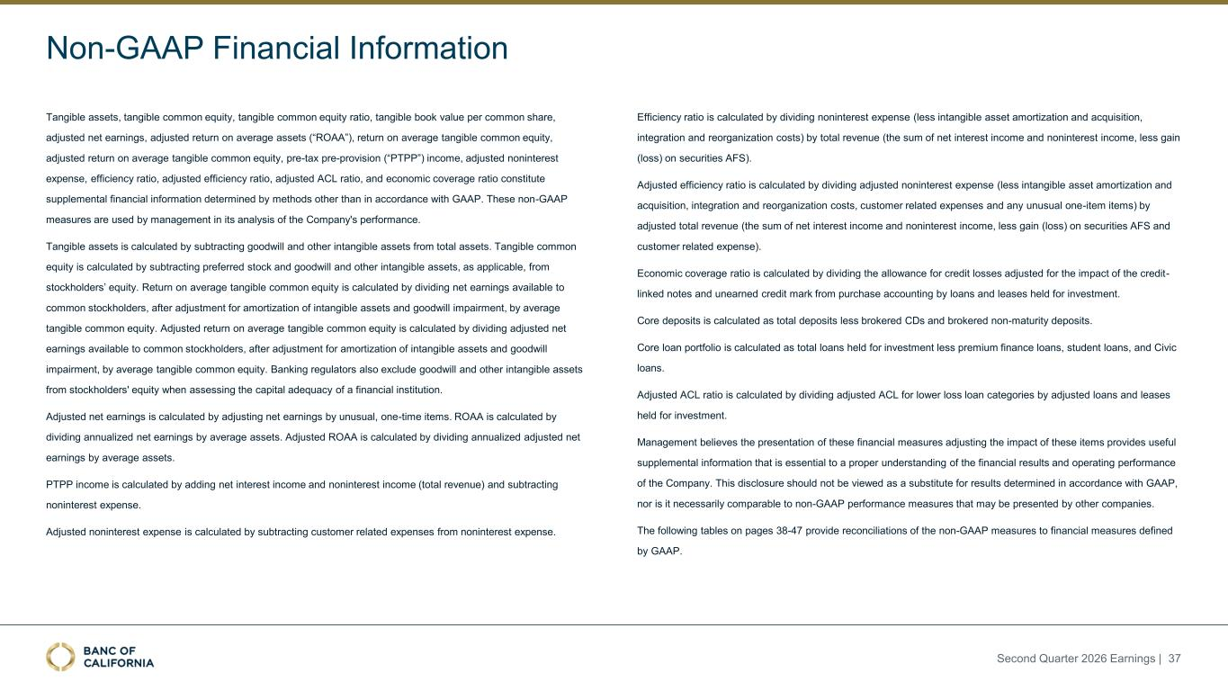
Non-GAAP Financial Information Tangible assets, tangible common equity, tangible common equity ratio, tangible book value per common share, adjusted net earnings, adjusted return on average assets (“ROAA”), return on average tangible common equity, adjusted return on average tangible common equity, pre-tax pre-provision (“PTPP”) income, adjusted noninterest expense, efficiency ratio, adjusted efficiency ratio, adjusted ACL ratio, and economic coverage ratio constitute supplemental financial information determined by methods other than in accordance with GAAP. These non-GAAP measures are used by management in its analysis of the Company's performance. Tangible assets is calculated by subtracting goodwill and other intangible assets from total assets. Tangible common equity is calculated by subtracting preferred stock and goodwill and other intangible assets, as applicable, from stockholders’ equity. Return on average tangible common equity is calculated by dividing net earnings available to common stockholders, after adjustment for amortization of intangible assets and goodwill impairment, by average tangible common equity. Adjusted return on average tangible common equity is calculated by dividing adjusted net earnings available to common stockholders, after adjustment for amortization of intangible assets and goodwill impairment, by average tangible common equity. Banking regulators also exclude goodwill and other intangible assets from stockholders' equity when assessing the capital adequacy of a financial institution. Adjusted net earnings is calculated by adjusting net earnings by unusual, one-time items. ROAA is calculated by dividing annualized net earnings by average assets. Adjusted ROAA is calculated by dividing annualized adjusted net earnings by average assets. PTPP income is calculated by adding net interest income and noninterest income (total revenue) and subtracting noninterest expense. Adjusted noninterest expense is calculated by subtracting customer related expenses from noninterest expense. Efficiency ratio is calculated by dividing noninterest expense (less intangible asset amortization and acquisition, integration and reorganization costs) by total revenue (the sum of net interest income and noninterest income, less gain (loss) on securities AFS). Adjusted efficiency ratio is calculated by dividing adjusted noninterest expense (less intangible asset amortization and acquisition, integration and reorganization costs, customer related expenses and any unusual one-item items) by adjusted total revenue (the sum of net interest income and noninterest income, less gain (loss) on securities AFS and customer related expense). Economic coverage ratio is calculated by dividing the allowance for credit losses adjusted for the impact of the credit- linked notes and unearned credit mark from purchase accounting by loans and leases held for investment. Core deposits is calculated as total deposits less brokered CDs and brokered non-maturity deposits. Core loan portfolio is calculated as total loans held for investment less premium finance loans, student loans, and Civic loans. Adjusted ACL ratio is calculated by dividing adjusted ACL for lower loss loan categories by adjusted loans and leases held for investment. Management believes the presentation of these financial measures adjusting the impact of these items provides useful supplemental information that is essential to a proper understanding of the financial results and operating performance of the Company. This disclosure should not be viewed as a substitute for results determined in accordance with GAAP, nor is it necessarily comparable to non-GAAP performance measures that may be presented by other companies. The following tables on pages 38-47 provide reconciliations of the non-GAAP measures to financial measures defined by GAAP. Second Quarter 2026 Earnings | 37

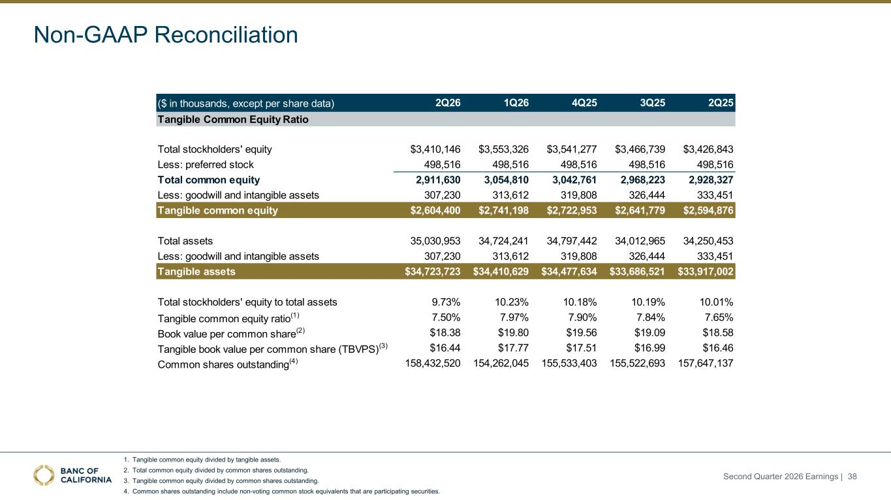
Non-GAAP Reconciliation 1. Tangible common equity divided by tangible assets. 2. Total common equity divided by common shares outstanding. 3. Tangible common equity divided by common shares outstanding. 4. Common shares outstanding include non-voting common stock equivalents that are participating securities. ($ in thousands, except per share data) 2Q26 1Q26 4Q25 3Q25 2Q25 Tangible Common Equity Ratio Total stockholders' equity $3,410,146 $3,553,326 $3,541,277 $3,466,739 $3,426,843 Less: preferred stock 498,516 498,516 498,516 498,516 498,516 Total common equity 2,911,630 3,054,810 3,042,761 2,968,223 2,928,327 Less: goodwill and intangible assets 307,230 313,612 319,808 326,444 333,451 Tangible common equity $2,604,400 $2,741,198 $2,722,953 $2,641,779 $2,594,876 Total assets 35,030,953 34,724,241 34,797,442 34,012,965 34,250,453 Less: goodwill and intangible assets 307,230 313,612 319,808 326,444 333,451 Tangible assets $34,723,723 $34,410,629 $34,477,634 $33,686,521 $33,917,002 Total stockholders' equity to total assets 9.73% 10.23% 10.18% 10.19% 10.01% Tangible common equity ratio(1) 7.50% 7.97% 7.90% 7.84% 7.65% Book value per common share(2) $18.38 $19.80 $19.56 $19.09 $18.58 Tangible book value per common share (TBVPS)(3) $16.44 $17.77 $17.51 $16.99 $16.46 Common shares outstanding(4) 158,432,520 154,262,045 155,533,403 155,522,693 157,647,137 Second Quarter 2026 Earnings | 38

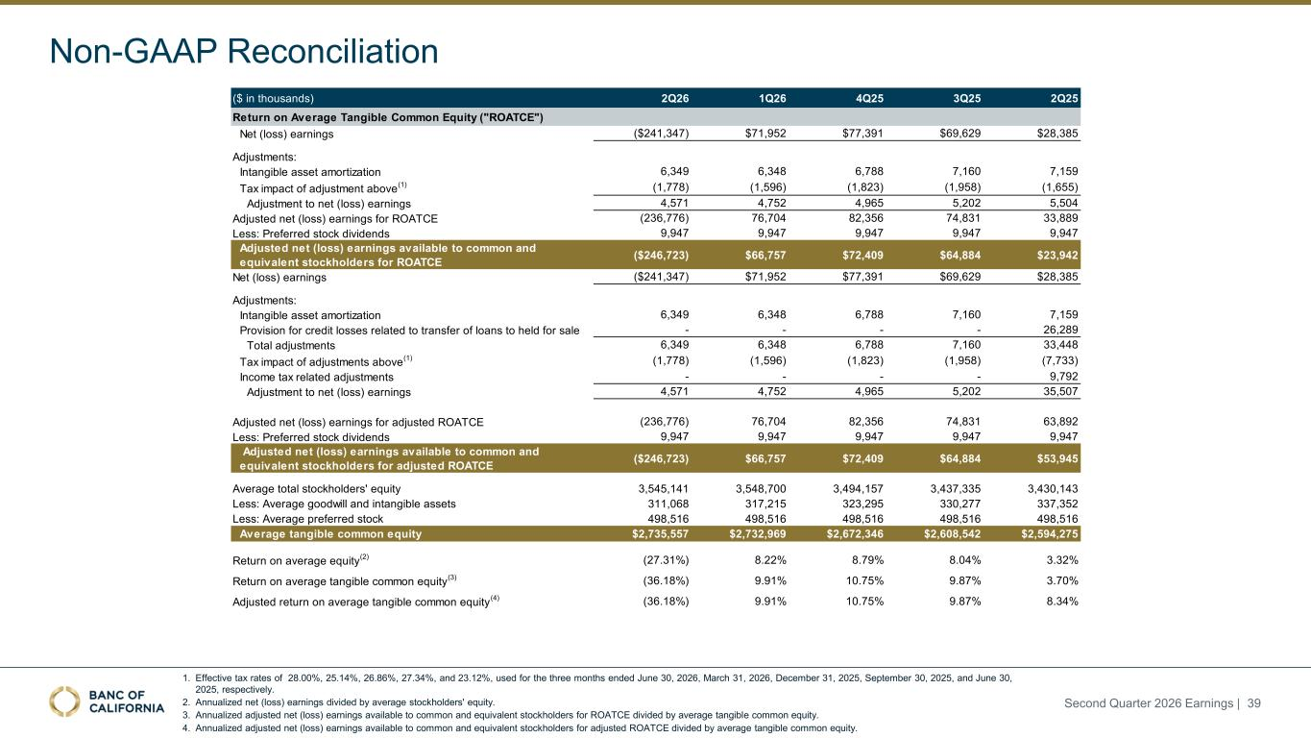
1. Effective tax rates of 28.00%, 25.14%, 26.86%, 27.34%, and 23.12%, used for the three months ended June 30, 2026, March 31, 2026, December 31, 2025, September 30, 2025, and June 30, 2025, respectively. 2. Annualized net (loss) earnings divided by average stockholders' equity. 3. Annualized adjusted net (loss) earnings available to common and equivalent stockholders for ROATCE divided by average tangible common equity. 4. Annualized adjusted net (loss) earnings available to common and equivalent stockholders for adjusted ROATCE divided by average tangible common equity. Non-GAAP Reconciliation Second Quarter 2026 Earnings | 39 ($ in thousands) 2Q26 1Q26 4Q25 3Q25 2Q25 Return on Average Tangible Common Equity ("ROATCE") Net (loss) earnings ($241,347) $71,952 $77,391 $69,629 $28,385 Adjustments: Intangible asset amortization 6,349 6,348 6,788 7,160 7,159 Tax impact of adjustment above (1) (1,778) (1,596) (1,823) (1,958) (1,655) Adjustment to net (loss) earnings 4,571 4,752 4,965 5,202 5,504 Adjusted net (loss) earnings for ROATCE (236,776) 76,704 82,356 74,831 33,889 Less: Preferred stock dividends 9,947 9,947 9,947 9,947 9,947 Adjusted net (loss) earnings available to common and equivalent stockholders for ROATCE ($246,723) $66,757 $72,409 $64,884 $23,942 Net (loss) earnings ($241,347) $71,952 $77,391 $69,629 $28,385 Adjustments: Intangible asset amortization 6,349 6,348 6,788 7,160 7,159 Provision for credit losses related to transfer of loans to held for sale - - - - 26,289 Total adjustments 6,349 6,348 6,788 7,160 33,448 Tax impact of adjustments above (1) (1,778) (1,596) (1,823) (1,958) (7,733) Income tax related adjustments - - - - 9,792 Adjustment to net (loss) earnings 4,571 4,752 4,965 5,202 35,507 Adjusted net (loss) earnings for adjusted ROATCE (236,776) 76,704 82,356 74,831 63,892 Less: Preferred stock dividends 9,947 9,947 9,947 9,947 9,947 Adjusted net (loss) earnings available to common and equivalent stockholders for adjusted ROATCE ($246,723) $66,757 $72,409 $64,884 $53,945 Average total stockholders' equity 3,545,141 3,548,700 3,494,157 3,437,335 3,430,143 Less: Average goodwill and intangible assets 311,068 317,215 323,295 330,277 337,352 Less: Average preferred stock 498,516 498,516 498,516 498,516 498,516 Average tangible common equity $2,735,557 $2,732,969 $2,672,346 $2,608,542 $2,594,275 Return on average equity (2) (27.31%) 8.22% 8.79% 8.04% 3.32% Return on average tangible common equity (3) (36.18%) 9.91% 10.75% 9.87% 3.70% Adjusted return on average tangible common equity (4) (36.18%) 9.91% 10.75% 9.87% 8.34%

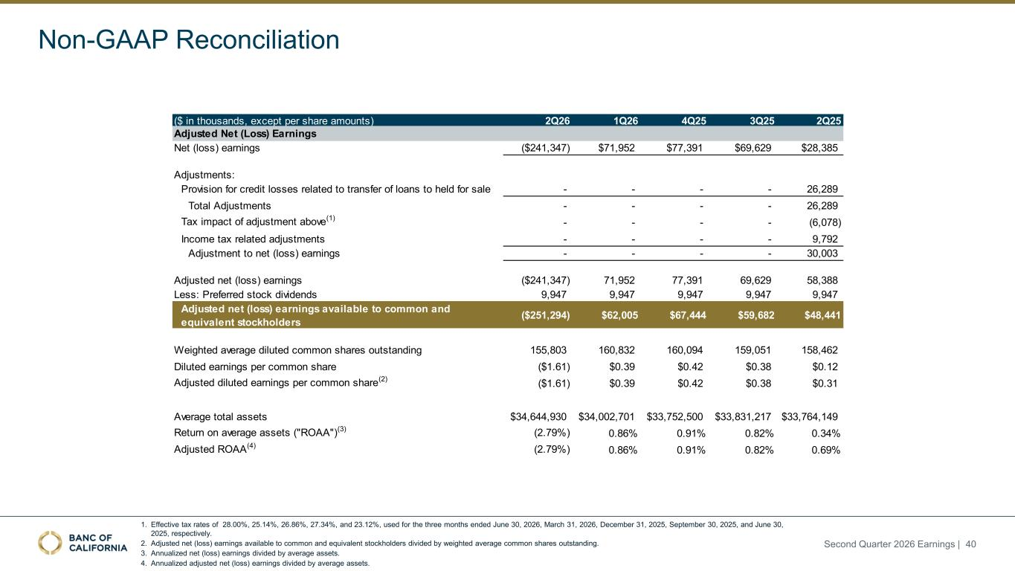
1. Effective tax rates of 28.00%, 25.14%, 26.86%, 27.34%, and 23.12%, used for the three months ended June 30, 2026, March 31, 2026, December 31, 2025, September 30, 2025, and June 30, 2025, respectively. 2. Adjusted net (loss) earnings available to common and equivalent stockholders divided by weighted average common shares outstanding. 3. Annualized net (loss) earnings divided by average assets. 4. Annualized adjusted net (loss) earnings divided by average assets. Non-GAAP Reconciliation Second Quarter 2026 Earnings | 40 ($ in thousands, except per share amounts) 2Q26 1Q26 4Q25 3Q25 2Q25 Net (loss) earnings ($241,347) $71,952 $77,391 $69,629 $28,385 Adjustments: Provision for credit losses related to transfer of loans to held for sale - - - - 26,289 Total Adjustments - - - - 26,289 Tax impact of adjustment above(1) - - - - (6,078) Income tax related adjustments - - - - 9,792 Adjustment to net (loss) earnings - - - - 30,003 Adjusted net (loss) earnings ($241,347) 71,952 77,391 69,629 58,388 Less: Preferred stock dividends 9,947 9,947 9,947 9,947 9,947 Adjusted net (loss) earnings available to common and equivalent stockholders ($251,294) $62,005 $67,444 $59,682 $48,441 Weighted average diluted common shares outstanding 155,803 160,832 160,094 159,051 158,462 Diluted earnings per common share ($1.61) $0.39 $0.42 $0.38 $0.12 Adjusted diluted earnings per common share(2) ($1.61) $0.39 $0.42 $0.38 $0.31 Average total assets $34,644,930 $34,002,701 $33,752,500 $33,831,217 $33,764,149 Return on average assets ("ROAA")(3) (2.79%) 0.86% 0.91% 0.82% 0.34% Adjusted ROAA(4) (2.79%) 0.86% 0.91% 0.82% 0.69% Adjusted Net (Loss) Earnings

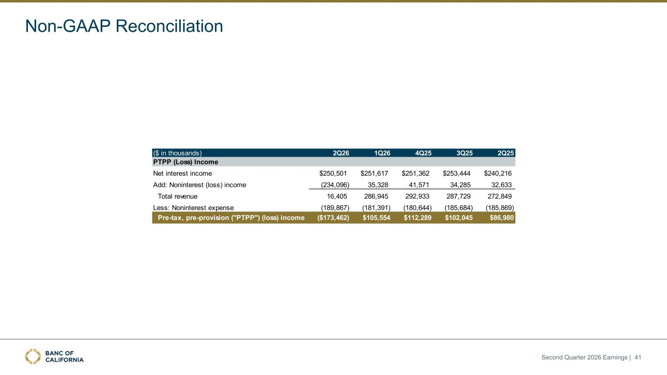
Non-GAAP Reconciliation Second Quarter 2026 Earnings | 41 ($ in thousands) 2Q26 1Q26 4Q25 3Q25 2Q25 PTPP (Loss) Income Net interest income $250,501 $251,617 $251,362 $253,444 $240,216 Add: Noninterest (loss) income (234,096) 35,328 41,571 34,285 32,633 Total revenue 16,405 286,945 292,933 287,729 272,849 Less: Noninterest expense (189,867) (181,391) (180,644) (185,684) (185,869) Pre-tax, pre-provision ("PTPP") (loss) income ($173,462) $105,554 $112,289 $102,045 $86,980

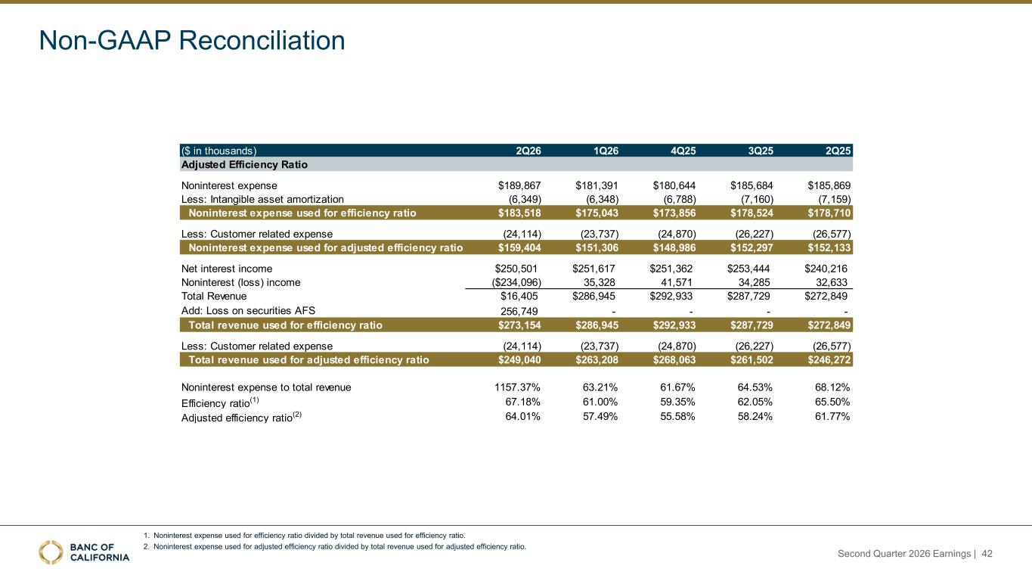
1. Noninterest expense used for efficiency ratio divided by total revenue used for efficiency ratio. 2. Noninterest expense used for adjusted efficiency ratio divided by total revenue used for adjusted efficiency ratio. Non-GAAP Reconciliation ($ in thousands) 2Q26 1Q26 4Q25 3Q25 2Q25 Adjusted Efficiency Ratio Noninterest expense $189,867 $181,391 $180,644 $185,684 $185,869 Less: Intangible asset amortization (6,349) (6,348) (6,788) (7,160) (7,159) Noninterest expense used for efficiency ratio $183,518 $175,043 $173,856 $178,524 $178,710 Less: Customer related expense (24,114) (23,737) (24,870) (26,227) (26,577) Noninterest expense used for adjusted efficiency ratio $159,404 $151,306 $148,986 $152,297 $152,133 Net interest income $250,501 $251,617 $251,362 $253,444 $240,216 Noninterest (loss) income ($234,096) 35,328 41,571 34,285 32,633 Total Revenue $16,405 $286,945 $292,933 $287,729 $272,849 Add: Loss on securities AFS 256,749 - - - - Total revenue used for efficiency ratio $273,154 $286,945 $292,933 $287,729 $272,849 Less: Customer related expense (24,114) (23,737) (24,870) (26,227) (26,577) Total revenue used for adjusted efficiency ratio $249,040 $263,208 $268,063 $261,502 $246,272 Noninterest expense to total revenue 1157.37% 63.21% 61.67% 64.53% 68.12% Efficiency ratio(1) 67.18% 61.00% 59.35% 62.05% 65.50% Adjusted efficiency ratio(2) 64.01% 57.49% 55.58% 58.24% 61.77% Second Quarter 2026 Earnings | 42

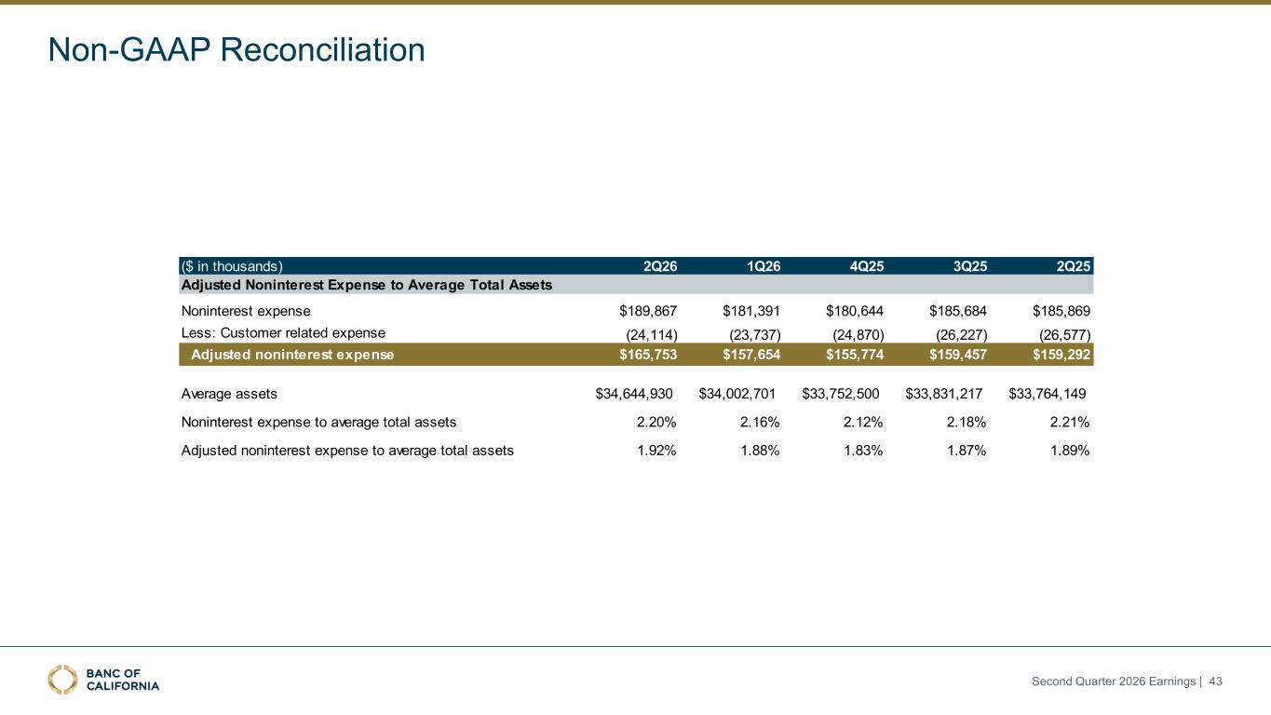
($ in thousands) 2Q26 1Q26 4Q25 3Q25 2Q25 Noninterest expense $189,867 $181,391 $180,644 $185,684 $185,869 Less: Customer related expense (24,114) (23,737) (24,870) (26,227) (26,577) Adjusted noninterest expense $165,753 $157,654 $155,774 $159,457 $159,292 Average assets $34,644,930 $34,002,701 $33,752,500 $33,831,217 $33,764,149 Noninterest expense to average total assets 2.20% 2.16% 2.12% 2.18% 2.21% Adjusted noninterest expense to average total assets 1.92% 1.88% 1.83% 1.87% 1.89% Adjusted Noninterest Expense to Average Total Assets Non-GAAP Reconciliation Second Quarter 2026 Earnings | 43

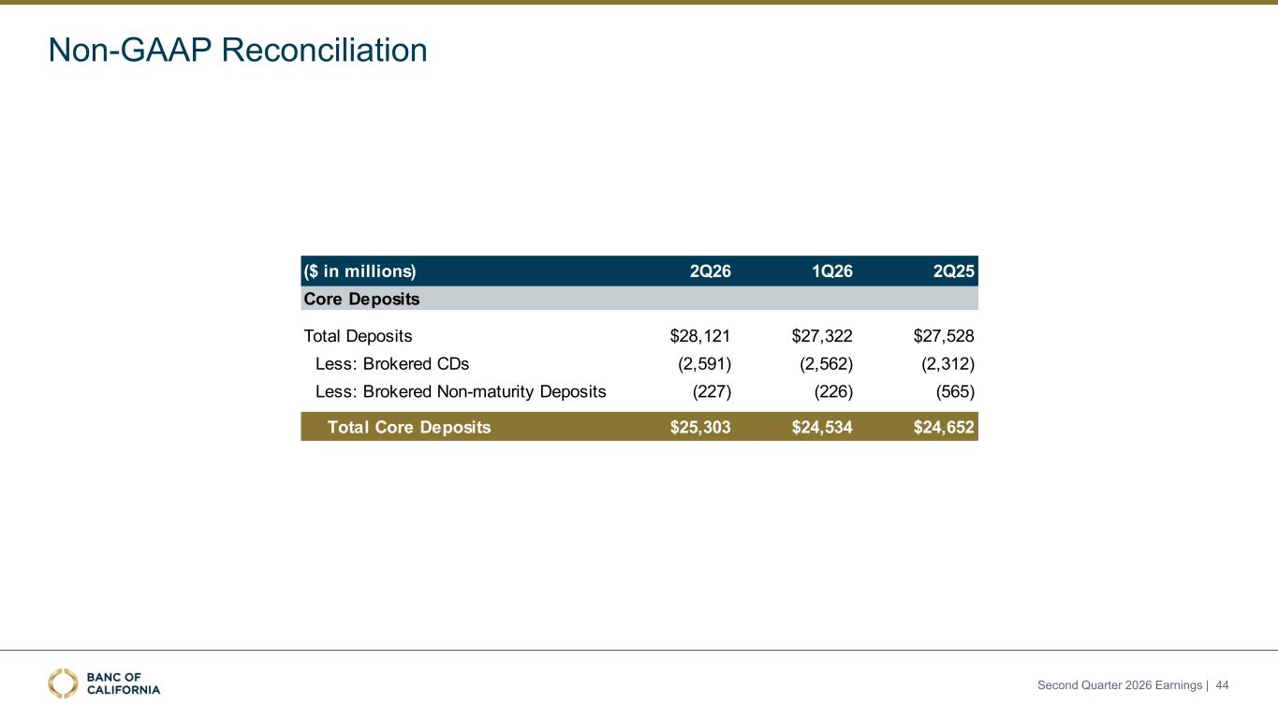
($ in millions) 2Q26 1Q26 2Q25 Total Deposits $28,121 $27,322 $27,528 Less: Brokered CDs (2,591) (2,562) (2,312) Less: Brokered Non-maturity Deposits (227) (226) (565) Total Core Deposits $25,303 $24,534 $24,652 Core Deposits Non-GAAP Reconciliation Second Quarter 2026 Earnings | 44

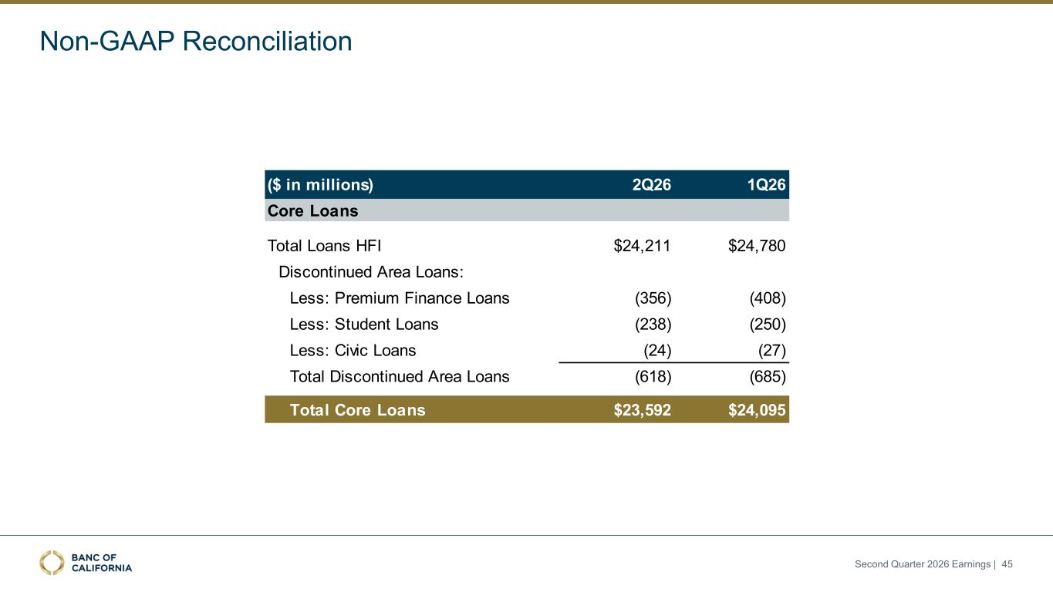
Non-GAAP Reconciliation ($ in millions) 2Q26 1Q26 Total Loans HFI $24,211 $24,780 Discontinued Area Loans: Less: Premium Finance Loans (356) (408) Less: Student Loans (238) (250) Less: Civic Loans (24) (27) Total Discontinued Area Loans (618) (685) Total Core Loans $23,592 $24,095 Core Loans Second Quarter 2026 Earnings | 45

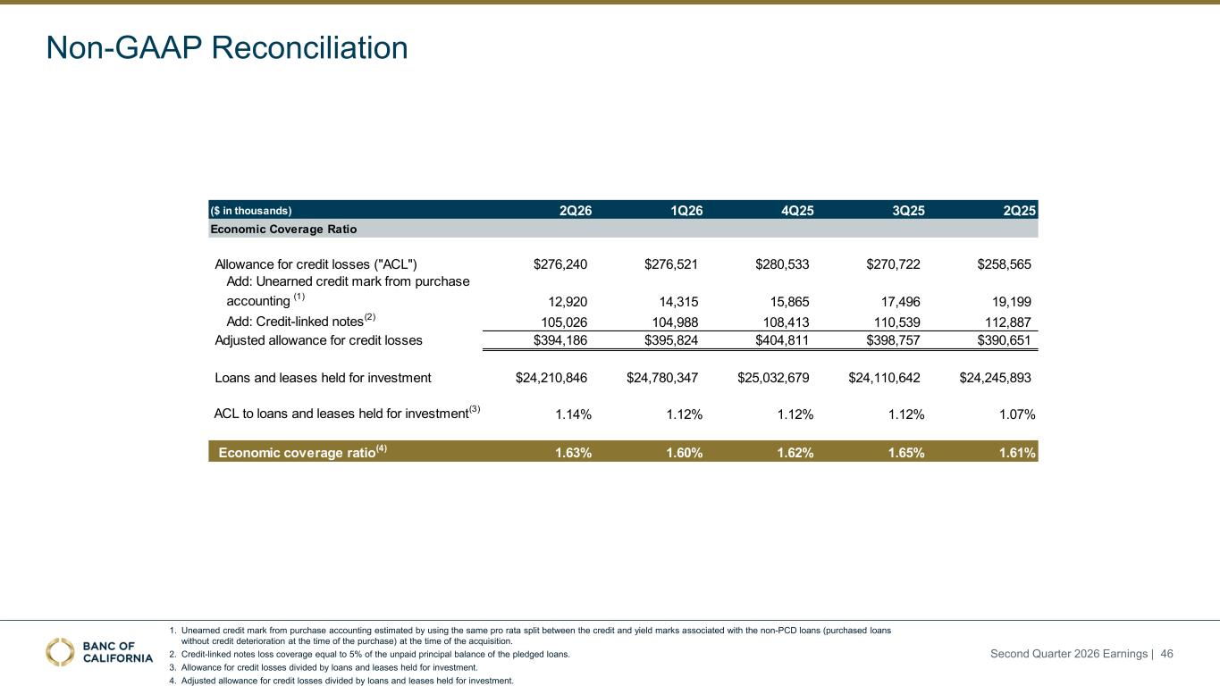
Non-GAAP Reconciliation 1. Unearned credit mark from purchase accounting estimated by using the same pro rata split between the credit and yield marks associated with the non-PCD loans (purchased loans without credit deterioration at the time of the purchase) at the time of the acquisition. 2. Credit-linked notes loss coverage equal to 5% of the unpaid principal balance of the pledged loans. 3. Allowance for credit losses divided by loans and leases held for investment. 4. Adjusted allowance for credit losses divided by loans and leases held for investment. ($ in thousands) 2Q26 1Q26 4Q25 3Q25 2Q25 Allowance for credit losses ("ACL") $276,240 $276,521 $280,533 $270,722 $258,565 Add: Unearned credit mark from purchase accounting (1) 12,920 14,315 15,865 17,496 19,199 Add: Credit-linked notes(2) 105,026 104,988 108,413 110,539 112,887 Adjusted allowance for credit losses $394,186 $395,824 $404,811 $398,757 $390,651 Loans and leases held for investment $24,210,846 $24,780,347 $25,032,679 $24,110,642 $24,245,893 ACL to loans and leases held for investment(3) 1.14% 1.12% 1.12% 1.12% 1.07% Economic coverage ratio(4) 1.63% 1.60% 1.62% 1.65% 1.61% Economic Coverage Ratio Second Quarter 2026 Earnings | 46

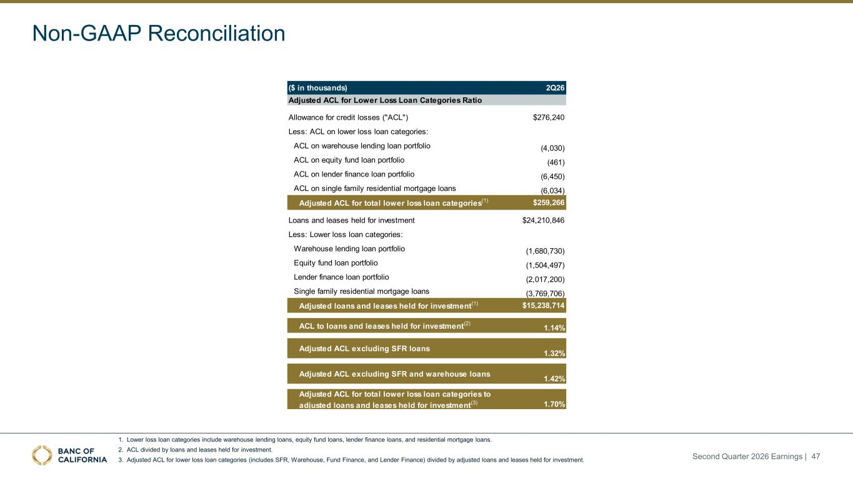
Non-GAAP Reconciliation 1. Lower loss loan categories include warehouse lending loans, equity fund loans, lender finance loans, and residential mortgage loans. 2. ACL divided by loans and leases held for investment. 3. Adjusted ACL for lower loss loan categories (includes SFR, Warehouse, Fund Finance, and Lender Finance) divided by adjusted loans and leases held for investment. ($ in thousands) 2Q26 Allowance for credit losses ("ACL") $276,240 Less: ACL on lower loss loan categories: ACL on warehouse lending loan portfolio (4,030) ACL on equity fund loan portfolio (461) ACL on lender finance loan portfolio (6,450) ACL on single family residential mortgage loans (6,034) Adjusted ACL for total lower loss loan categories(1) $259,266 Loans and leases held for investment $24,210,846 Less: Lower loss loan categories: Warehouse lending loan portfolio (1,680,730) Equity fund loan portfolio (1,504,497) Lender finance loan portfolio (2,017,200) Single family residential mortgage loans (3,769,706) Adjusted loans and leases held for investment(1) $15,238,714 ACL to loans and leases held for investment(2) 1.14% Adjusted ACL excluding SFR loans 1.32% Adjusted ACL excluding SFR and warehouse loans 1.42% Adjusted ACL for total lower loss loan categories to adjusted loans and leases held for investment(3) 1.70% Adjusted ACL for Lower Loss Loan Categories Ratio Second Quarter 2026 Earnings | 47

